Guidance for Teaching Assistant using IT (tablets, computers, etc.) to support EAL learners in lessons:
IT devices (iPads, Android and Windows-based) have incredible potential for supporting EAL learners because they promote multi-modal learning through clearly rendered text, high quality audio-visual elements and kinaesthetic, gesture-based activities.
Electronic dictionaries and translation services such as Google Translate, provide support for spelling, word meanings and vocabulary development. They can provide instant translation for keywords and common phrases, etc. On the other hand, those services are lacking of contextual nature and translation may be incorrect. It is very important for EAL pupils to use all IT tools under adult supervision and guidance.
While supporting EAL pupils using IT, please:
- Use translate apps (Google, Say-Hi, etc.) to interpret the words into the EAL pupils’ own language. Do not use them to translate full sentences.
- Show pictures to illustrate key language where possible, so EAL pupils have a visual image to allow them to link with own language or/and previous experience.
- Demonstrate to EAL pupils, the words in context, in English language so that they can see the word in use.
- Ask EAL pupils to explain the meaning of any language used (using their own words) and model language as appropriate for them to practice.
- Help EAL pupils to practice using the words in context by using an app like Clicker Sentences (or with the words written on a whiteboard.)
- Ask pupils to use the same words in a sentence of their own.

Examples of helpful apps and websites for reading and writing with EAL pupils:
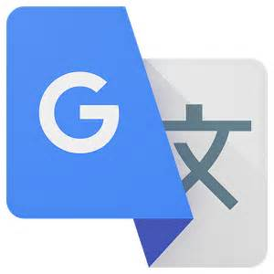 | Google Translate. It is free service instantly translates words, and phrases between English and over 100 other languages. This application provides users with tools to translate between languages. Google Translate app is usually accurate for single words only.
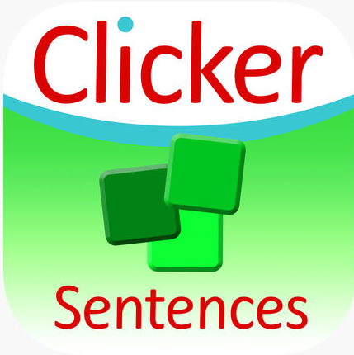 | Clicker Sentences app enables English language learners (or older children struggling to acquire basic literacy skills) to produce work they can be proud of while learning the key skills necessary for independent writing. Clicker Sentences includes the Sassoon font, a lower-case keyboard and many other child-friendly features to create an accessible and engaging environment for pupils to work in.
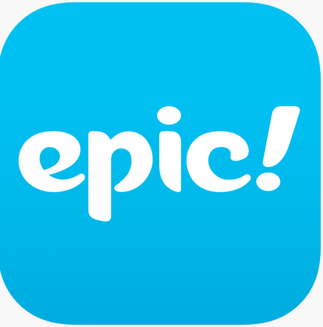 | Epic app is children’s ebook library, offering unlimited access to over 25,000 high-quality children’s books.
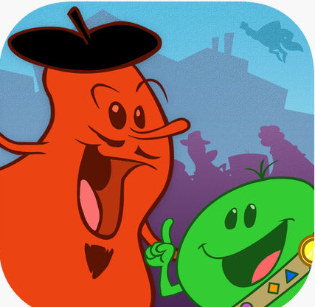 | Grammaropolis makes learning grammar enjoyable. Grammaropolis uses the parts of speech as animated characters whose personalities are based on the roles they play in the sentence. Because the parts of speech are personified based on their roles in the sentence, the characterisation provides EAL pupils with a more effective way to visualise the roles of the parts of speech and to identify how a sentence is put together.
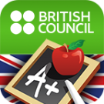 | LearnEnglish Grammar is designed for all learners, whether they are beginners or advanced. Lessons are divided into four levels: Beginner, Elementary, Intermediate and Advanced. Each set of sample questions covers 12 grammar topics, with over 20 activities per topic. Learner can purchase and download more questions as their grammar accuracy improves.
 | Johnny Grammar’s Word Challenge is a quiz for English learners to test common vocabulary, spelling and grammar that appears in everyday English.
 | LearnEnglish GREAT Videos contains 24 videos to learn more about life in the UK. EAL learners learn more about the history of the English language and find out more about British entrepreneurs like Richard Branson. Constant practice using the LearnEnglish GREAT Videos app helps learners to understand native speakers and improve their pronunciation. After using this app, EAL students understand more when listening to English, such as the videos and podcasts in our LearnEnglish Audio & Video app.
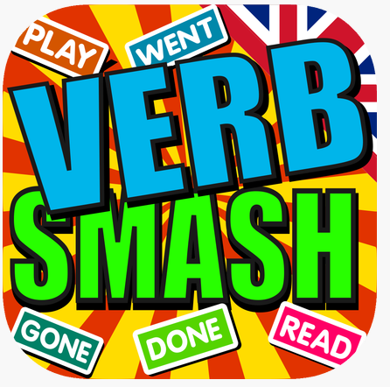 | Verb Smash is an innovative course in English grammar that teaches questions and answers using auxiliary verbs, contractions, negatives, regular verbs and irregular verbs in four of the most common tenses of the English language. This interactive game includes over 500,000 unique question and answer sentence combinations for practicing the present simple tense, present continuous tense, past simple tense and present perfect tense with real life examples.
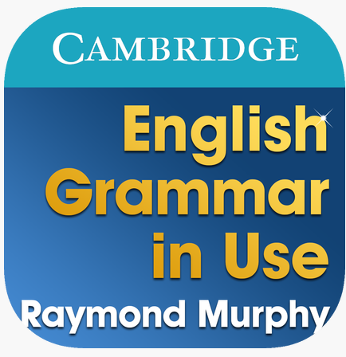 | Raymond Murphy’s English Grammar in Use is the world’s best-selling grammar book for intermediate learners of English, published by Cambridge University Press. The Starter Pack includes six grammar units (Present and Past tenses) with clear explanations and interactive exercises, a Glossary of grammar words, and a Study Guide to help learners decide which grammar units they need to study. After downloading the Starter Pack EAL learner can buy additional 145 grammar units or just the units they need.

EAL – USEFUL WEBSITE LINKS:

https://learnenglishteens.britishcouncil.org
LearnEnglish Teens can help improve EAL students’ English with reading, writing and listening practice, tips for exams, grammar and vocabulary exercises, games and videos.
http://www.toolsforeducators.com/handouts/
For teachers and teaching assistants to create their own templates (for worksheets and flashcards).

Online books for children in multiple languages:
http://en.childrenslibrary.org/
International Children’s Digital Library. More then 1000’s of books in multiple languages.
http://www.childrensbooksonline.org/
Free translated and digitalized audio books (multimedia books are also available for purchase).
https://www.oxfordowl.co.uk/for-home/reading-owl/reading
Over 250 free eBooks (for mobile device) to share with children as well as simple ideas, top tips, activities and games to help children with their reading at home and school.
https://www.storylineonline.net/
Free stories read by celebrity screen actors.

