APPS helpful for New Arrivals
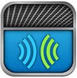 | SayHi. Purely conversational translation. Tap your language button, speak into the microphone and your voice will be instantly translated. Have a conversation with anyone without needing to switch languages. You can also type at anytime by simply pressing the keyboard buttons.
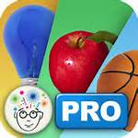 | Picture cards are an integral part of an effective learning program and are used to help teach new words and concepts and foster self-expression. Brain Parade’s See.Touch.Learn app combines the effectiveness of picture cards with the power and interactivity of the iPad. Create custom exercises and lessons, automatically track performance and carry your entire library collection with you at all times.
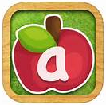 | Little Writer is a tracing app that is ideal for new arrivals. Little Writer is super fun and is so easy to use that your kids will think letter tracing is a game rather than a boring chore.
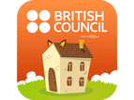 | Over 100 quality videos and games. Animated songs and stories as well as games designed by the British Council’s language learning experts.
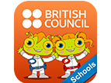 | Young learners of English will enjoy LearnEnglish Kids: Phonics Stories (School Edition), a phonics-based, interactive storybook app that features audio narration and fun games. The story follows super space spies Sam and Pam as they arrive on Earth and learn how to speak and spell English words.
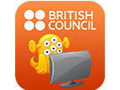 | Stories app takes the most popular stories from the LearnEnglish Kids website and transforms them into fun, animated video stories for handheld devices.
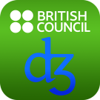 | LearnEnglish Sounds Right is the British Council’s free pronunciation chart for learners and teachers of English worldwide.
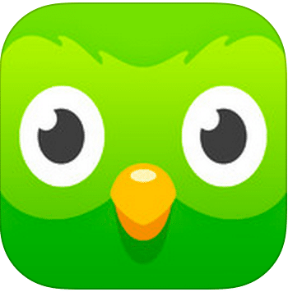 | Duolingo is a free language-learning platform that includes a language-learning website and app. EAL pupils can practise their speaking, reading, listening and writing skills while playing different games. Good for new to English as it starts with basic verbs, phrases and sentences. Children learn new words daily.
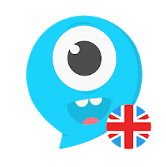 | Lingokids is a learning experience for children. It involves lots of activities such as games, songs, audio books and traceables.
 | Memrise is a language platform which uses flashcards as memory aids, but also offers user-generated content on a wide range of other subjects. Memrise has official courses in 16 languages and its combinations.
 | ESL Library is a bank of teaching materials like new lessons, resources and flashcards. Unlike traditional textbooks, our ESL Library of resources continues to grow every month.

EAL – USEFUL WEBSITE LINKS
https://eal.britishcouncil.org/ = https://ealresources.bell-foundation.org.uk/ - Lots of advice and resources for EAL. Very up-to-date and practical.
http://www.collaborativelearning.org/ - Great site with resources across the curriculum. Lots of games and group work activities as well as curriculum-linked resources up to key stage 4.

https://www.mamalisa.com/?t=eh - Songs and nursery rhymes from around the world – useful for EYFS.

http://www.newburyparkschool.net/langofmonth/ - Language of the month activities to promote and support first language in schools.

http://www.eal-teaching-strategies.com/ - Strategies and resources for supporting EAL learners of all ages.

http://www.mes-english.com/ - Excellent website with flashcards, games, Power Points, etc; you can create your own worksheets/dice/flashcards/certificates, etc.

http://www.racingtoenglish.co.uk - A CD ROM, to buy with more than 200 fun and flexible activities to print out and use with EAL pupils.
http://www.toolsforeducators.com/handouts/ - For teachers and teaching assistants to create their own template for worksheets and flashcards.
http://a4esl.org/ - Grammar, crosswords, bilingual quizzes, games, etc.
http://www.schoolslinks.co.uk/resources_dl.htm - Free dual language signs.
http://www.naldic.org.uk - The site of National Association for Language Development in the Curriculum: you can find researches relating to EAL, resources, etc.
RESOURCES AVAILABLE FOR SALE:
http://handsonconcepts.com/ - online shop with printable barrier games and practical, printable resources for new to English children.
http://www.mantralingua.com/homephp/
Lots of resources for New Arrivals, but not free: CD-ROMs, talking pens, posters, books, etc.

