



EAL New Arrivals
Survival Brochure

EAL New Arrival’s Survival Brochure
Guidance for Teachers
in Solihull

CONTENTS:

- Important definitions
- Conditions for learning – cultural implications
- New Arrival (before the pupil’s arrival and ongoing support)
- Referral process for New Arrivals in Solihull
- Dos and Don’ts
- Some ideas to use with New Arrivals (NA)
- Vocabulary topic checklist
- Basic language for NA
- Checklist for planning
- EAL useful website links
- Helpful apps for EAL pupils

Definitions

New arrivals: New arrivals may be described as international migrants including refugees, asylum seekers and economic migrants from overseas.They could also be children who were born in the UK but have not spoken English until they started school.

This brochure focuses primarily on meeting the needs of pupils who have arrived in school as a result of international migration.

EAL stands for English as an Additional Language and recognises the fact that many children learning English in schools, in this country, already know one or more other languages and are adding English to that repertoire.

Bilingual is used to refer to those children who have access to more than one language at home and at school. It does not necessarily imply full fluency in both or all of their languages. It can be used interchangeably with EAL.

Minority Ethnic Group is used in this publication for all those groups other than the white British majority. Although children from these groups may well form the majority in some school contexts, they are still members of groups in a minority nationally and will continue to be referred to as children from minority ethnic groups. Most children learning EAL are from ethnic groups.

Conditions for learning – cultural implications
Culture shock
Whilst adapting to a new culture, children may go through different stages. Initially, there can be excitement at the newness of the surroundings. Later, as children become more aware of the cultural differences, this can affect their own sense of security and self-image - they may look for the support of other children from their own culture and they may complain about the new culture. As children begin to accept the differences between the new and the old culture, there may be feelings of uncertainty and regret - of being in between two cultures.
Although children seem to adjust to new situations much more quickly than adults do they still experience culture shock. This can be manifested in irritability, poor behaviour and lack of motivation.
Potential challenges:
- Feelings of insecurity or trauma due to prior experiences.
- Isolation and lack of friends.
- Separation from one or both parents.
- No previous schooling due to lack of opportunities or instability in the home country.
- Different style or emphasis of education.
- Children may feel misunderstood and unvalued if they cannot see any of their culture or language in the classroom/school.
- Experiencing racism in or out of school.

Cultural differences – examples
- Due to cultural differences some children may:
- avoid eye contact with teachers since in their culture, looking someone directly in the eye may have a meaning other than an acknowledgement of listening. In some cultures, this may be a mark of respect and does not indicate that they are not listening.
- smile even when they are in disagreement with what is being communicated, or when they are being reprimanded, since in their culture a smile is a gesture of respect.
- nod their heads to acknowledge that you are talking to them, but, this does not mean that they understand you.
- not want to eat with other pupils, because they are not used to eating with anyone but members of their own family.
- not answer unless they know the answer. An incorrect answer or guess may mean ‘losing face’.
- be very quiet and co-operative in the classroom. This does not mean that they understand or that they do not need help from the teacher.
- feel that written work is the most important part of their work and pay little attention to oral work or related learning activities.
- be uneasy at the more liberal approach of some classroom activities in schools in this country. When they are used to a more formal teaching style, they need to learn how to work co-operatively and the boundaries of behaviour expected in the class.
- will avoid physical contact for cultural reasons. For example;- some Muslim women and girls do not shake hands. On the other hand, some young African children may be accustomed to more physical contact than is the norm in English classrooms.
- not use knives and forks for eating. Using hands is a skilled and proper way of eating in some cultures.
- may seem aggressive in the playground or may show other behavioural patterns. This is sometimes because their English is limited and their only form of communication with their peers is non-verbal.

If you have any concerns regarding your pupil’s resilience please discuss these further with your Solihull EAL Advisory contact

Before the pupil arrives
- Make sure staff, including office staff, are aware of school procedures for newly arrived bilingual pupils. This will include notifying the EAL Co-ordinator (EALCo) or staff member with responsibility for bilingual learners.
- Gather information for the admissions interview such as language spoken by parents/carers/child and whether you need to arrange an interpreter.
- Identify whether the family needs support to complete the school registration or admission forms. These can be returned at the admissions interview.

Admissions interview
- Make the school environment as familiar and welcoming as possible.
- Provide an interpreter if needed. Parent Ambassadors or interpreters from a professional interpreter’s agency. Contact SMBC EAL Service on 0121 704 8613 for information on local interpreters.
- Alternatively use a website for new arrivals such as:
http://newarrivals.segfl.org.uk
- Use the additional admissions form to gather vital personal information about the pupil. (see Appendix 1)
- Spend time helping families to complete forms.
- Spend time touring the school.
- Provide contact details of local community organisations/networks.
- Provide an induction pack including visual timetables, maps of the school, calendar of term dates and any other key facts about the school
- Allow 2-3 days between the interview and the pupil starting school.
Preparation
- Use the 1-3 days after the interview to let adults in the school know of the pupil’s arrival, including as much information about the pupil’s background as possible.
- Prepare your class for the new arrival welcome:
- Ask children to consider what the new arrival may find difficult and how they could help.
- Explain strategies that the children can use such as speaking to the newly arrived child in natural English, making sure the child is included in all activities, showing the child how to do a task, talking through tasks while they are doing them.
- Explain to the class what the new arrival will bring with them (e.g. language, culture, knowledge of another country).
- Ensure that children know how to pronounce the new arrival’s name correctly.
- Support the class to learn a few words of the new arrival’s language and/or find out something about their country/ culture.
- Arrange ‘buddies’ (or several buddies) to help the child to settle in and make friends. Placing pupils with peers of the same linguistic and cultural background if possible but, ensuring that assigned buddies are mature and good role models. Being a buddy is a big responsibility and can be emotionally draining, try to assign more than one pupil to the role.
- Assign a member of staff to the role of ‘induction mentor’; this could be a TA or EAL Co.
- Locate appropriate resources (see ‘EAL handy websites’). Make a selection of bilingual books and dictionaries available.
- Ensure that the child has a place within school where they can go if they need some ‘time out’ and a designated adult responsible for their well-being.

Induction – the first few weeks
- Re-familiarise the pupil with the school, prioritising key locations such as the classroom, the toilets, and the lunch area.
- Take time to re-clarify the school routine, using visuals to help.
- Provide the pupil with a visual timetable
- Offer the pupil, with the use of picture cards, to express basic needs. Provide fans with pictures and simple phrases which the child can use to indicate if he/she feels thirsty/sad/sick/ needs a pencil/needs to go to the toilet/is okay etc.
- Give the pupil a tray or locker to promote a sense of belonging.
- Avoid placing pupils with SEN groups; they need good role models of English.
- Accept that the pupil may experience a ‘silent’ period and do not force the pupil to participate if they are unwilling.
- Encourage the pupil to use their first language to access the school curriculum.
- Plan a variety of collaborative activities so the pupil may participate.
- Refer new arrival pupil to Solihull EAL Service for assessment if required.
*See page 11 for Referral Process in Solihull

Ongoing Support
- As much as possible, try to implement the strategies advised by the EAL Report
- Set EAL targets regularly using the EAL Solihull Tracker
- Review progress regularly using the EAL Profile of Competence
- Provide opportunities for pre-teaching vocabulary and new skills
- Implement a wide range of strategies including lots of speaking and listening opportunities
- Include the EAL pupil’s language development in your whole class weekly planning
- Plan in advance for the use of additional adults, allowing time for the preparation of resources
- Maintain regular contact with parents/carers (through a home-school link book) and whenever possible encourage parental support
- Do not over-correct developing English
- Keep an eye on social progress – is the pupil involved in extra –curriculum activities, school trips etc?
- Do not get too impatient. Nearly all pupils will become conversationally fluent within 2 years, but academic language can take 5-7 years to develop

REFERRAL PROCESS FOR NEW ARRIVAL IN SOLIHULL

Child arrives in school. Parent meeting to obtain basic information for referral form. Child left to settle for approx. 3 weeks before EAL referral if required.

If referral is required school to send completed from to EAL Service to request a visit and assessment. EAL Service aims to visit within 3 weeks where possible.

Prior to visit and assessment, school is required to complete the Profile of Competence and have this available for the member of EAL staff when they visit.

EAL team member will visit school, meet parents, observe the child, speak to teachers and (where appropriate) complete a formal assessment of the child.

The following outcomes may result after assessment

- No further input required
- Advisory Support – follow up appointment made for next term or sooner if needed
- Direct Support – this usually lasts for no more than 2 terms

SUPPORTING PUPILS WITH LITTLE OR NO ENGLISH

 | DON’T
Do find out what the pupil’s home/first language is and how to pronounce/spell their names correctly.  Do allow them to stand back and watch at first – passive language skills develop before active skills.  Do keep the pressure off and the stress low – happy pupils settle more quickly and begin to learn English faster.  Do provide a group of supportive, strong language role models as buddies. Actively encourage and support peer interaction. Collaborative group work will provide opportunities to use language in meaningful situations.  They will learn a lot from their peers, especially those with good language.  Do accept that children learning EAL may have well developed skills in their home language despite their lack of English, so ensure tasks and activities are age appropriate.  Do reassure parents that maintaining and developing the home language will support learning English.  Do remove the pressure to speak – accept nods, gestures, pointing, facial expression, etc., for some time.  Do accept, value and praise any means to communicate, whatever the language.  Do respond to the content of what they say, not the grammar. Accept one word answers and ignore initial mistakes.  Do encourage speech when it starts voluntarily. (This can be from two weeks to a year!) Insisting on oral responses too early may seriously hinder learning English.  Do use gestures, pointing, and demonstration, concrete and visual clues when you speak. Repeat rather than rephrase instructions etc.  Do sit them where they can hear the teacher and see lip movements and gestures. Use clear, normal speech, moderate speed if you are a fast talker. Repeat and rephrase if needed.  Do allow the pupil to copy from a paper version when appropriate. Copying from the board is difficult if the alphabet is unfamiliar. Write legibly on the board.  Do scaffold lessons to make them as accessible as possible through talk, visuals, writing frames, use of TAs, modelled language, explaining key vocabulary. Give different work, when appropriate.  Do remember that all new arrivals will be going through some form of culture shock and trauma because they have left behind family, friends, sense of achievement, what is familiar, etc.  Do make them feel a part of the school from the start, e.g. dual language materials, signs in first/home language, culturally familiar objects and images, etc.  Do value the pupil’s culture, languages and experiences by letting them be the expert. | Don’t S-H-O-U-T! This is often the first response to a non-native speaker. Don’t talk with exaggerated pronunciation and volume to the pupil or parents.  Don’t use unnatural speech e.g. baby talk, unnaturally slow speech or telegrammatic (broken) English: talk in sentences.  Don’t panic! Many bright, able, normal pupils remain silent for six months or more. When they start speaking, they may be amazingly fluent and have an excellent English accent after listening for so long.  Don’t insist on full sentences when they speak or make them repeat ‘incorrect’ sentences ‘correctly’ when they try to talk.  Don’t use colloquial English e.g. phrases such as put on/down/across/upon/off. It is too subtle and therefore confusing for beginners.  Don’t tell parents to speak English at home. Supporting the development of the first language will enhance the learning of English. Home language literacy skills can be transferred to their work in the English language.  Don’t encourage parents who have limited English skills to teach them English at home.  Don’t place EAL pupils on tables or in groups with pupils with special educational needs. Pupils should not be placed in bottom sets unless there is clear evidence that they have specific learning difficulties.  Don’t expect their reading and writing skills to develop at the same rate as their spoken or understanding skills. Until they have sufficient exposure to English, they cannot be expected to use strategies for reading and writing that their monolingual peers may use.  Don’t make pupils work in silence all the time. EAL pupils need lots of speaking and listening opportunities to hear language being modelled and practice it. Talk is a rehearsal for writing.  Don’t ignore the pupils because communication is difficult. Take time to talk to them and find out about them as a person.  Don’t treat all pupils the same. Equality means respecting our differences whilst affirming our similarities. EAL pupils are not a homogenous group – they all have specific needs as with any group of pupils.  Don’t confuse low English proficiency with low intelligence, lack of experience or uncooperativeness.  Don’t assume that children (or parents) are being deliberately difficult if they do not always comply with your expectations. They may have developed strategies for appearing to understand by copying others.

Some Ideas to Use with New Arrivals

The use of visuals is essential for teaching children with little or no understanding of the English language. Games and practical activities are excellent for speaking practice.

Ideas | Examples
Take photographs | Take photos of the places, people and activities in and around school. Stick them onto a record book in an orderly and structured manner. Use it for regular revision and extend talk gradually.
Access ICT | Use lCT to access information with photographs about the pupil's home country/culture, and then introduce the UK in the same way.
Share photographs | Encourage Teacher/pupils to share a photo of a family (own family photo, if appropriate) and introduce key words for family members. Ask parents to share home photos.
Make illustrated books | Use old catalogues, pictures/photos to make a picture dictionary of everyday objects. Make an "I like ... " book, or a diary illustrated with pictures. Pupils can take this home to show parents and revise.
Use flash cards | Use pictures from this pack, photos taken, or any pictures obtained for targeted vocabulary. Turn them into flash cards and use them to refresh memory regularly. Make 2 sets and use them to play snap, pelmanism, or matching games.
Memory games | Work in a small group of 3/4 children to reinforce targeted vocabulary. Play "Kim's game", visual sequential or auditory memory games. Always use picture cards to recap vocabulary first and start with a small number of words.
Miming and guessing | Use flash cards to recap targeted action words. The pupil mimes the actions and the teacher guesses and says the words. Repeat with teacher miming and the pupil guessing. Can also be played in a small group.
Hiding game | Good for practising prepositions. Hide an object and tell the pupil where it is, using targeted preposition. E.g. teddy is behind the book/under the teacher's chair". Children may also ask for clues: "ls it next to/behind the .. ?"
Board games | Make your own board games e.g. Bingo, Snakes and Ladders, puzzles etc. with pictures from this pack, or photos taken, or any pictures obtained for targeted vocabulary. You can also find many interesting games in Primary Vocabulary Box by Cambridge University Press.
Craftwork (for younger children) | Make 3-D pictures. e.g. a house with windows that open, showing family members; a book in the shape of a school, showing different rooms and classroom objects; a school bag for putting in stationery. Make a butterfly on a stick and practise prepositions and vocabulary. e.g. fly it "under the table/behind the computer".

Vocabulary Topic List

Please tick when visited
Colours
Numbers 1 – 10
Numbers 10 – 20
Adjectives of size
Opposites
Prepositions
Outside the house
The garden
The living room
The bedroom
The kitchen
The bathroom
Clothes
Fruit
Vegetables
Drinks
Body parts
Pets
Animals
Days
Months
Seasons
Weather
The street
The park
Shapes
Time
Words for +, -, x, ÷, =

Basic Language for New Arrivals

Here is a list of basic language that an EAL child will need to survive the first few weeks of school. It is important to familiarize the child with everyday vocabulary in and around his/her new school. Practising these vocabulary and language structures orally, supports the child with understanding simple instructions and communicating with others at a basic level.

Subject | Vocabulary  (Always include “a/an” and “the” as appropriate when teaching nouns.) | Simple instruction | Basic questions/  Response
Greetings | Hello  Good morning  Good afternoon  Goodbye | Please answer the register.  Please say “good morning”. | Hello  Good morning  Good afternoon  Goodbye  How are you?  I am fine/good thank you.
Names of People | Child’s name  Child’s family names  Mother/mummy/mum  Father/ daddy/ dad  Brother  Sister  Head teacher’s name  Class teacher’s name  Teaching assistant’s name  Names of peers in working group | Tell me your name.  This is…  He is/ his name is…  She is/ Her name is… | What is your name?  My name is…
Myself;  Facial /Body Parts/ Personal Items/ Colours | Facial parts: eyes, nose, mouth, ears, etc.  Body parts: head, arm, hand, finger, leg, foot, etc.  Personal items: coat, bag, shoes, PE kit etc.  All main colours. | Touch the…  Point at the…  Give me the… | What is this?  This is…  Is this…?  Yes/No  Do you like..?  I like…  I don’t like…
Places around school | Playground, hall, classroom, library, toilet, ICT room, music room, etc. | This is…  Come here  Go to…  Walk quietly.  Line up.  Wash hands. | Ask for toilet.  Can I go to..?  Where is..?
Inside the classroom | Teacher  Children  Classroom objects: table, chair, computer, whiteboard, etc. | Sit down.  Sit on the floor/ carpet/ chair.  Stand up.  Listen.  Be quiet.  Put up your hands.  Put it in…/put it away…  Show me…  Point to…  Line up.  Wash your hands.  Read…  Write… | Ask for toilet  Ask for coloured crayons  Ask for stationery  Can I go… please?  Can I have… please?
Days of the week and a school day | School diary  Weekdays: Monday to Friday  Weekends: Saturday, Sunday.  School day: play/break time, dinner/lunch time, home time, assembly, PE etc.  Activities: reading, writing, painting, drawing, colouring, etc. | Open your diary.  Turn to…  Point at…  Write down…  Read quietly.  Bring PE kit on…  Put your PE kit on. | What do you like doing?  I like (activity name)  I don’t like…  When is play time/ diner time?  Play time is…  Dinner time is…
Numbers and shapes | Numbers 0 to 20+ (extend as appropriate to ability)  Basic shapes: circle, rectangle, square, triangle  Big/ bigger  Small/ smaller | Point at…  Give me…  Say the number/ name  Write down…  Draw the | What is this number?  This is…  …is bigger than…  …is smaller than…
Prepositions | in, on, under, behind,  in front of, next to, between, over etc. | Stand behind…  Sit next to…  Put the… in…  Put the… between…and… | Where is…?  It is… Is it…?  Yes, it is. No, it isn’t.
Food and cutlery | Lunch choices.  apple, banana, orange, tomato, carrot, chips, egg, sandwich, burger, pizza, sausage, milk, juice, water, etc.  cup, glass, plate, bowl, spoon, knife, fork, etc. | What would you like?  Do you want the..?  Would you like the..? | Yes/no, thank you.  Can I have… please?

Other topics include ‘Clothes’, ‘Household items’, ‘Animals’ and ‘Transport’. As with all areas of language development, the teaching of basic vocabulary is best done within a natural learning environment and a real learning context as part of word/sentence level work. The topic above should not be seen as hierarchical, but incorporated in curriculum planning as much as possible.

Planning
- Where possible plan collaboratively with EAL staff, and support assistants
- Ensure effective communication of planning to other adults where collaboration is not possible
- Plan for inclusion by differentiating planning using strategies outlined above
CHECKLIST FOR PLANNING

- Do the bilingual pupils understand the learning intention?
- Do I know their prior knowledge of this topic?
- Do I know what English language skills they have and need to develop? (refer to Profile of Competence)
- Have I planned for opportunities to develop these skills in this lesson?
- Have I used any opportunities to relate this lesson to their country / culture / language?
- Have I highlighted / written on the board, the key words and phrases for this lesson?
- Are the pupils using a bilingual dictionary and recording any new words?
- Have I used visual support for understanding?
- Have I modelled the key language structure for the activity?
- Do the bilingual pupils have the opportunity to communicate purposefully in this lesson?
- Do the bilingual pupils have an opportunity to discuss the work in their home language?
- Am I using supportive questioning to check understanding and develop talking?

EAL USEFUL WEBSITE LINKS RECOMMENDED:

http://newarrivals.segfl.org.uk
Very useful for new arrivals. It helps to collect information from parents.

https://eal.britishcouncil.org/
Lots of advice and resources for EAL. Very up-to-date and practical.

http://eal.britishcouncil.org/teachers/country-information/
Information on countries and education systems.

http://eal.britishcouncil.org/teachers/language-information/
Information on home languages.

http://www.collaborativelearning.org/
Great site with resources across the curriculum. Lots of games and group work activities as well as curriculum-linked resources up to key stage 4.

http://en.childrenslibrary.org/
International Children’s Digital Library; 1000’s of books in multiple languages.

http://www.eal-teaching-strategies.com/
Strategies and resources for supporting EAL learners of all ages.

http://www.mamalisa.com/?t=eh
Songs and nursey rhymes from around the world – useful for EYFS.

http://www.schoolslinks.co.uk/resourcesdl.html/
Free dual language signs.

http://www.mantralingua.com/homephp/
Lots of resources for New Arrivals, but not free: CD-ROMs, talking pens, posters, books, etc.

http://www.mes-english.com/
Excellent website with flashcards, games, PowerPoints, etc; you can create your own worksheets/dice/flashcards/ certificates, etc.

www.naldic.org.uk
The site of National Association for Language Development in the Curriculum: you can find research relating to EAL, resources, etc.

HELPFUL APPs FOR EAL PUPILS:

- Translating



- Reading

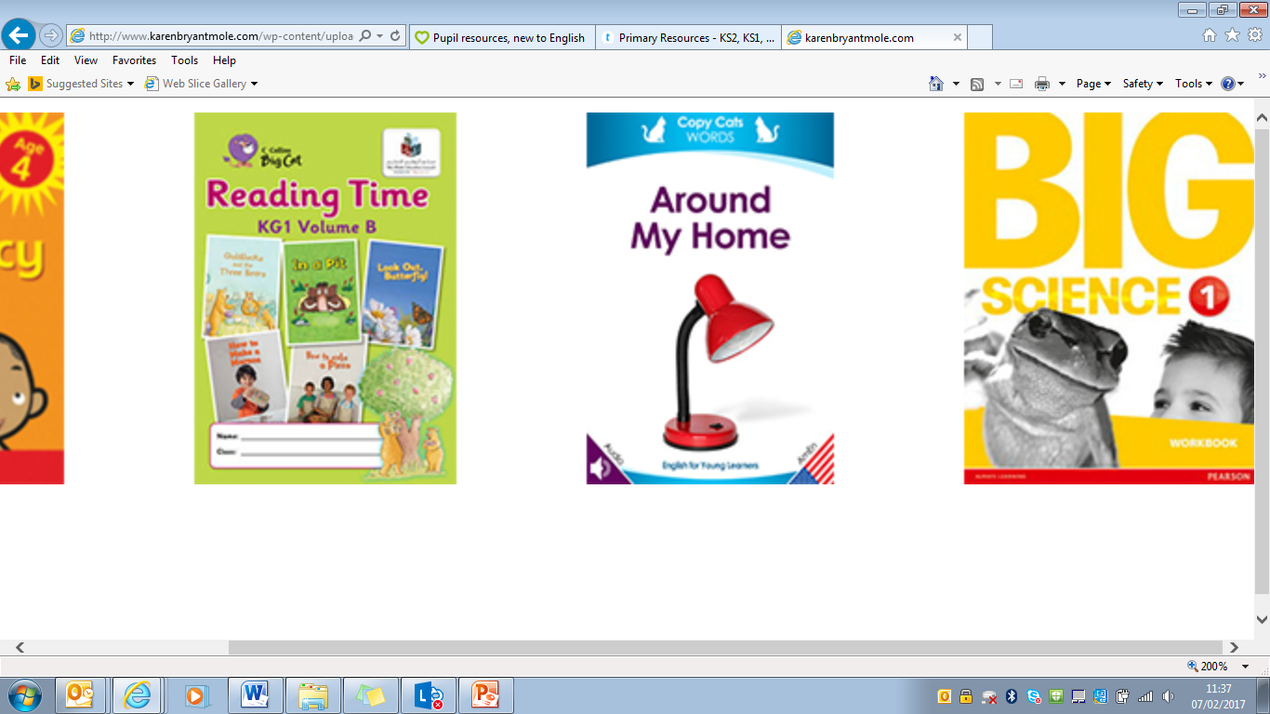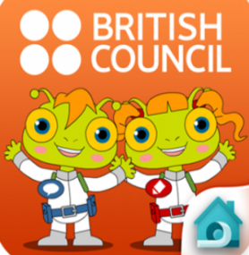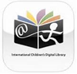

- Writing

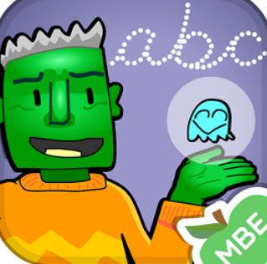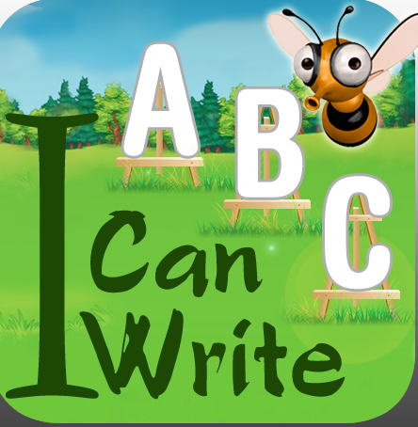

- Grammar

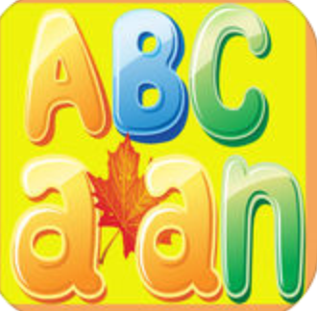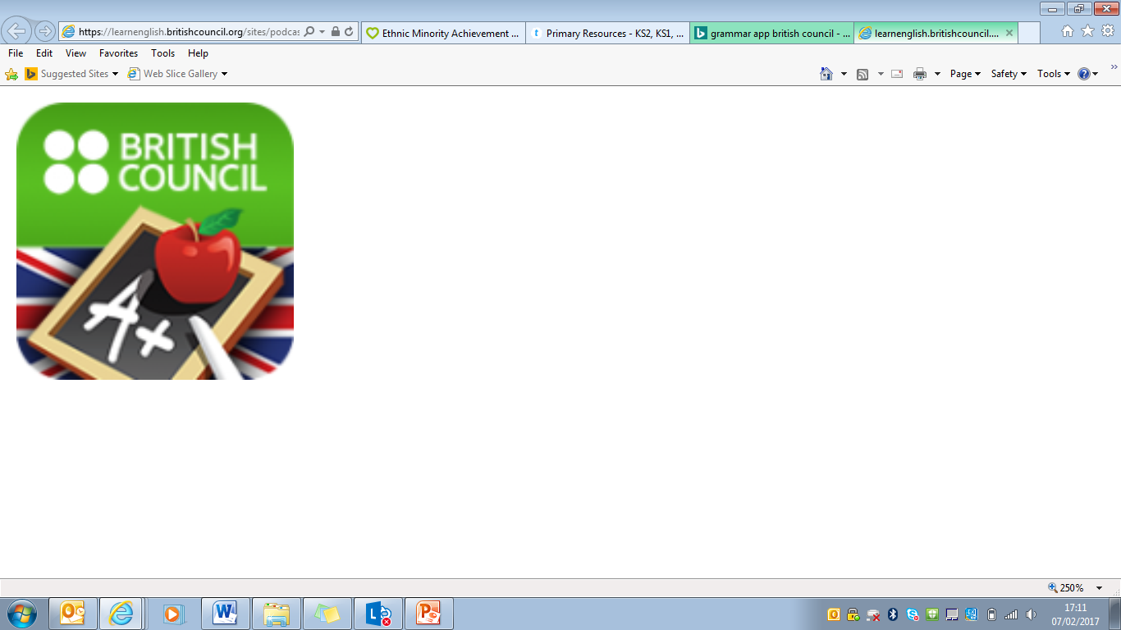

CHILDREN’S SERVICES
EAL Service

Council House
Manor Square
B91 3QB
Solihull, West Midlands
Tel: 0121-704-8613
Email:ealservice@solihull.gov.uk
Twitter: @eal_service
www.solihull.gov.uk

Information on
https://extranet.solgrid.org.uk

