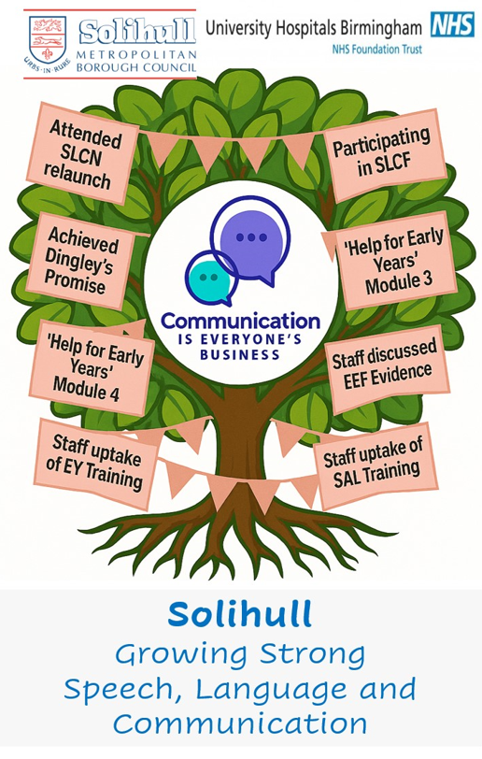
- Dingley’s Promise - https://dingley.org.uk/dingleys-promise-training/early-years-inclusion-programme/
- Education Endowment Foundation- https://educationendowmentfoundation.org.uk/early-years
- DfE Help for early years - https://help-for-early-years-providers.education.gov.uk/
- Solgrid Early Years and Childcare- https://www.solgrid.org.uk/eyc/training/special-events/

Solihull Early Years SLCN Toolkit
Guidance | Weblink | Resource outline
Early Years Foundation Stage Statutory Framework | https://www.gov.uk/government/publications/early-years-foundation-stage-framework--2   | EYFS -mandatory for all Learning and development & safeguarding and welfare requirements
Non-statutory child development guidance | https://www.gov.uk/government/publications/development-matters--2  https://birthto5matters.org.uk/wp-content/uploads/2021/04/Birthto5Matters-download.pdf  https://progress-checker.speechandlanguage.org.uk/  https://shop.speechandlanguage.org.uk/products/stages-of-speech-and-language-development-advisory-poster-set-of-5 | Development Matters  Birth to Five Matters  Speech and Language Uk’s progress checker for parents  Free poster-stages- download – S&L UK
Solgrid/eyc website | Currently here - https://www.solgrid.org.uk/eyc/  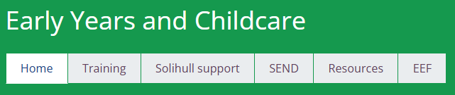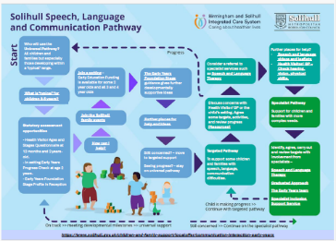 | Pathways and resources  SEND support- Graduated Approach and Assessment Toolkit  Training
Solihull Therapies website | https://childrenscommunitytherapies.uhb.nhs.uk/speech-and-language-therapy/   | Resources for everyone - try this  Support for pre-school children  Targeted resources  Make a referral
Solihull Local Offer | https://www.solihull.gov.uk/children-and-families/solihull-local-offer/early-years-education-0-4-years  https://www.solihull.gov.uk/local-offer-communication-and-learning-difficulties-team-parent-information   | Early Years Team-parents support  SISS: CLD Team
CBeebies- Tiny Happy People | https://www.bbc.co.uk/tiny-happy-people  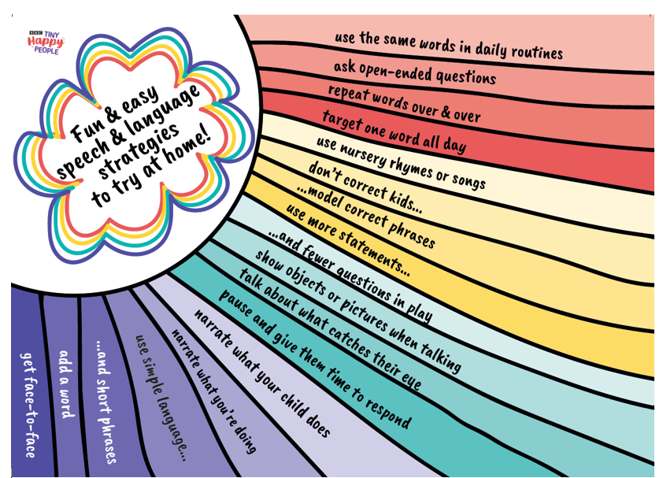 | Child development and milestones, tips and advice, and activities.

