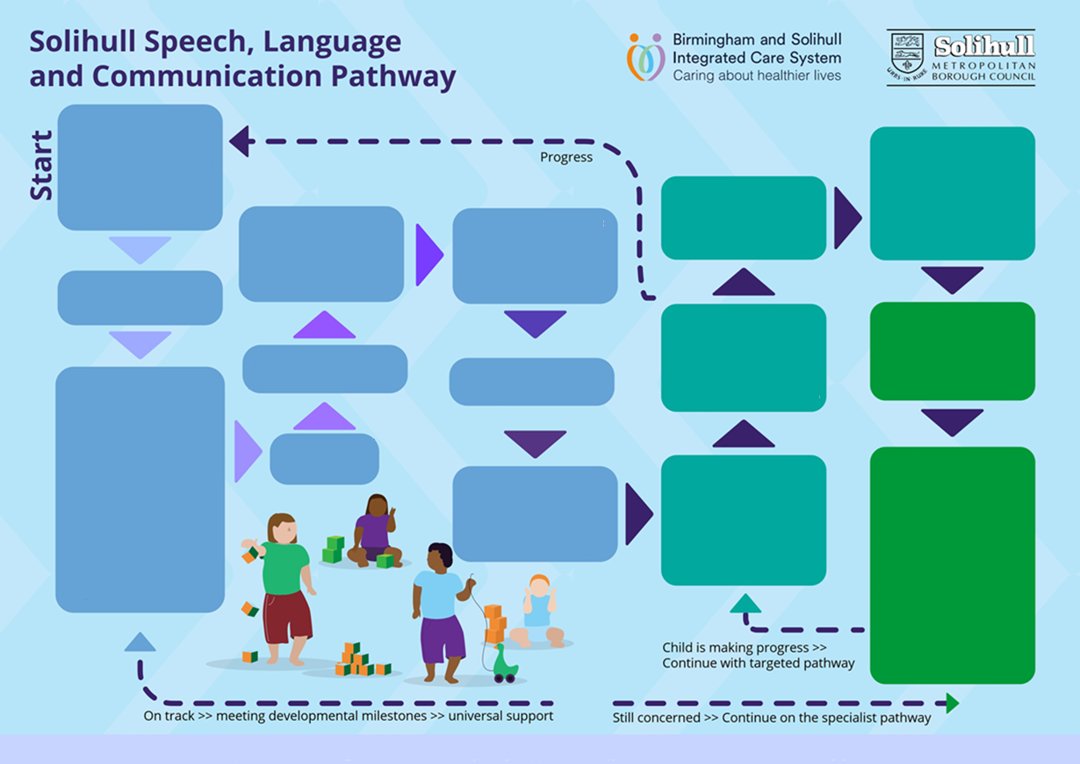

Further places for help?

* **[Speech and language videos and leaflets](https://childrenscommunitytherapies.uhb.nhs.uk/speech-and-language-therapy/play-interaction/)**
* [**Health Visitor/ GP – Check hearing, vision, physical skills.**](https://www.solihull.gov.uk/children-and-family-support/localoffer/communication-interaction-early-years)

**Targeted Pathway**

To support some children and families with speech, language, communication difficulties.

[**Join the Solihull family events**](https://edportals.solihull.gov.uk/Synergy/Live/SynergyWeb/Solihull_Childcare/)

[**Join a setting**](https://edportals.solihull.gov.uk/Synergy/Live/SynergyWeb/Solihull_Childcare/Childcare.aspx) – Early Education Funding is available for some 2 year olds and all 3 and 4 year olds

[**Further places for help and ideas**](https://www.solihull.gov.uk/children-and-family-support/localoffer/communication-interaction-early-years)

[**How can I help?**](https://www.solihull.gov.uk/children-and-family-support/localoffer/communication-interaction-early-years)

Identify, agree, carry out and review targets with involvement from specialists –

[**Speech and Language Therapy**](https://childrenscommunitytherapies.uhb.nhs.uk/speech-and-language-therapy/)

[**Graduated Approach**](https://www.solgrid.org.uk/eyc/send/graduated-approach-incl-ehcp-process/)

[**The Early Years team**](https://www.solihull.gov.uk/Children-and-family-support/localoffer/Early-Years-Team)

[**Specialist Inclusion Support Service**](https://www.solihull.gov.uk/Children-and-family-support/localoffer/Communication-and-Learning-Difficulties-Team)

**Specialist Pathway**

Support for children and families with more complex needs.

Consider a referral to specialist services such as [**Speech and Language Therapy**](https://childrenscommunitytherapies.uhb.nhs.uk/speech-and-language-therapy/)

Discuss concerns with Health Visitor/ GP or the child’s setting. Agree some targets, activities, and review progress [**[Resources]**](https://www.bbc.co.uk/tiny-happy-people/send)

Still concerned? – move to targeted support

Seeing progress? – stay on universal pathway

[**The Early Years Foundation Stage**](https://assets.publishing.service.gov.uk/media/64e6002a20ae890014f26cbc/DfE_Development_Matters_Report_Sep2023.pdf) guidance gives further developmentally supportive ideas

Who will use the **Universal Pathway?** All children and families but especially those developing within a ‘typical’ range.

[***https://www.solihull.gov.uk/children-and-family-support/localoffer/communication-interaction-early-years***](https://www.solihull.gov.uk/children-and-family-support/localoffer/communication-interaction-early-years)

[**What is ‘typical’ for children 0-5 years?**](https://foundationyears.org.uk/files/2021/09/What-to-expect-in-the-EYFS-complete-FINAL-16.09-compressed.pdf)

**Statutory assessment opportunities**

- Health Visitor Ages and Stages Questionnaire at 12 months and 2 years-old. - In setting Early Years Progress Check at age 2 years. - Early Years Foundation Stage Profile in Reception