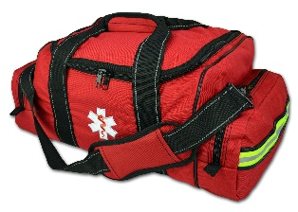
Setting Name: *****
Emergency Grab Bag
Location:
[Grab bag(s) may contain valuable equipment, or documents with sensitive information, so must be kept secure. Children should not be able to access the grab bag(s).]
Staff lead:
[For checking grab bag contents at regular intervals, sharing emergency plan with staff, collecting grab bag in an emergency… what is your procedure?
- Are there any items that aren’t included within the grab bag but should be?
- Are there any other items which need to be readily available to staff?
- If you have any questions about the plan, or suggestions for improving it, please contact staff lead – name above.]

Contents:
[Suggested, not an exhaustive list – consider what your setting needs… keep with the bag, share emergency plans with staff]
- Emergency plan
- First aid kit
- Medication
- Copies of important documents in a waterproof bag (Register, emergency contact details of parents, services, medical / send needs etc)
- A battery torch with spare batteries or a wind up torch
- A battery radio with spare batteries or wind up radio
- Two way radios
- Whistle / Hailer
- Bottled water and some non-perishable emergency foods
- Childcare supplies or other special care items
- Notebook with pen and pencil / log book
- Toiletries and sanitary supplies
- Infant supplies
- Spare sets of keys (these may not be appropriate to store with the grab bags – location?)
- Mobile phone and charger
- Money
- Hi-vis jackets or tabards
- Some warm clothes or blankets
- Other items your setting will need?
- Any other items that might provide some comfort if you have to leave your setting in a hurry

