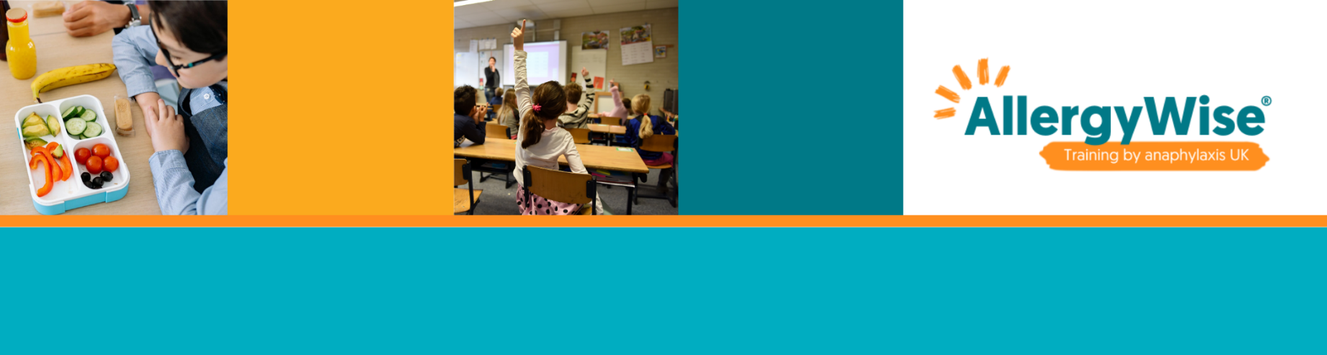
Copy onto your school’s headed paper before use.
Template letter for informing school community about children with allergies

It’s time to take our AllergyWise® for Sschools course and be ready to support students living with allergies in your class and school. Find out what you need to think about when planning your activities ensuring that they are safe and inclusive for everyone. Learn about signs and symptoms of allergy, anaphylaxis and how to administer an adrenaline autoinjector. You’ll even be able to access lesson resources and assembly materials to help your students learn about allergy and you’ll meetwhilst meeting the requirements of the RSE curriculum.

Dear Parents and Carers,

I hope that you are really enjoying your summer break and this special time before your little ones start school. I am writing to you about the need for your help in keeping one of your child’s new friends safe and healthy when we start in September.

One of the children who is starting in September has a number of allergies. He/she is not allowed to eat or drink lots of things: (insert the specific allergies here). Everything that he/she eats has to be checked and even if it says ‘may contain’ it has to be checked because it may not be safe for him/her to eat. He/she will become particularly poorly if he/she eats or has contact with (insert allergies here). He/she has medication to help him/her recover but sometimes he/she has needed to go to hospital.

We need your help to keep him/her safe and healthy. You can do this by:
- Ensuring that he/she only eats his own food; please let your child know that touching his/her food or swapping food will make him/her poorly
- Ensuring that your child is able to wash their hands with soap thoroughly every time after eating so they don’t get any crumbs/splashes on anything in the classroom
- Helping the teachers to talk to your child about allergies and how they can make the child feel (this is a good link for adults to view Leo’s Story; a very short video about a child’s experience living with an allergy: https://youtu.be/MqncMJY1rL0)
- Ensuring that you don’t send cake or sweets into school for birthdays
- Ensuring that you talk to his/her parents about the best way to include him/her in out of school parties and events
The little boy/girl is just like your son/daughter; he/she loves to play and be with his/her friends, but his/her parents do worry because they want him/her to enjoy school and all the experiences as much as your son/daughter will do. Thank you for reading this letter and for talking to your son/daughter about why we are asking them to do these things as their understanding will help him/her stay safe. If you have any questions, please do ask any of the staff.

Anaphylaxis UK has a huge range of resources to help you understand more about allergies and anaphylaxis and support you if you or your child has allergies.

Thank you for your understanding.
Yours sincerely

