|  |  |  |
| --- | --- | --- |
| theme | details | Notes/ actions |
|  | <https://www.solgrid.org.uk/eyc/training/> |  |
| EYFSP | <https://foundationyears.org.uk/2024/03/vodcast-for-schools-on-the-eyfs-profile/>  <https://foundationyears.org.uk/2023/11/early-years-foundation-stage-profile/> |  |
| SEND- Graduated Approach and Assessment Tool | <https://www.solgrid.org.uk/eyc/send/graduated-approach-incl-ehcp-process/> |  |
| SEND / ACES | <https://www.solgrid.org.uk/eyc/send/examples-of-send-paperwork/>  <https://www.youtube.com/watch?v=XKJuBemELjI> ACEs and early childhood |  |
| Reading and writing | <https://www.youtube.com/watch?v=f6tQlt31wlE>  World Book Day and Reading for Pleasure  <https://vimeo.com/917659701/b29e462bb0?share=copy>  Write from the Beginning East London Research School |  |
| Curriculum and progression- EYFS good practice | Link to Headlines below |  |
| Effective CPD | <https://www.solgrid.org.uk/eyc/training/>  <https://educationendowmentfoundation.org.uk/education-evidence/guidance-reports/effective-professional-development> |  |
| Reception Readiness – Super Starts  What parents want and need?  Transition |  | Please let us know what you would find helpful and what parents need |
| Evaluation- | <https://forms.office.com/e/TGtY9uhQPu?origin=lprLink>  QR below |  |

You may want to have a look at the following ahead of the session:

* Watch the Leaders briefing for spring 2024- <https://www.solgrid.org.uk/eyc/training/>
* Watch the EYFS Profile podcast - <https://foundationyears.org.uk/2024/03/vodcast-for-schools-on-the-eyfs-profile/>
* Watch the Outstanding EYFS recording I hope will be in Headlines on Monday [link to Headlines below]

Bring examples of

* your school curriculum progression
* a typical day/ week in EYFS
* your SEND assessment tools

Headlines- [Headlines (our weekly update for school leaders) (sharepoint.com)](https://solgrid365.sharepoint.com/sites/EducationCommunications/SitePages/headlines/Headlines.aspx)

<https://solgrid365.sharepoint.com/sites/EducationCommunications/SitePages/headlines/Headlines.aspx>

I hope that the recording of this session will be shared in Headlines on Monday….

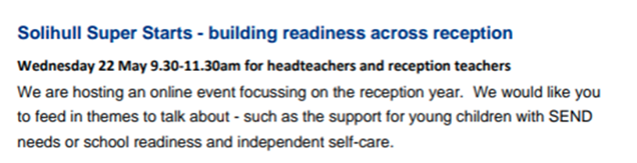

Notes

|  |
| --- |
|  |