**PLAY PARTNERING**

**What is it?**

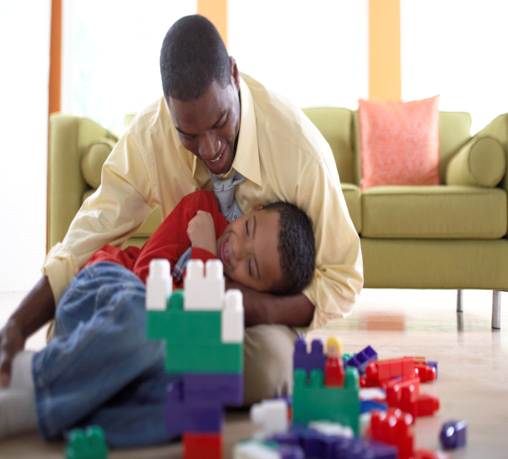Interaction between a child and his/her carer stimulates the brain to develop in an optimum way. A baby will learn to copy an adult’s facial expression, share sounds and find out what happens in response to their own sounds and expressions. Play and playful interacC:\Users\Margaret.Moss\AppData\Local\Microsoft\Windows\Temporary Internet Files\Content.IE5\V164V84P\MP900430914[1].jpgtions between a carer and child provide opportunities for containment, reciprocity and behaviour management. Children use play to understand the world, test new ideas or replay things they have experienced. Spending time playing with your child can help a parent to understand their child’s view of the world and help the child to make sense of their world and understand what is expected of him/her.

**How do I do it?**

Teach your child how to play appropriately with the toy/game by modelling its use. As a child grows and develops the interaction becomes more involved. Play can be used to teach children to share, take turns, use social interaction and modify behaviour. Carers should initially follow the child’s lead and allow him/her to explore and experiment. The child should be allowed to work out difficulties but be provided with appropriate support to moderate frustration. E.g. when a child is completing a jigsaw, the carer may help by orientating the pieces to enable the child to fit them together. Notice when a child’s pretend storyline comes to an end and help to open new ideas e.g. ‘I wonder who lives in that castle?’ Your child will learn to share and take turns with you and ultimately his peers.