

Promoting Positive

Behaviour Pack



**Tips and strategies to promote positive behaviour**

All children need to learn to deal with frustration and accept boundaries. Challenging behaviour can be difficult to manage, but there are positive and effective ways to help children to regulate their emotions. Children respond more positively to encouragement than to punishment and all children learn by example.

We have put together some tips to support settings to promote positive behaviour and strategies to help manage behaviours that may challenge.

Remember, there is always a trigger for any behaviour. No child is born ‘naughty”. When a child displays challenging behaviour, there is a need for diversion, support and reassurance for the child.

**Contents**

1. An environment that promotes positive behaviour and  
   self-esteem
2. How to help children behave positively
3. Helping children to express their feelings
4. Help to identify reasons for challenging behaviour:
5. behaviour flow chart
6. ‘behaviour iceburg’
7. ABC chart with guidance on its use
8. What to do if a child demonstrates challenging behaviour:
9. practical ‘in the moment’ steps to manage challenging behaviour
10. emotional coaching: Helping children cope with negative feelings
11. four steps of emotional coaching
12. Suggested ‘heavy work’ activities
13. Example positive behaviour support plan
14. Example risk assessment proforma
15. Signposting to further information

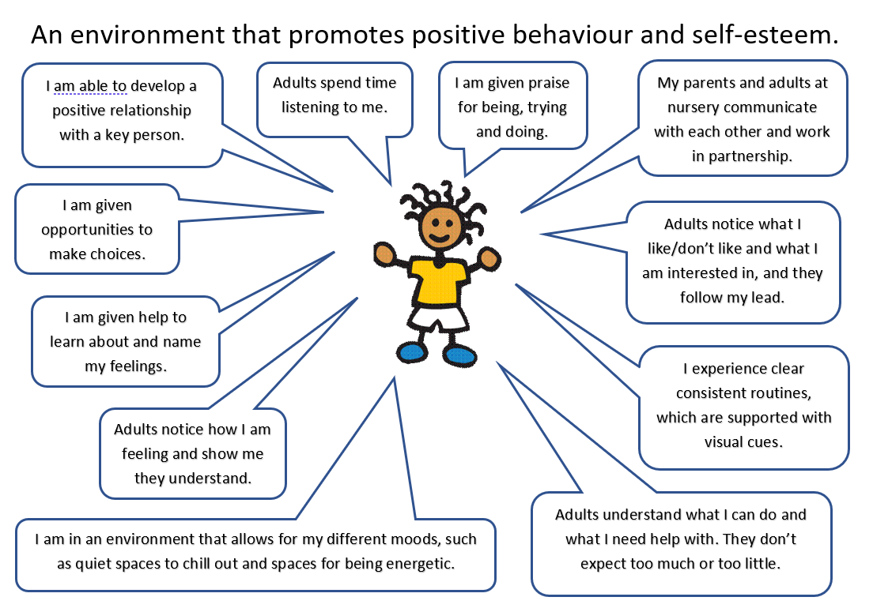

**How to help children behave positively**

1. **Put yourself in their shoes**. Try to understand how they are seeing things. Remember their simplicity; they need to learn about life from you.
2. **Show you like them** with smiles, thumbs up, specific praise … i.e.. good sitting, good walking, good red colours, rather than good boy/girl. ‘Good boy/girl’ doesn’t inform them that you value their ideas only that you want them to please you.
3. **Find things to praise** e.g. what a great T-shirt, mmm you smell nice. Praise the behaviour that you want to see. Give praise whenever you can. We all thrive on it.
4. **Keep spoken directions simple, clear and repeat yourself**. The less wordy the better. This helps all those whose attention is distracted. Get their attention before a request.
5. **Use visual support to all you say**. Hold up what you’re talking about, point, show.
6. **Make life predictable**. We all feel happier when we know what’s happening next. Get in the habit of explaining ‘*It’s this then it’s that’* as many times as it needs repeating. Flitting brains will be helped by kindly reminding. As far as possible, have a regular routine to your day so he gets used to what’s happening and how it happens.
7. **Use ’STOP’ rather that ‘NO’**. It is less confrontational.
8. **Show you understand.** Name the problem they are having i.e. ‘you wanted the car’, ‘you’re feeling busy’, ‘you’re feeling sad/happy/cross’ before you offer a solution.
9. **Give them an outlet for ‘busy’ feelings**. Plan your day to include physical experiences.
10. **Explain what he can do to solve their problems** e.g. ‘Ah you want the car’. Use words ‘Car please mummy’ to provide the model of the behaviour you want to see.
11. **Support sharing/turn taking and waiting**: It’s perfectly understandable that children get worried they will miss out or won’t get what they were hoping for. Show you understand and are on their side by offering solutions for them. You will find they are then more willing to listen to you. As they see your suggestions work for them, they will hopefully learn patience and compromise. Help them to share with turn taking after a set time. You might use a timer, but counting works on the spot e.g. ‘Your turn for 5 … then my turn after 5 …(you can count as fast as necessary or slow it down).
12. **With bad behaviour REDUCE YOUR OWN EMOTION**: your child needs you to remain calm and in control.
13. **ALWAYS separate the behaviour from the child**. With young children you can do this very literally when you talk ‘I like you very much, but I do not like kicking….’ or whatever it was. Use the language of choice ‘I like the choice you are making to sit nicely’, ‘I like you VERY much, but I did not like the choice you made to throw your book’.
14. **Playing together**

• Play at your child’s developmental level; don’t expect too much – give your child time.

• Don’t compete with your child; Follow your child’s lead.

• Engage in role play and make believe with your child.

• Be an attentive and appreciative audience.

• Describe what you see and do together instead of asking questions.

• Laugh and have fun.

• Break social learning down into small steps

1. **Give time warnings** to give time for cueing into a change of activity.
2. **Give positive requests**: ‘please walk’ rather than ‘don’t run’.

**Helping children to express their feelings**

The first feelings that children usually learn are **‘happy’, ‘sad’**, **‘angry’** and **‘scared’**

**Help children learn and use the names for feelings**

* Name how you think they are feeling e.g. “Sam is happy” or “I can see you are a bit sad”. Model talking about feelings by labelling your feelings e.g. “I am happy playing in the sand with you”.
* Play games with puppets etc. Puppet might feel sad, happy, angry, scared etc.
* Use mirrors for experimenting with different expressions whilst playing.
* Looking at books together – mention feelings, expressions.

**Support children to feel that it’s ok to show emotion**

* Tell them and show them It’s ok to feel sad, to be angry, to be scared etc.

**When children have learned some emotional vocabulary, we can help them to tell us how they are feeling**

* Continue naming and describing their feelings for them (when you think you know what they are).
* Leave pauses for them to join in.
* Avoid asking questions that put pressure on them.
* Talk about feelings in stories.
* Create role play opportunities.
* Use puppets to ask questions and have conversations that involve feelings.

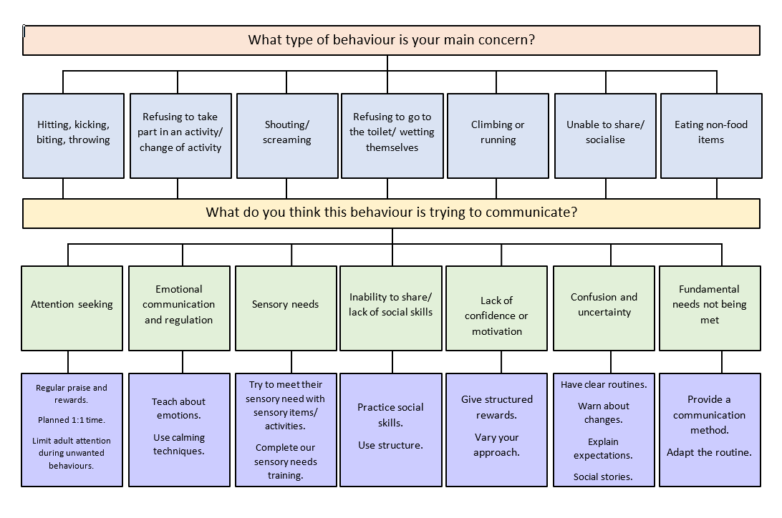

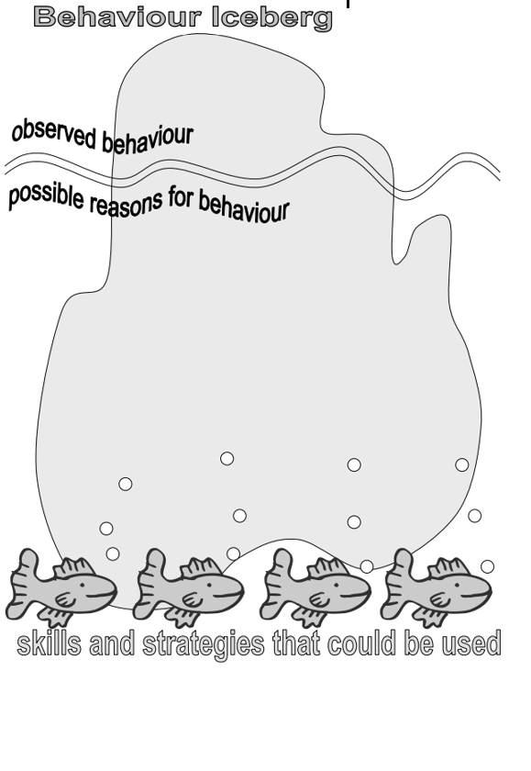

**How to use an ABC chart**

An ABC chart is an observational tool that allows us to record information about a particular behaviour. The aim of using an ABC chart is to better understand what the behaviour is communicating.

The ‘A’ refers to the *antecedent* or the event that occurred before the behaviour was exhibited. This can include what the person was doing, who was there, where they were, what sights/sounds/smells/temperatures/number of people that were in the environment.

The ‘B’ refers to an objective and clear description of the *behaviour* that occurred e.g. X threw item on the floor.

The ‘C’ refers to what occurred after the behaviour or the *consequence* of the behaviour e.g. children moved away from X, noise levels in the room decreased.

It is important to decide on one or two target behaviours to record initially. Place the ABC chart in an accessible place to make it easier to use after the target behaviour has been exhibited.

**Filling in an ABC observation record sheet**

* Record what happened (Behaviour).
* Record what happened before (Antecedent).
* Record what happened afterwards (Consequence).
* Record the date and time the behaviour took place.
* Record where the behaviour took place.
* Record which other children and/or adults were involved.
* Write down observations immediately or as soon as possible after the event.
* Be as objective and factual as possible.
* Show only what happened, not your opinion.

**Using ABC observation record sheets**

Using the observations you have made, think about what may be causing the behaviour:

* Is there a pattern to the activities in which the child is involved?
* Is the child involved in something they find difficult?
* Is there a pattern to the other children or adults present?
* Is there a pattern to the antecedent? Do certain things trigger the behaviour?
* Is there a pattern to the time of day when a particular behaviour happens?  
  e.g. Is it at the end of the day when the child is tired/just before lunch when they are hungry, at the beginning of the day when they are upset at leaving their parent or carer?
* Is there a pattern to the place where the behaviour occurs e.g. the outdoor play area/quiet area/role play area?
* Is there a pattern to the consequences?

**Setting targets**

Use the ABC sheets and other observations:

* Identify any triggers for the behaviour? N.B. these are not always obvious/visible.
* Decide (as a whole staff) on the behaviour that is causing the most distress/having the greatest impact and is a priority to change. Try to involve parents at this stage.
* Identify when this behaviour occurs? Are there any changes that can be made to:

1. routines
2. environment
3. practitioner response that could reduce the triggers and improve the behaviour?

* If not, think about the child’s likes and dislikes. How could these be used to motivate the child?
* Decide on a response to the behaviour that ALL staff will use. When you respond to the behaviour, be specific; ‘I don’t like it when you …’
* Ensure the child knows it’s the behaviour you don’t approve of – not the child.
* Agree a time limit to try the new, consistent response to the behaviour – at least two weeks (longer if the child doesn’t attend very often).
* Explain to parents what you are going to do, and why. Strongly encourage using the same strategy at home.
* During the allotted time keep records of frequency of the unwanted behaviour and child’s response to the strategy.
* After the allotted time period, review how things are going using your records, other observations and possibly ABC sheets.
* If the behaviour has improved, continue with the strategy (and possibly start to think about targeting another aspect of behaviour, if relevant).
* If the behaviour hasn’t improved or has worsened, spend some time reflecting on what has been happening. Does it just need more time?
* If not, re-start the process and try a different strategy

**ABC (Antecedent, Behaviour, Consequence) chart form**

|  |  |  |  |  |
| --- | --- | --- | --- | --- |
| **Date/Time** | **Activity** | **Antecedent** | **Behaviour** | **Consequence** |
| **Date/Time when**  **the behaviour occurred** | **What activity was**  **going on when the behaviour occurred** | **What happened right before the**  **behaviour that may have triggered the behaviour** | **What the behaviour looked like** | **What happened after the behaviour, or**  **as a result of the behaviour** |
|  |  |  |  |  |
|  |  |  |  |  |
|  |  |  |  |  |
|  |  |  |  |  |
|  |  |  |  |  |
|  |  |  |  |  |

**Practical ‘in the moment’ steps to manage challenging behaviour**

All children need to learn to deal with frustration and accept boundaries. Challenging behaviour can be difficult to manage but there are positive and effective ways to help children to learn self-control:

* Where possible, ignore or give minimal attention to, as many negative or unwanted behaviours as possible. Ignore the behaviour, without ignoring the child – or their needs.
* If the behaviour starts to escalate, use distraction techniques as an alternative to demands, for example if the child is outside, say, “Let’s go and play with this on the carpet” rather than, “Go in the classroom”.
* Use emotional coaching strategies to help the child recognise their emotions and develop better reactions to them. (see ‘emotional coaching’ for more information). Initially concentrate on recognising**,** labelling and validating the emotions that the child demonstrates.
* If a child does go into crisis, there may be a need to clear the area around them in order to keep everyone safe. Keep words to a minimum at this stage because the child has gone beyond the point of reason. Do not fuel the situation with recriminations or asking them to calm down.
* Give the child space to calm down but be there in a supportive way. Taking them to a quiet space may help them to regulate and walking there may help with the process.
* Once the child is feeling calm, follow up by offering and practising strategies to help them manage their emotions more appropriately, such as ‘big breathing’, ‘soldier marching’, a ‘heavy work’ activity or going to their quiet space etc.

**Emotion coaching: Helping children cope with negative feelings**

Emotion coaching is the practice of tuning into children’s feelings, and helping kids learn to cope with — and self-regulate — negative emotions like fear, anger, and sadness.  As proposed by psychologist John Gottman, the practice includes these key components:

* becoming aware of emotions, even low-intensity emotions, in yourself and the child
* viewing negative emotions as opportunities for “intimacy or teaching”
* accepting and validating the child’s feelings
* helping the child describe and label emotions with words; and (when a child has calmed down)
* talking with the child about practical strategies for dealing with the situations that trigger difficult emotions

Does this approach make a difference? Yes. Here’s an overview of emotion coaching and its effects, with some tips for becoming a more effective emotion coach.

**Tuning in: Why kids need us to empathise**

Their bodies might be small, but the same can’t be said for their emotional reactions. Young children encounter lots of frustrations and reasons for negativity. They are frequently beset by emotions like anger, sadness, anxiety, and fear.

**What can we do about it?**

Children are works in progress. Parts of the brain that specialise in self-regulation are still developing, so we shouldn’t expect a 3-year-old child to handle disappointment in the same way that a 30-year-old does.

Moreover, young children lack our life experiences. They are just beginning to learn how emotions work. They aren’t as competent at reading other people’s feelings and intentions. They need opportunities to learn and practice.

And some children have a tougher time than others. Certain personality traits are quite stable over time, and some personality traits put you at greater risk for emotional problems – like moodiness, aggression, anxiety, or depression.

But that doesn’t mean that children can’t improve. Even young children, can learn how to better manage their moods. They just need our help. The trick is to make sure we provide it.

**Dismissing, disapproving, and ignoring**

How do you react when a child is upset? John Gottman and their colleagues have identified several common patterns.

In some cases, adults can dismiss a child’s negative emotions. They send the message that the feelings are silly or unimportant.

In other cases, can be disapproving. They take notice of a child’s feelings, but regard displays of negative emotion as inappropriate.

Sometimes adults acknowledge and accept a child’s negative feelings but make no effort to help a child begin to manage them.

They often see negative emotions, like sadness, “as something to get over, ride out, but look beyond and not dwell on” (Gottman et al 1996). They might wish there was something more they could do, but they don’t know what that something is.

Adults — who dismiss, disapprove, or ignore — aren’t necessarily insensitive to children. On the contrary, they may find it painful to witness children in distress but they fail to teach children how to handle those emotional storms going on inside.

Instead, they remain on the side-lines, or try to suppress the emotions through teasing, threats, or punishment. For instance, they might respond to a child’s anger by imposing a “time out” – even if the child hasn’t done anything wrong (Gottman et al 1996).

**Emotion coaching represents a very different approach**

Adults who adopt an emotion coaching philosophy view a child’s bad mood as opportunities to empathise, connect, and teach.

They take time to see things from the child’s perspective, and make the child feel understood and respected. They talk with children about emotions, and help children put their own feelings into words.

They also help children come up with strategies for dealing with negative emotions, and the situations that that trigger such emotions.

**How does emotion coaching work?**

**1. Try to notice signs of emotion before your child’s feelings become intense**

Is a child looking a bit frustrated? Disappointed? Sad? Worried? Your initial reaction might be to ignore it and push past whatever situation has given rise these feelings. But researchers advise the opposite. This is a golden opportunity to check in with the child.

Tell them you’ve noticed a change (e.g., “You seem a little quiet…”) and invite the child to talk about the cause. If you suspect a specific trigger, bring it up gently (e.g., “maybe you’re finding it a little hard, having to take turns with your friend…”)

**2. Listen, validate, and show empathy**

You need to be calm for this, and ready to imagine things from the child’s perspective. No, you don’t have to have memories of what it was like to be a toddler or teenager, though of course that could be helpful. What you really need to do is relate to the child’s experiences, and you can do this by drawing parallels in your own life.

For example, if a child feels rejected, you can imagine being in a similar situation at work. If a child is upset about being asked to share a favourite toy, ask how you would feel if somebody asked you to hand over your phone — with all your personal information on it.

You don’t have to approve of the child’s behaviour. Hitting other people, for example, isn’t acceptable. But the child needs to know that you understand the emotions they are struggling with. You can relate to the situation and empathise. You can see why the child feels that way.

**3. Help the child find verbal labels to describe their emotions**

Learning how to verbalise emotions is valuable for multiple reasons. It’s useful for talking with other people, obviously. But it can also help us shift into a more detached, analytical mode, and view our emotions as a normal, human reaction to a triggering situation.

So, as we listen and empathise with children, we can help them identify what — exactly — their feelings are. The idea isn’t to tell children how they should feel. But rather to ask questions, volunteer our own experiences, and help the child analyse their own emotions.

For instance, suppose a child arrives at a pizza party. She wants cheese pizza, but all the cheese pizza has been eaten. There is only pepperoni pizza left, and the child hates pepperoni. The child starts to get upset, so the adult listens, empathises, and helps the child verbalise their feelings.

**Adult:** “It looks like you’re feeling upset about that.”

**Child:** “I only want cheese pizza. I can’t eat pepperoni!”

**Adult:** “I know what you mean. That’s happened to me before…I thought I was going to get to eat my favourite food, and then they didn’t have any. I felt really disappointed and frustrated.”

**Child:** “I’m mad because other kids got to eat cheese pizza. It isn’t fair!”

**Adult:** Yeah, that’s a really hard feeling, when something happens that isn’t fair. It can make you feel mad, even when it isn’t anybody’s fault. Like this party. Nobody meant it to happen. But it still can make us feel mad about it.”

**4. If the child is in the grip of strong emotions, allow for time to calm down**

When your child is upset, you might be tempted to start problem-solving, or to expect the child to start reasoning with you about the situation. But powerful emotions — including anxiety, anger, and fear — trigger a “fight or flight” response. They block our ability to reason and control our impulses and make us vulnerable to overreacting to additional triggers.

So if, for example, a child is highly-distressed about going indoors, this isn’t the time to list all the reasons why you want them to do so, why it is important, or to bribe or pressure your child to cooperate. The immediate focus is to take a pause and allow the stress response to wind down. Look for signs that your child’s breathing has slowed down and become more regular.

**5. If needed  — and when your child is ready — you can also focus on problem-solving**

This includes setting limits and talking with the child about possible ways to prevent or avoid future conflicts. For instance, if — during an angry tantrum — a child hits another child, you will want to reaffirm that this behaviour is unacceptable. You can discuss why we have rules like these, and practise with the child, other acceptable ways to cope with anger in the future.

**Evidence: Does emotion coaching really make a difference?**

In a study involving pre-schoolers, researchers spent just 15 minutes reinforcing parents’ emotion coaching practices. Immediately afterwards, they watched while the parents interacted with their children during a challenging task. Post-intervention, parents showed more emotional sensitivity and good humour, and their children responded to frustrating events with greater persistence and enthusiasm (Loop and Roskam 2016).

Of course, this doesn’t mean that emotion coaching is a magic cure-all. Some children have troubles that require more than emotion coaching to remedy (Dunsmore et al 2016). But it makes sense that empathy, sensitive talk, and thoughtful problem-solving can help children develop emotional competence.

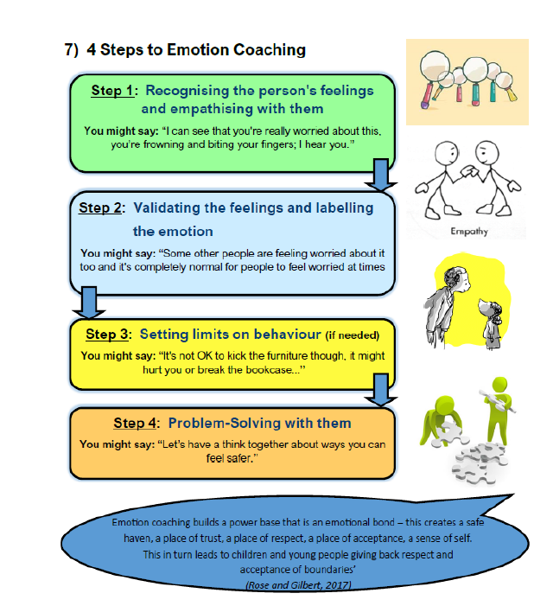

**Suggestions for ‘heavy work activities’ to help children calm**

* Help to move furniture
* Pushing or pulling boxes with toys/books in
* Opening doors for people
* Pushing lunchbox trolleys
* Carrying a rucksack with books in
* Cleaning surfaces
* Carrying beanbags on heads or shoulders across room
* Pulling other children on sheet/blanket
* Seat push ups
* Squeeze toys
* Push against a wall
* Fill up trucks with heavy blocks to push
* Colouring whilst on hand sand knees
* Pushing cars with one hand whilst supporting self with the other
* Playing catch with a heavy ball
* Playing with damp sand
* Animal walks e.g. crab, bear, lizard or army crawls
* Help to put out mats and equipment
* Climbing on playground equipment
* Running and jumping
* Obstacles courses

**Positive behaviour support plan**

|  |  |
| --- | --- |
| **People involved in writing the plan:** |  |

|  |  |
| --- | --- |
| **Child’s name:**  **DOB:** | |
| **Behaviour**  What X does, says and looks like that gives us clues that s/he is calm and relaxed | **Support strategies**  The things that we can do or say to keep X in the green for as much time as possible |
|  |  |

|  |  |
| --- | --- |
| **Behaviour**  What X does, says and looks like that gives us clues that s/he is becoming anxious | **Support strategies**  The things that we can do or say to stop the situation from escalating further and return X to the green phase as soon as possible |
|  |  |
| **Behaviour**  What X does, says and looks like when their behaviour is challenging | **Support strategies**  The things that we can do or say to quickly manage the situation and to prevent distress, injury and/or destruction |
|  |  |

|  |  |
| --- | --- |
| **Behaviour**  What X does, says and looks like that tells us s/he is becoming calmer | **Support strategies**  The things that we can do or say to support X to become calm again and return to the green phase. |
|  |  |

|  |  |  |  |
| --- | --- | --- | --- |
| The plan was started on: |  | The plan with be reviewed on: |  |
| Signed (Key person responsible) |  | | |

**Individual risk assessment**

|  |  |  |  |  |  |  |  |  |  |  |  |
| --- | --- | --- | --- | --- | --- | --- | --- | --- | --- | --- | --- |
| **Child’s name:** | |  | | | | **Date:** |  | | | | |
| **Assessor’s name** | |  | | | | **Review date:** |  | | | | |
|  | |  | | | |  |  | | | | |
| **Behaviour** | **Who is at risk?** | | **Level of risk (L/M/H)** | **Likelihood of risk**  **(L/M/H)** | **Existing support/ measures in place** | | | **Further action required** | | | |
| **Action** | **By when** | **Person responsible** | **Action complete?** |
|  |  | |  |  |  | | |  |  |  |  |
|  |  | |  |  |  | | |  |  |  |  |
|  |  | |  |  |  | | |  |  |  |  |
|  |  | |  |  |  | | |  |  |  |  |

**Signposting to further support**

* [SEND (solgrid.org.uk)](https://www.solgrid.org.uk/eyc/send/) - Solihull Early Year’s Team SEND Website: Copies of all resources in this pack as well as further advice and recordings of training.
* [Dingley's Promise – Early Years Specialist](https://dingley.org.uk/) – Training Module: Behaviours that Challenge
* [Early Support Information on Behaviour (councilfordisabledchildren.org.uk)](https://councilfordisabledchildren.org.uk/resources/all-resources/filter/schools-colleges-and-fe/early-support-information-behaviour?gclid=Cj0KCQiA2-2eBhClARIsAGLQ2Rn6wcsMhAKA4fVoAhwv_Nfw5BU8ZCwYAG74pZa4GIico6i0hcjiCn8aAk-QEALw_wcB) – Information resource to support parents and carers to help them support children who exhibit challenging behaviour.