# Visual support in the early years

## What is it?

A visual support system uses photos or symbols to break down steps of a task, support instructions, or set out a routine throughout the day. It is like an adult using a diary or following a recipe. It can be used to tell a child what is happening next or to help them sequence simple tasks to encourage independence. It will however take time to embed the strategies, and for the child to start responding. Do not stop once the strategies start to work.

## Why is it useful?

* It provides structure and predictability.
* Photos and symbols remain long after the words spoken to a child have disappeared.
* A lot of children with SEND are visual learners and photos or symbols can hold their attention.
* They reduce anxiety as your child can anticipate what happens next.
* Concepts such as before, after, first and next are more concrete and meaningful.
* They communicate things that a child might otherwise find difficult to understand.

## Choosing photos or symbols

Children often start with an object of reference (see separate advice sheet). Once they show they can understand this, it is time to move onto photos or symbols. All children are different, but children usually understand photos of the objects of reference or activity; ‘next’, ‘then’ and ‘move onto’ symbols, and eventually the written word. This process will take a lot of time. Never move onto the next stage until the child is totally secure using the stage before.

## Using photos or symbols to support the structure of the day

* Start with one photo and use it as you would an object of reference i.e. show it to the child immediately before the activity whilst saying what the activity is, for example, a photo of the table set up for snack time, and say ‘snack time’.
* If a child can understand and respond to using one photo or symbol i.e. they go to the activity shown in the photo/symbol, then you can introduce a two symbol timetable, first snack, next outside.
* Once a child understands first and next, you may gradually introduce more photos/symbols, for example, first, next and later. Be careful not to do this too quickly and overwhelm or confuse the child.
* Use it consistently and refer to it throughout the day.
* Make sure the language you use is simple and consistent i.e. first tidy up, then outside.
* Use the timeline alongside other approaches such as signing. This makes sure you have a multi-sensory approach to help the child’s communication needs.
* Keep the timeline where your child can see it and use it – at their height!
* Laminate your pictures so that they last longer!
* The child may like to remove the symbol when an activity has finished and return it back to the folder or posting box.

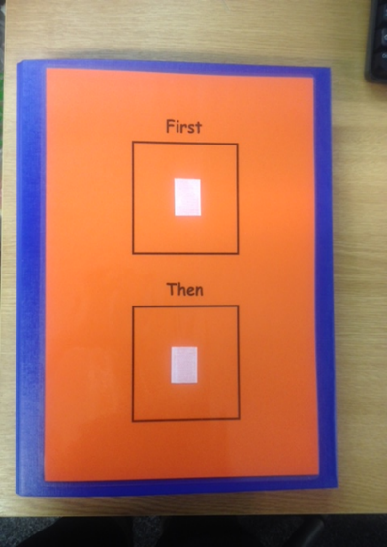 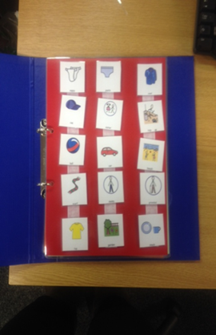

**Using photo/symbols to support instructions.**

Photos or symbols can be used to support a child to understand instructions such as sit down, wait or line up . These photos/symbols are another tool to support the child to process the instruction. They should always be used with spoken words as well as signs and gestures.

* Start with one or two instructions you use regularly. It may be stop, sit, wait etc.
* Show the symbol by getting to the child’s height and allow enough time for the child to look at it and process the instruction. Give 5 or 10 seconds for the child to process and respond to the instruction. If they don’t, the adult should show and say it again and prompt the required action.
* Have the symbols available to all adults quickly and at all times. Some settings have them on a lanyard around an adult’s neck. This is ok as long as they don’t have lots of symbols for them to search through or the lanyard is too short to allow the symbol to be shown at an appropriate height for the child. Some children will want to hold the symbol to allow processing time. This can’t happen if it is on a lanyard.
* All adults interacting with the child must use the symbols not just a key adult.
* All adults must use the same symbols with the child and use the same words or signs to support the instruction.
* The symbols must be used every time the instruction is given.
* As the child begins to understand the instruction, you can add more symbols.

**Using photos or symbols to support a child to sequence steps in an activity**

Lots of children find it difficult to remember all the steps they need to do to complete an activity, for example, using the toilet or getting dressed. Things need to be done in order to be successful and if a child misses a step or does things in the wrong order, it can lead to frustration. Creating simple photo or symbolled instructions will really help a child develop sequencing skills and achieve more independence from adult support and prompts.

Look at the task a child is needing a lot of adult support with. Is most of the support from the adult just verbal reminders of what to do next?

If so, this is a good task to make a task list for:

* Break the task down into clear steps i.e. taking off and hanging up their coat would be (1) unzip coat (2) take coat off (3) find hood (4) put hood over your peg (5) go to class.
* Photograph or symbolise each step.
* Initially, the adult may need to show the child each step using an individual card for each step. When they understand this, it can be put together as a list top to bottom.
* An adult may need to point to each step on the list and encourage the child to do the same, so eventually the adult can step back and allow the child to point to each step by themselves.
* All staff must use this process and it must be used every time the child does the task until they can use it independently.

