

**Child Safety Week 7th-13th June 2021**

**Child Safety Week is an annual community education campaign run by the Child Accident Prevention Trust (CAPT), acting as a catalyst for thousands of safety conversations and activities UK-wide.**

The focus of this years child safety week is

**“Share because you care”**

Sharing safety knowledge saves lives.

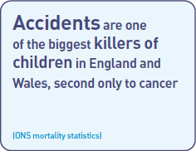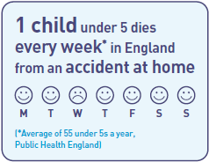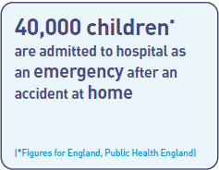

These websites have a range of safety resources that you can use and share with the families you work with. Click on the logo to go to the website.

[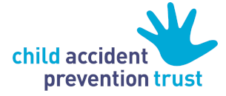](https://www.capt.org.uk/about-child-safety-week)

Capt have a range of factsheets to share with parents, resources and posters to promote your child safety week activities and links to more information, resources and training on [facebook](https://www.facebook.com/ChildAccidentPreventionTrust).

[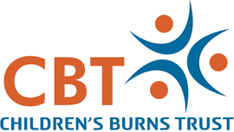](https://www.cbtrust.org.uk/wp-content/themes/cbt_v1/img/logo.png)

CBT are working alongside CAPT to raise awareness of the number of children that are seriously burned and scalded each year. Many of these accidents are entirely preventable.

CBT are holding a [free webinar](https://www.eventbrite.co.uk/e/child-safety-week-2021-burn-prevention-and-first-aid-webinar-tickets-153455833529?aff=CBTWebsite) on burn prevention and first aid during child safety week. They also have a range of resources for early years including the electronic story of [Francis the firefly](https://youtu.be/mmflkVzAIeE).

[](https://www.redcross.org.uk/get-involved/teaching-resources/kindness-safety-and-first-aid-at-home)

The British Red Cross a focussing on kindness, safety and first aid at home. They have resources for adults and children to learn about safety and first aid at home, including first aid for burns, and reflect on a kinder world.

[](https://roadsafetygb.org.uk/resources-services/pre-school/)

Road Safety GB is a national road safety organisation made up of representatives from groups across the UK, including local government road safety teams. Click on the log for teaching road safety in early years.

[](https://www.think.gov.uk/education-resources/explore-education-resources/?age%5B%5D=3-to-6)

The UK government has been running road safety campaigns for more than 75 years. The Central Office of Information (COI) ran the government’s road safety campaigns until 2000, when THINK! was officially established as the government’s designated road safety campaign. Click on the THINK! Logo for stories, activities and games to teach road safety to all ages.

[](https://www.nhs.uk/conditions/baby/first-aid-and-safety/safety/baby-and-toddler-safety/)

**Baby and toddler safety**

Each year 40,000 under-5s are admitted to hospital following accidents, and lots of these accidents are preventable. This NHS website provides information for parents on how to protect babies and toddlers from some of the commonest accidents that affect young children.