**30 Hours Free Childcare for 3 and 4 year olds**

|  |  |
| --- | --- |
| **Name of childcare provider:** | |
| Your home post code |  |
| Age of child | 1 / 2 / 3 / 4 |

|  |  |
| --- | --- |
| **How many hours of childcare do you use now?** | |
| Free Early Learning | hours |
| Paid for Childcare | hours |
| Informal Childcare  (for example, from a family member) | hours |

|  |  |
| --- | --- |
| **From September 2017, if both parents or a lone parent work over 16 hours they’ll be able to claim 30 hours free childcare.** | |
| Would you be eligible for the 30 Hours? | Yes / No |
| If **Yes**, how many hours would you use? | hours |
| If **No**, would you seek work or  increase your hours? | Yes / No |

|  |  |
| --- | --- |
| **You may be allowed to use up to three providers.** | |
| Would you use more than one provider? | Yes / No |
| Would you still use informal childcare? | Yes / No |
| Do you want childcare near home or work? | Home/ Work |

|  |  |
| --- | --- |
| **What kind of childcare would you prefer?** | |
| Starting at: |  |
| Finishing at: |  |
| Term time only or all year round? | Terms / All year |

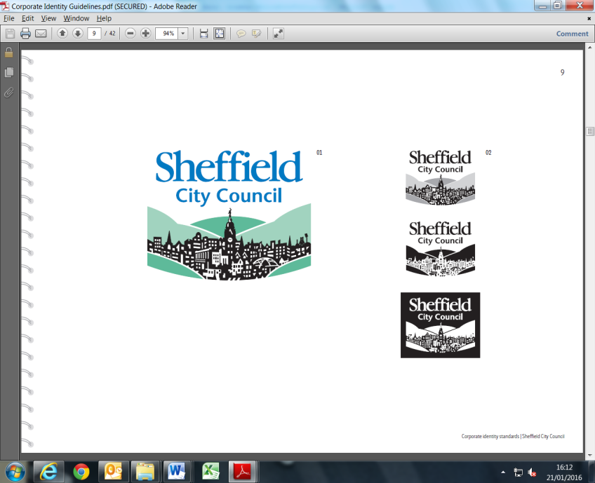

**Thank you** for your time.   
Please return this form to your childcare provider.