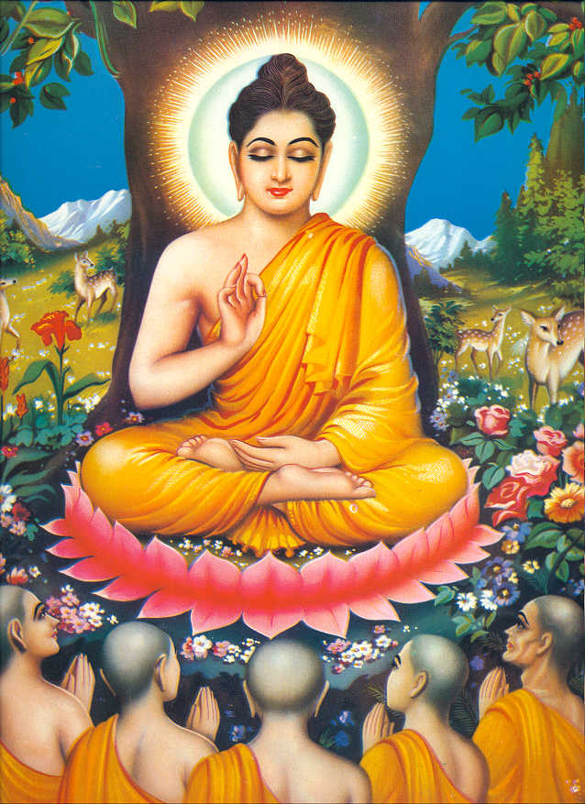
Looking at Faith week at George Fentham

AT 1: What does it mean to live like a Buddhist monk?

AT 2: Could I live without possessions? Do possessions really make us happy?

AT 2: The Spiritual versus the Material – How can we get pupils to focus on what is really valuable ?

The story of Siddharta Gautama – the Buddha ( Faith stories DVD)

The teachings of the Buddha – The Four Noble Truths and the 8 Foldpath

Visit: £60.00 Max 30 pupils not Tuesday
Birmingham Buddhist Centre
11 Park Road Moseley
Birmingham West Midlands
B13 8AB Tel: 0121 449 5279
Email: info@birminghambuddhistcentre.org.uk
Please make all cheques payable to ‘Birmingham Buddhist Centre’
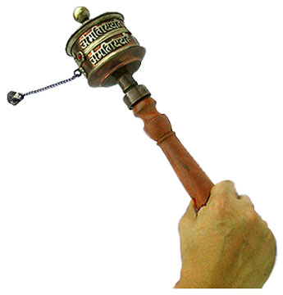
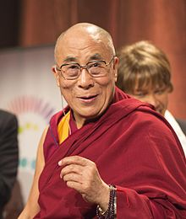
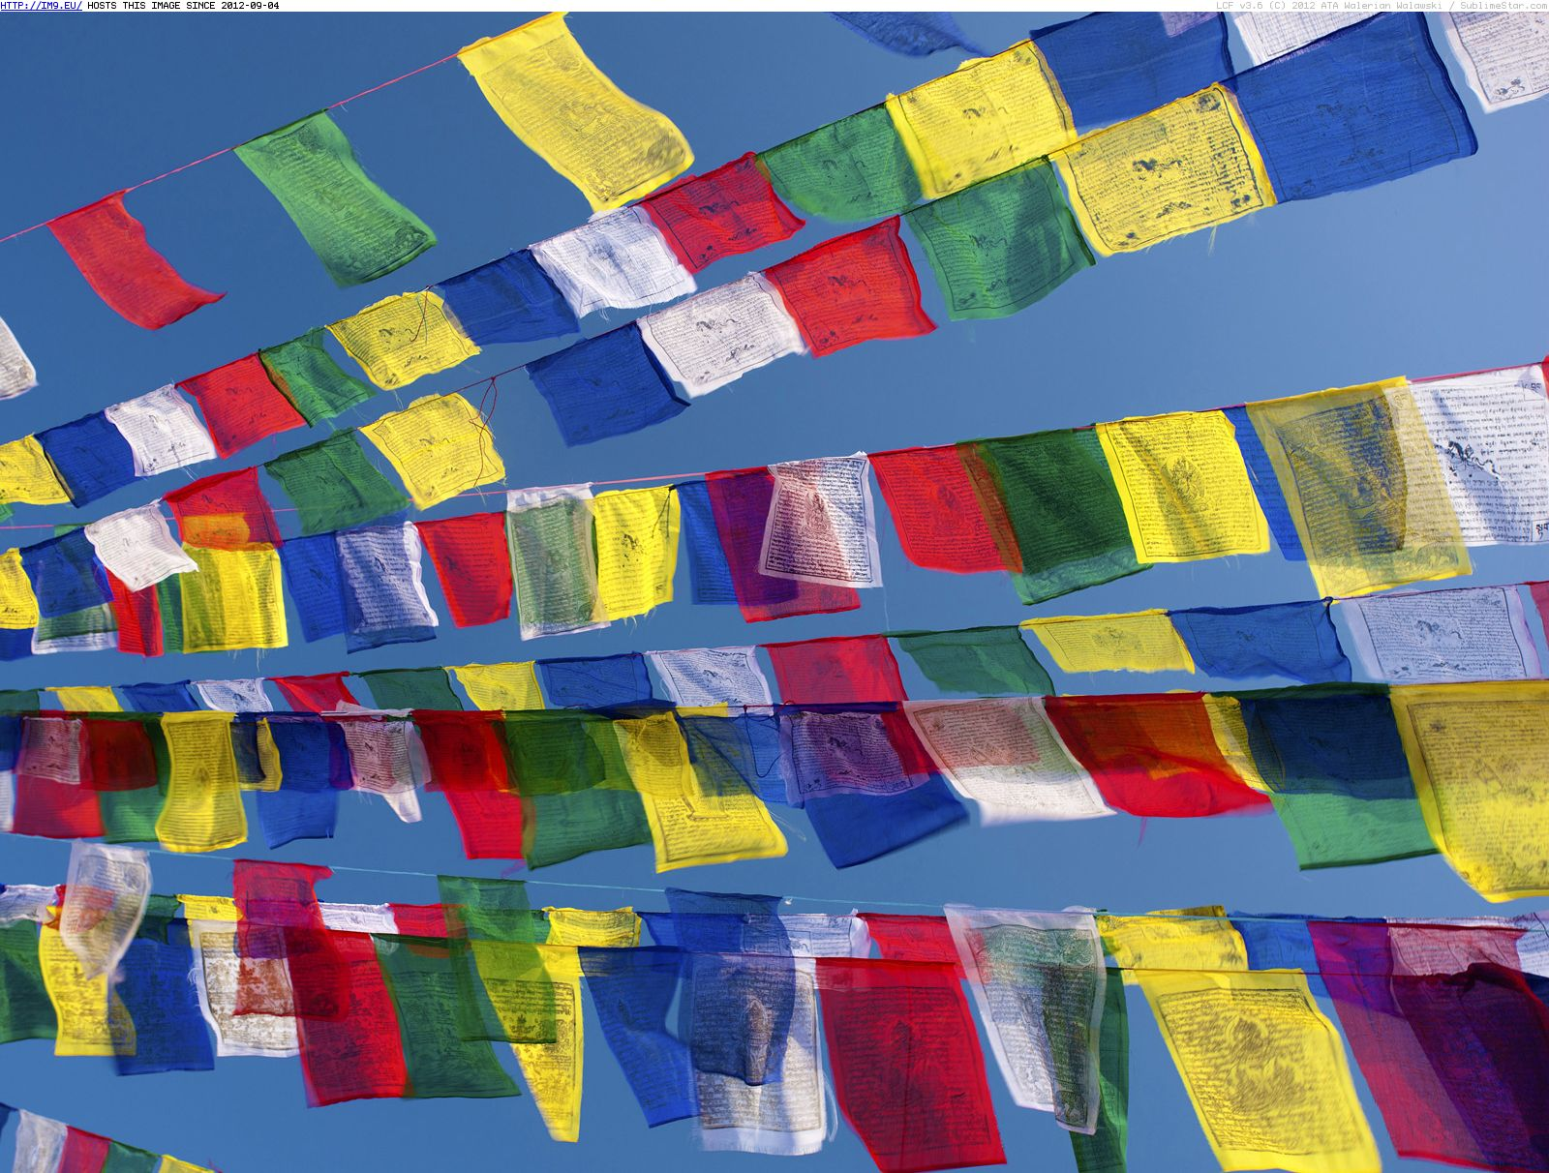

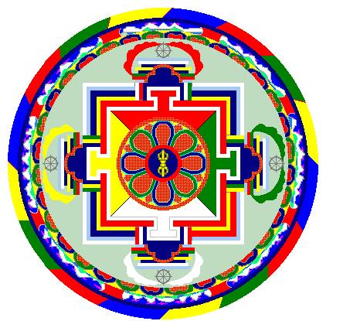
The story of Ashoka – the king that became a Buddhist
The story of Sobinu and the alms bowl. – Simon - Available Thursday to run carousel sessions
Story of a young Buddhist monk – giving up all possessions – to achieve Nibbana.

Tibet – Geography
History: Who is the Dalai Lama?
English writing the prayers – the prayer flags
Making the prayer wheels
Wheel of the Darma
Making mandalas patterns that can help meditation - Art
http://www.cumbriagridforlearning.org.uk/getfile.php?src=1326/4+Teaching+Buddhism.doc

http://www.buddhanet.net/pdf_file/med-guided2.pdf
Meditation:
Some nice examples of relaxation meditation on youtube

