The Cosmological Argument:
Contingency and Kalam

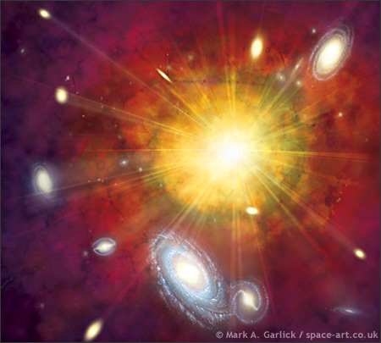
‘Then God commanded, “Let there be light” – and light appeared’ –The Book of Genesis

Formulation
- The term cosmological derives from the Greek term cosmos which refers to the universe and also to order as opposed to the original chaos that existed before everything.
- The argument is a posteriori, meaning it stems from our experience of the world and how it operates.
- It uses inductive reasoning
- This argument attempts to provide an explanation for the origins of the universe and works to infer that this is the God of Classical Theism.

Aquinas’ Five Ways
- St Thomas Aquinas devised his five ways as a method to logically justify the existence of God. The first three are cosmological arguments, most the ideas deriving from Aristotelian philosophy.
- The first is the concept of an Unmoved Mover; everything is moved by something else, but this cannot go back ad infinitum so there must be a mover, which is in itself unmoved.
- The second way is the Uncaused Cause; everything is held in a string of causality, but this chain cannot stretch back to infinity so there must be cause which was not an effect of something else. This is the Uncaused Cause.
- The Third is an early version of what we call the Contingency Argument. He postulates that there must have been a time when no physical things existed, but since they do exist now there must be a necessary non-physical being and this is what ‘we understand to be God.’

The Contingency Argument
- The Contingency argument was expanded upon later by Leibniz and F.C Copleston. Leibniz asks the question: ‘Why is there something rather than nothing?’ The fact that there is something suggests something is sustaining the universe which isn’t dependant on something else.
- Copleston presented a modern version of the argument in a radio debate with Bertrand Russell in 1947:
-Everything is in contingent in that it would be logically possible for it to not exist
-The universe, being the sum of contingent things, then must also be contingent
-‘So this totality of objects must have a reason for its existence external to itself’
-This necessary being is God
- The fact that there would otherwise be nothing is suggestive that there was an intelligence behind the decision

The Kalam Argument
- Another form of the argument known as the Kalam argument was formulated by Islamic scholars and is similar to the first cause argument. William Lane Craig provided a modern, Christian, formation:
-Everything that began to exist has a cause for its existence
-The Universe began to exist
-Ergo, the Universe has a cause
-This cause is what we call God
- Craig’s argument operates on the concept of a finite universe
- The idea of an actual infinity, he claims is impossible, a temporal series of events that stretches ad infinitum is not possible since would never reach the present moment.
- This conforms to the scientific theorem of the Big Bang where a colossal explosion originating from a point smaller than atom expanded outward to form time and space as we currently perceive it
- He then goes on to claim that the terminator that is required for the infinite regress is the Judeo-Christian God who created the universe ex nihilo. He reasons that if the string of causality that we observe is a natural phenomenon then an uncaused cause must be supernatural by definition. Like the contingency argument it is suggested that the reason that there is something rather than nothing is because it was an intelligent choice brought about by a personal creator.

Key Quotes
- ‘Why is there something rather than nothing?’ -Leibnitz

