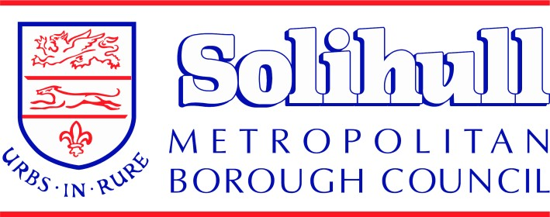


Understanding the
Far Right
and the
Extreme Right


Supporting Practitioners who work with Children and Young People in Solihull

Version 1

Version 4 – October 2008



Page

Contents

Contents 2
Aims 3
Context: What are CONTEST and PREVENT about? 3
The local dimension: 4
Types of extremism: 4
The Far Right and the Extreme Right 5
Radicalisation 7
Extremism: Is this relevant to your role? 8
Monitoring and Evaluating Provision 8
Useful Resources and Websites: 8
Appendix A – Logos of Far Right Groups 10
Appendix B – Logos of Extreme Right Wing Groups 11
Appendix C - How to Act on a Concern and Make A Referral 13

Understanding the Far Right and the Extreme Right

Aims

This publication has been produced to:

- Provide a resource dedicated to facilitating an understanding of extremisms and how to counteract the concept as well as the activity
- Support practitioners who work or interactive young people, families and communities in Solihull who may be vulnerable to extreme movements
- Promote community cohesion
- Promote good relations between different communities
- Support safeguarding requirements
- Raise awareness of definitions, issues and preventative initiatives to minimise repetition
- Provide a mechanism, for practitioners to be able to sign post young people, communities or other agencies to appropriate services to provide specialist support.
- Support the PREVENT Strategy in the wider context of the CONTEST Strategy

Context: What are CONTEST and PREVENT about?

The aim of CONTEST is to reduce the risk to the UK and its interests overseas from terrorism, so that people can go about their lives freely and with confidence. It covers all forms of terrorism and is organised around 4 workstreams, each comprising a number of key objectives:
- Pursue: to stop terrorist attacks
- Prevent: to stop people becoming terrorists or supporting terrorism
- Protect: to strengthen our protection against a terrorist attack
- Prepare: to mitigate the impact of a terrorist attack

PREVENT addresses all forms of terrorism, including the extreme right wing, the focus of this publication. It has three objectives:
- Responding to the ideological challenge of terrorism and the threat from those who promote it
- Preventing people from being drawn into terrorism and ensuring that they are given appropriate advice and support
- Working with sectors and institutions where there are risks of radicalisation that we need to address.

It focuses on the three I’s:

- Ideologies - respond to the ideological challenge of terrorism and the threat we face from those who promote it. Challenging ideology and disrupting the ability of terrorists to promote it is seen as a fundamental part of the Prevent strategy.
- Individuals - prevent people from being drawn into terrorism and ensure that they are given appropriate advice and support. The strategy says that radicalisation is “usually a process not an event” and it is possible to intervene to prevent vulnerable people being drawn into terrorist related activity.
- Institutions - work with sectors and institutions where there are risks of radicalisation which we need to address. The strategy recognises there are a wide range of sectors in this country helping to prevent people becoming terrorists or supporting terrorism. Priority areas include education, faith, health, criminal justice and charities. The Internet is included as a sector in its own right.

The local dimension:

Solihull Metropolitan Borough Council has a longstanding commitment to the elimination of unlawful discrimination, the promotion of equality of opportunity and to promote good relations between different individuals, people and community groups. The Borough’s Counter Terrorism Local Profile identifies a risk from the far right wing and extreme right wing and addressing this issue is part of the work of our PREVENT Board, reporting to our CONTEST Board.

Solihull MBC is committed to ensuring young people and communities of Solihull, particularly our most vulnerable groups, are well safeguarded and protected against making lifestyle choices that mean they could become involved in extreme behaviours.

This publication has been produced by Solihull’s multi-agency PREVENT Board to support all practitioners within Solihull, regardless of profession or sector, that work or interact with children, young people and communities, to foster greater understanding of the issues.

Types of extremism:

Extremism comes into existence when a root passion for a cause has led to illegal action to pursue that cause. It condones violence as a means to a political end. The political element is a key part of extremism. It includes expressing views which justify or provoke terrorist acts, promote serious criminal activity or foster hatred which may lead to inter-community violence in the UK.

Extremism:
- Having strong values and beliefs
- Often going beyond the norms of society, but this is subjective as what is the norm in one society or community may not be the norm for another
- It can be a strong view with no room for manoeuvre

Violent Extremism:
- Fostering hatred, causing inter-community conflict
- Engaging in physical violence against conflicting values
- Presenting threatening behaviour causing bodily and mental harm
- Essentially a move to action
It is important to understand what causes young people to be drawn into supporting violent extremism. Contributory factors resulting in violent extremism:
- Negative messages about people from minority groups/people from other countries portrayed by the media
- Vulnerable young people being targeted by extremist groups.
- The offer of extremist training for young people can be seen as an ‘exciting’ social opportunity for young people resulting in strong friendships.
- Unemployed young adults sometimes feel that extremism gives them a purpose.
- Young adults who did not achieve well at school sometimes use extremism as a way to feel that they are succeeding.
- Influential extremist networks operating in certain areas of the country
- Family members promoting or encouraging extremism
- Accessing extremist websites/videos which are hard to regulate
- Inappropriate social networking
- Mis-alignment by some extremist groups to religious beliefs
- Some citizens feel that they have been treated unfairly throughout life, and want someone to blame or punish.
- Some citizens who move to a different country find it hard to adapt to their new life.
- Glamorisation of violence by the media
- Professionals (such as education, police and health workers) not being sufficiently trained to recognise extremism or to act on concerns

The Far Right and the Extreme Right
The Office of Security and Counter Terrorism (OSCT) and the National Domestic Extremism and Disorder Intelligence Unit (NDEU) have provided an understanding of what categories specific groups fit into, whether it is a Far Right group or an Extreme Far Right group. Below are details of those categories and of some of the groups involved:

Far Right Groups:
- English Defence League
- British National Party
- National Front
- Democratic Nationalists
- English Democrats
(See Appendix A for logos of these groups.)

Extreme Right Wing Groups:
- British Freedom Fighters
- Blood and Honour
- Aryan Strike Force
- Combat 18
- Racial Volunteer Force
- British KKK
- November 9th Society
- British Movement
- White Nationalist Party
- British Peoples Party
- League of St George
- Knights Templar
(See Appendix B for logos of these groups.)

Current additional threats include:

- The Lone Actor Threat

'Lone actors' continue to pose a threat to the UK. Although by definition they have not received training or tasking from terrorist organisations, they are usually inspired and motivated by extremist ideological materials available online. These individuals motivate themselves, develop the capability to carry out attacks and select targets completely independently of established terrorist groups.

Domestic extremists may seek to carry out solo acts of violence. In 1999, David Copeland, a neo-Nazi, carried out a series of bomb attacks against gay and ethnic minority targets in London. His attacks killed three people and injured 129 more. In Norway, as another example, Anders Breivik killed 77 people in two consecutive attacks. First, he killed eight people with a heavy car bomb placed in the heart of the Norwegian government headquarters in Oslo. An hour later, he appeared at the summer camp of the Worker's Youth League, the youth organization of the Labour Party, at the island of Utøya, 35 kilometres west of Oslo. There were 500 people on the island. Impersonating a police officer, he shot for approximately 90 minutes, killing 69 people.

The problem with the “lone actor” is that:
- There is no profile
- The lone actor is often described as a ‘loner’ with few social contacts.
- The lone actor may not have previously come into contact with police.
- They may be secretive and suspicious and be very guarded in thei
communication.
- They may identify with but not be a specific member of a particular group
- They may have had some private personal event or condition that can lead to a terrorist act. This could include psychological issues.

They are generally a loner, but sometimes want to join a group but can’t. Sometimes they join a group but later regret it and struggle to interact. Sometimes they join a group but choose to act independently

Potential indicators of the lone actor include:
- Warning behaviours, planning and preparation behaviours
- Communicating with others, developing capability
- Practice and preparation, surveillance
- Tests of security, suspicious activity

- Internet safety

The Internet is used by some people to promote terrorism and violent extremism and corrupt individuals who are vulnerable to radicalisation. Some examples of illegal terrorist or extremist content include:
- Speeches or essays calling for racial or religious violence
- Videos of violence with messages of ‘glorification’ or praise for the attackers
- Chat forums with postings calling for people to commit acts of terrorism or violent extremism
- Messages intended to stir up hatred against any religious or ethnic group
- Bomb-making instructions.

Specific concerns about websites should be reported at:
https://eforms.homeoffice.gov.uk/outreach/terrorism_reporting.ofml

An e-learning toolkit has been designed by the Association of Chief Police Officers to give advice for parents, teachers and guardians around safeguarding principles. The toolkit aims to provide awareness of dangers posed to young people from those who look to exploit their vulnerabilities through the use of the Internet. Please see the attached flyer at the rear of this booklet for further details. Further information is available by email to Prevent@acpo.pnn.police.uk, by calling 020 7084 8776, or online at http://www.acpo.police.uk/documents/TAM/2013/201303tam-prevent-internet--safety-toolkit.pdf . For schools, these resources should be considered alongside Solihull’s suite of supportive guidance around maintaining an e-safe school.

Radicalisation

Radicalisation is the process by which people are drawn in to support violent extremism and in some cases join terrorist groups. Various factors contribute to the radicalisation process but on their own these factors do not presume radicalisation or extremist activities.
Contributing factors:
- Search for identity (young people and adolescents are particularly vulnerable as the transition into adulthood brings a lot of uncertainty as they develop their new identity)
- Social interaction (face to face contact or contact via the Internet with individuals or groups who promote extremist ideologies)
- Ideology (a distorted narrative given to vulnerable individuals that may use untruths that have no factual basis to promote ideas)
- Grievances (real or perceived)
- Personal crisis (individuals leaving home, relationship break-ups are some examples that may leave people in a vulnerable position)

Some signs of radicalisation:

The following may indicate vulnerability to or possible interaction with violent extremist influences:

- Expressing support for the use of violence by extremist groups
- Expressing a belief in the ideology of extremist groups
- Support for radical organisations
- Extreme hatred for the value of other’s faith/cultures
- Extreme hatred towards people of different faiths

The following examples indicate where changes in behaviour or observations have indicated the need to raise a concern.

- A lunch time support assistant notices change in a child’s behaviour. During break time the child no longer interacted with children of a certain cultural or religious background. The child is heard by the assistant to be making comments that encourage separation e.g. “I don’t want to hang around with you anymore. My Mum and Dad say you people…”

- During a talk with an Adviser, talking to a young person about future options, the young person makes comments such as “there’s no point in getting qualifications because there is no work, all our jobs are being taken by them coming over, we need to stop them.”

- An early years worker is working with a family where dad is unable to find work and the family, including 3 small children, are struggling. The worker hears Dad express his frustration of their cramped living conditions and insufficient benefits to help them. He then comments on how he’s always paid his taxes when working. Now he can’t even get the proper help he needs, but instead the council wants to give money to build another mosque.

- A Local Authority property services employee, as a result of safeguarding training, raised awareness having noted what he felt were worrying signs at a property he was working in.

- Nicky Reilly was 22 years old and as a child described by many as ‘quiet’ and ‘a gentle giant’. Nicky did have Special Educational Needs and mental health concerns, but he converted to Islam and is now known as Mohammed Abdulaziz Rashid Saeed-Alim. Recruited by extremism over the internet Nicky Reilly tried to detonate a home-made nail bomb in Exeter.

Extremism: Is this relevant to your role?

Over the past 5 years, much research and Government-led initiatives have all highlighted the need for communities and individuals within those communities to have their own responsibilities as part of the fight against extremism. As previously mentioned as part of the Prevent section of this publication, there have been recent changes to the Government Prevent Strategy to try and address this particular issue along with a few others.

How to Act on a Concern and Make A Referral

The chart in Appendix C outlines the Solihull Local Authority process and who to contact.

Monitoring and Evaluating Provision

When monitoring and evaluation provision for children and young people, leaders should reflect on:

- The extent to which pupils understand, respond to and calculate risk around radicalisation and extremism
- How pupils are helped to understand these issues
- How the curriculum supports learning in this area
- How well staff are trained and respond to concerns raised
- The effectiveness of school’s processes in acting on a concern

Useful Resources and Websites:

Department for Children, Schools and Families: Learning Together to be Safe: A toolkit to help Schools contribute to the prevention of violent extremism

Channel: Supporting individuals vulnerable to recruitment by violent extremists A guide for local partnerships (March 2010)

Channel: Preventing vulnerable people from being drawn into terrorism – a guide for local partnerships (October 2012)

Keeping Children Safe in Education 2014 - https://www.gov.uk/government/uploads/system/uploads/attachment_data/file/350747/Keeping_children_safe_in_education.pdf

Additional resources from Jas
March 2010
http://www.homeoffice.gov.uk/publications/counter-terrorism/prevent/prevent-strategy/

http://www.searchlightmagazine.com

http://www.cohesioninstitute.org.uk/home

Appendix A – Logos of Far Right Groups
LOGOS OF FAR RIGHT GROUPS

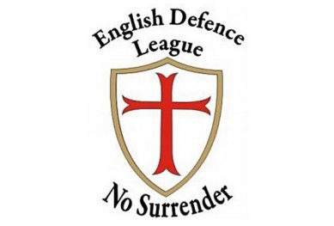
EDL


BNP


National Front

Democratic Nationalists
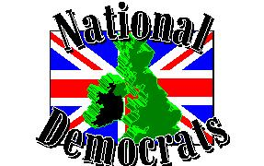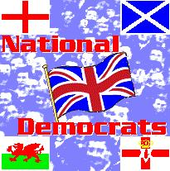

English Democrats
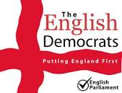

This is not an exhaustive list but is shown to clarify the 'categorisation' at time of writing.

Appendix B – Logos of Extreme Right Wing Groups

British Freedom Fighters
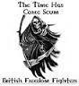

Blood and Honour

Aryan Strike Force



Combat 18


Racial Volunteer Force


British KKK
No specific logo found

November 9th Society


British Movement
No specific logo found

White Nationalist Party


British Peoples Party


League of St George


Knights Templar

This is not an exhaustive list but is shown to clarify the 'categorisation' at time of writing.

Appendix C - How to Act on a Concern and Make A Referral
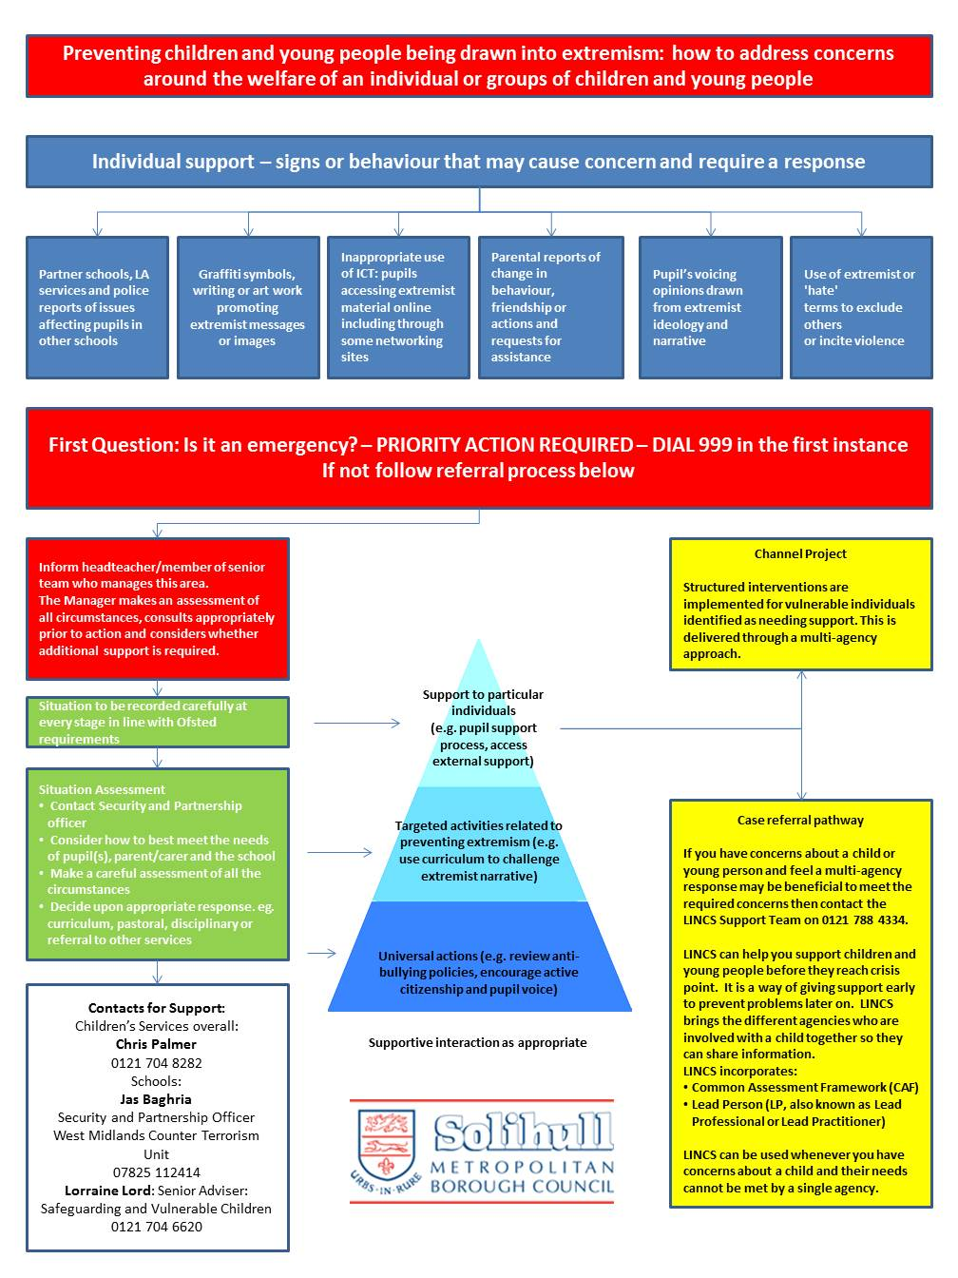

Appendix – ACPO Flyer

