**Female Genital Mutilation**

**Campaign Brief for partners**

**Background**

The Home Office was successful securing approx £250,000 from the European Union PROGRESS fund to tackle Female Genital Mutilation (FGM) in the UK. Part of this fund is being used to launch a marketing campaign to raise awareness of FGM within the UK.

FGM is an unacceptable form of abuse and violence against girls and women, and this government is absolutely committed to preventing and tackling FGM.

Prevention is at the heart of the government’s work on FGM. We aim to safeguard and protect all girls and women who may be at risk to avoid the often severe consequences for their physical and mental health.

FGM is illegal in the UK. It is also illegal to take a British national or permanent resident abroad for FGM or to help someone trying to do this.

The Home Office is working in partnership with the NSPCC who launched a dedicated FGM helpline in June 2013to provide advice and support to both members of the public and professionals who need information on FGM.

The marketing campaign launched on 2 June 2014 and will run through to August 2014. It will help to raise awareness of FGM and signpost the NSPCC FGM helpline and website as a place where members of the public and professionals can seek help, advice and support on FGM. A full media schedule is listed in this brief.

This campaign brief has been developed to provide you with the background to the campaign along with details on how you can support the campaign within your local area. You can also help support the campaign by tweeting our new campaign with [@NSPCC](https://twitter.com/NSPCC) calls on mothers and carers to [#endFGM](https://twitter.com/hashtag/endFGM?src=hash) [http://tinyurl.com/lrtrtrz](http://t.co/Cw18MOB6FA)

If you have any questions about the campaign please email [**FGMEnquiries@homeoffice.gsi.gov.uk**](mailto:FGMEnquiries@homeoffice.gsi.gov.uk)

**Contents:**

|  |  |
| --- | --- |
| **Section One:** | **Information on the Female Genital Mutilation campaign**   * Aim of the campaign * Target audiences * Key campaign messages * Channels to reach target audiences * Media schedule * Campaign launch * Partnership with NSPCC * Evaluation |
| **Section Two:** | **Girl Summit 2014: A future free from female genital mutilation, child and forced marriage** |
| **Section Three:** | **Campaign Support materials**   * How to order hard copy support materials * How to access electronic support materials * How to access FGM Multi-Agency Practice Guidelines |
| **Section Four:** | **Other useful background information and resources**   * Violence Against Women and Girls Action Plan * NSPCC website * EU PROGRESS Fund to tackle FGM |

**Section One: Information on the Female Genital Mutilation campaign**

**Aim of the campaign**

The aim of the campaign is to raise awareness of FGM and signpost the NSPCC FGM helpline (0800 028 3550) and website [www.nspcc.org.uk/fgm](http://www.nspcc.org.uk/fgm) as a place to seek advice, support and information on FGM from trained professionals. The campaign will also encourage people to report suspected cases of FGM.

**Target audiences**

The campaign is aimed at three audience groups:

* Second generation mothers and carers of girls at risk of FGM from Somalia, Kenya and Nigeria communities.
* Professionals (eg. Doctors, teachers and midwives).
* Communities including first generation elders.

The Home Office undertook research through qualitative focus groups with partners and specialist research agencies and identified three key communities of parents and carers; Somalis, Kenyans and Nigerians. These groups have both a higher than average prevalence of FGM and a significant UK population. By targeting these specific communities we will ensure that we have the maximum impact on a limited budget.

**Key campaign messages**

Partners and research has also told us that the main barriers to tackling FGM are that it is deeply ingrained in communities, especially amongst first generation grandmothers, whilst second generation mothers may be starting to question the practice. Also, families tend not to see FGM as abuse and that it is not openly discussed in communities.

All campaign activity signposts the NSPCC FGM helpline and website as a place to get further advice, support and information on FGM. We have grouped messages by each key audience listed below:

**Parents and carers** of young girls who are at risk of having FGM committed against them:

* FGM is child abuse and should not be ignored.
* FGM can have serious consequences for a woman’s health and in some instances can lead to death (infections, severe pain, bleeding and tetanus are just some of the short term consequences). Women who have had FGM are significantly more likely to experience difficulties during childbirth and may need to have a caesarean. section, or experience dangerously heavy bleeding after the birth of the baby and prolonged hospitalisation following the birth. Also, their babies are more likely to die as a result of the practice.
* In the long term women can suffer pain and discomfort during sex, chronic pain, infection, cysts, abscesses, difficulties with periods and fertility problems.
* Women can also often suffer severe psychological trauma, including flashbacks and depression.
* FGM is a serious criminal offence in the UK with a maximum penalty of 14 years in prison for anyone found guilty of the offence.
* Signpost places to get help:
  + NSPCC FGM helpline for further information, advice, and support and to report suspected cases of FGM.
* You can also contact the police direct (if you are in the UK and are concerned that a child may be taken overseas for the purpose of FGM call the police by dialling 999).
* If you are abroad and require help or advice please call the Foreign and Commonwealth Office on +44 (0) 20 7008 1500.

**Professionals (before FGM procedure has happened)**

* FGM is child abuse and should not be ignored.
* FGM is a serious criminal offence in the UK with a maximum penalty of 14 years in prison for anyone found guilty of the offence.
* Be aware of the communities in which FGM is practised.
* Be aware of any families within those communities who are making preparations for the child to take a holiday, arranging vaccinations or planning absence from school.
* Be aware of the child talking about a special procedure/ceremony that is going to take place.
* Signpost the Multi Agency Practice Guidelines on FGM for practitioners.
* Signpost places to get help:
  + NSPCC helpline for further information, advice, and support and to report suspected cases of FGM.
* Contact the police (if you are in the UK and are concerned that a child may be taken overseas for the purpose of FGM call the police by dialling 999).

**Professionals (after FGM procedure has happened)**

* FGM is child abuse and should not be ignored.
* FGM is a serious criminal offence in the UK with a maximum penalty of 14 years in prison for anyone found guilty of the offence.
* Signpost the Multi Agency Practice Guidelines on FGM for practitioners
* Signpost places to get help:
  + NSPCC helpline for further information, advice, and support and to report suspected cases of FGM.
* You can also contact the police (if you are in the UK and are concerned that a child may be taken overseas for the purpose of FGM call the police by dialling 999).

**Channels to reach key audiences**

**Audience: mothers and carers**

We will be using washroom panel posters, which are discrete and private spaces, to reach mothers and carers of young girls who could be at risk of FGM. The washroom poster will be located in women’s toilets in areas with there is likely to be a high population from our three target audiences. The posters will also be displayed in GPs surgeries. We will also be using digital and mobile advertising, as well as ‘paid for’ search, to reach second generation mothers who may be browsing sites such as mother’s forums ie Netmums and Facebook.

**Audience: Professionals**

To reach professionals, such as teachers and doctors, we will be using online trade advertising to direct them to educational material on FGM provided by the NSPCC, and on GOV.UK. Messages to these audiences will reinforce that FGM is child abuse and that it is their duty to report it. We are also sending information on the campaign to teachers via The Student Room on 16 June.

**Audience: Communities**

To reach communities on the ground, we are working with a specialist agency to develop a set of resources, which will include a DVD with interviews with health professionals, survivors and the NSPCC. This will enable supported advocates from within those communities, such as community leaders, to deliver educational sessions on FGM in trusted environments to open up conversation on the issue.

We will also be using existing community events to deliver the campaign messages, using the DVD mentioned above and health professionals who will be speaking at these events to members of the community. Street teams will also go out into the community to speak directly to mothers and carers about FGM and raise awareness of the NSPCC FGM helpline. You can view the DVD on the Home Office You Tube channel <http://youtu.be/HkDuzLA8T9w> , or order a hard copy from the storage centre. Details on how to do this are included in Section Three.

We will also be working with black and minority ethnic (BME) media to deliver educational messages via trusted messengers.

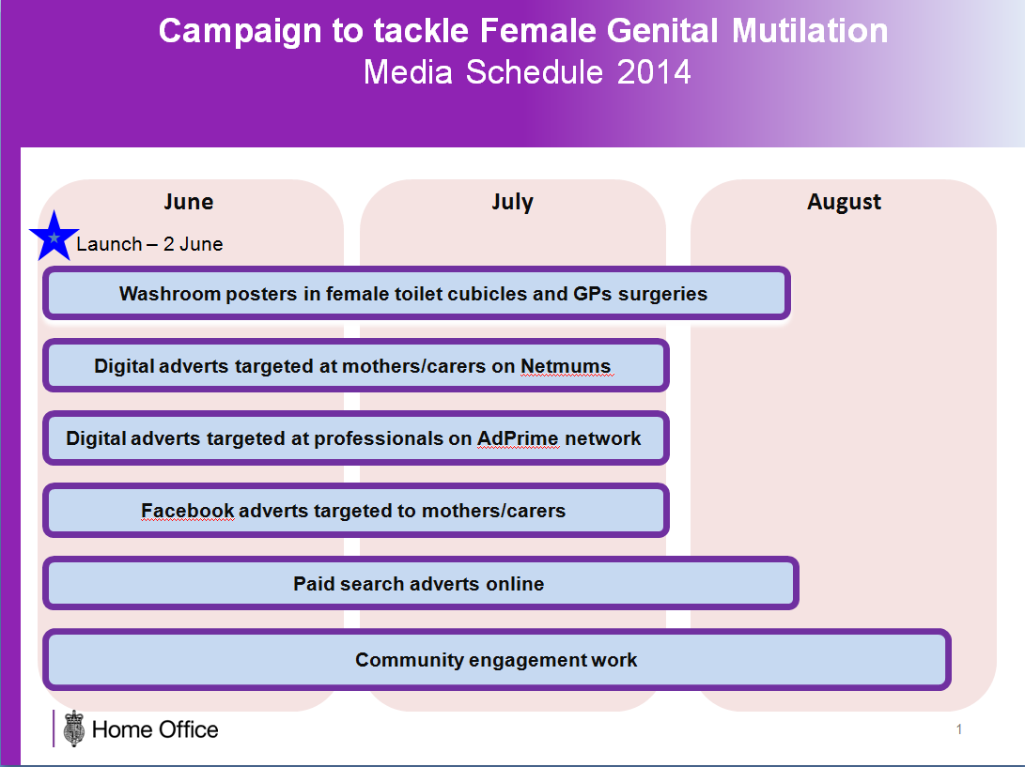

**Campaign launch**

Crime Prevention Minister, Norman Baker, took part in a panel discussion on FGM along with health professionals, the NSPCC and survivors of FGM, which will be aired on Universal TV (reaching the Somali Diaspora in UK and in Africa) on 2 June.  The Minister also took part in a pre-recorded interview with BEN TV (covering the West African Diaspora in UK and in Africa), which will also air on 2 June. Interviews on the day were carried out with local BBC where the washroom posters are being displayed.  You can also help to support the campaign by re-tweeting. Our new campaign with [@NSPCC](https://twitter.com/NSPCC) calls on mothers and carers to [#endFGM](https://twitter.com/hashtag/endFGM?src=hash) [http://tinyurl.com/lrtrtrz](http://t.co/Cw18MOB6FA)or by using the support materials listed in Section Three.

**Partnership with NSPCC**

The NSPCC launched a free 24-hour dedicated FGM helpline, 0800 028 3550, in June 2013. The helpline gives advice, information and support for anyone concerned that a child’s welfare is at risk because of female genital mutilation. Though callers’ details can remain anonymous, any information that could protect a child from abuse will be passed to the police or social services. All campaign activity will signpost the NSPCC FGM helpline as place to get advice, support and to report suspected cases of FGM.

**Evaluation of FGM campaign**

We will be evaluating the campaign, once the advertising has finished and will share a summary of the results once the evaluation has been completed. Once the campaign advertising has finished we will also be evaluating the support materials and DVD by asking you for feedback. The results will be used to inform our development of future campaign materials.

**Section Two: Girl Summit 2014: A future free from FGM and child and forced marriage**

The UK Prime Minister and UNICEF will, this July, co-host a Girl Summit on female genital mutilation (FGM) and child, early and forced marriage (CEFM).

These are practices which affect millions of girls in this country and overseas. In the last decade 58 million girls, 1 in 3, have been married before the age of 18. Early marriage ends a girl’s education, exposes her to life-threatening complications during pregnancy and childbirth and leaves her vulnerable to domestic violence. Over 120 million girls have been subjected to FGM. It is an extremely damaging and excruciating painful practice which has a devastating impact on girls’ and women’s physical and mental health and well-being and their opportunities

Girls around the world should have the same right to live free from violence and achieve their potential. So in July, we will bring together community leaders from the UK and overseas, governments, international organisations and companies to mobilise action to end CEFM and FGM everywhere, forever.

The event will have three broad outcomes:

1. commitment to action in the UK and globally through an international declaration, and funding and other commitments
2. a platform for sharing experiences, lessons and information about both issues
3. increased awareness and engagement from the public on these issues

**Section Three: Campaign support materials**

Support materials are available to order now, free of charge, from the Home Office central storage and distribution centre; Prolog.

**You can either place your order by telephone or email.**

**Order line: 0870 241 4680** (press ‘0’ on your keypad to speak to the Home Office publications team)

**Order email:** [**homeoffice@prolog.co.uk**](mailto:homeoffice@prolog.co.uk)

You just need to give them the product codes, see grids below, the quantity you would like to order along with your name and delivery address.

**Campaign support materials**

|  |  |  |
| --- | --- | --- |
| **Product code** | **Item description** | **Maximum order limit per order** |
| FGM-NSPCC-POSTER | NSPCC FGM Washroom poster | 10 |
| FGM-NSPCC-POSTER-C | NSPCC FGM Community poster | 10 |
| FGM-NSPCC-CARD | NSPCC FGM Wallet card | 100 |
| FGM-NSPCC-DVD | NSPCC FGM DVD | 10 |

You can also access the artwork to the NSPCC Washroom panel poster by emailing [FGMEnquiries@homeoffice.gsi.gov.uk](mailto:FGMEnquiries@homeoffice.gsi.gov.uk).Any amendments to the copy will need to be approved by the Home Office.

The Home Office have also produced some other support materials which you may find useful. You can also order these, free of charge, from the storage centre.

You can also view them on GOV.UK at: <https://www.gov.uk/government/publications/female-genital-mutilation-leaflet>

(<https://www.gov.uk/government/publications/statement-opposing-female-genital-mutilation>)

|  |  |  |
| --- | --- | --- |
| **Product code** | **Item description** | **Maximum order limit per order** |
| FGM-THE-FACTS | FEMALE GENITAL MUTILATION: THE FACTS LEAFLET | 250 |
| FGM-S-AMHARIC | Statement opposing FGM – AMHARIC | 500 |
| FGM-S-ARABIC | Statement opposing FGM – ARABIC | 500 |
| FGM-S-ENGLISH | Statement opposing FGM – ENGLISH | 500 |
| FGM-S-FARSI | Statement opposing FGM – FARSI | 500 |
| FGM-S-FRENCH | Statement opposing FGM – FRENCH | 500 |
| FGM-S-SOMALI | Statement opposing FGM – SOMALI | 500 |
| FGM-S-SWAHILI | Statement opposing FGM – SWAHILI | 500 |
| FGM-S-TIGRNYA | Statement opposing FGM – TIGRINYA | 500 |
| FGM-S-TURKISH | Statement opposing FGM – TURKISH | 500 |
| FGM-S-URDU | Statement opposing FGM – URDU | 500 |
| FGM-S-WELSH | Statement opposing FGM – WELSH | 500 |

The Home Office have also published FGM Multi-Agency Practice Guidelines to support front line professionals in recognising and preventing FGM.

You can access the guidelines on GOV.UK.

<https://www.gov.uk/government/publications/female-genital-mutilation-guidelines>

**Section Four: Other useful background information and resources**

**Violence Against Women and Girls (VAWG) Action Plan**

You can view the latest version of the VAWG Action Plan, which was published in March 2014

<https://www.gov.uk/government/publications/a-call-to-end-violence-against-women-and-girls-action-plan-2014>

**NSPCC website**

NSPCC FGM helpline: 0800 028 3550 (free phone 24/7)

The NSPCC have specific pages with information for parents and carers and for professionals:

Parents and carers: <http://www.nspcc.org.uk/fgm>

Professionals:<http://www.nspcc.org.uk/inform/resourcesforprofessionals/minorityethnic/female-genital-mutilation_wda96841.html>

**EU PROGRESS Fund to tackle FGM**

Other strands of work using the PROGRESS funding include:

**FGM E-learning tool** for professionals which will:

* Introduce child protection professionals to FGM through an e-learning training package. The tool includes how to identify both survivors and girls at risk of FGM and the measures that can be used to help prevent it from happening.

**FGM Community Engagement Initiative**

£100,000 of the EU PROGRESS fund was made available for organisations to bid for up to £10,000 to fund work in their local communities. Applications for funding closed on 6 March.

**Local Safeguarding Children Boards (LSCB) Outreach Programme**

* To deliver training to LSCBs using the e-learning tool.
* To encourage wide dissemination of this free resource amongst safeguarding professionals across all local authorities.

**European Conference 2015**

* To share effective practice and lessons learned with all member states following completion of all strands of the project.
* To increase awareness and understanding of alternative approaches in tackling FGM and the communication techniques used to deliver messages.
* To foster new working relationships across Europe.