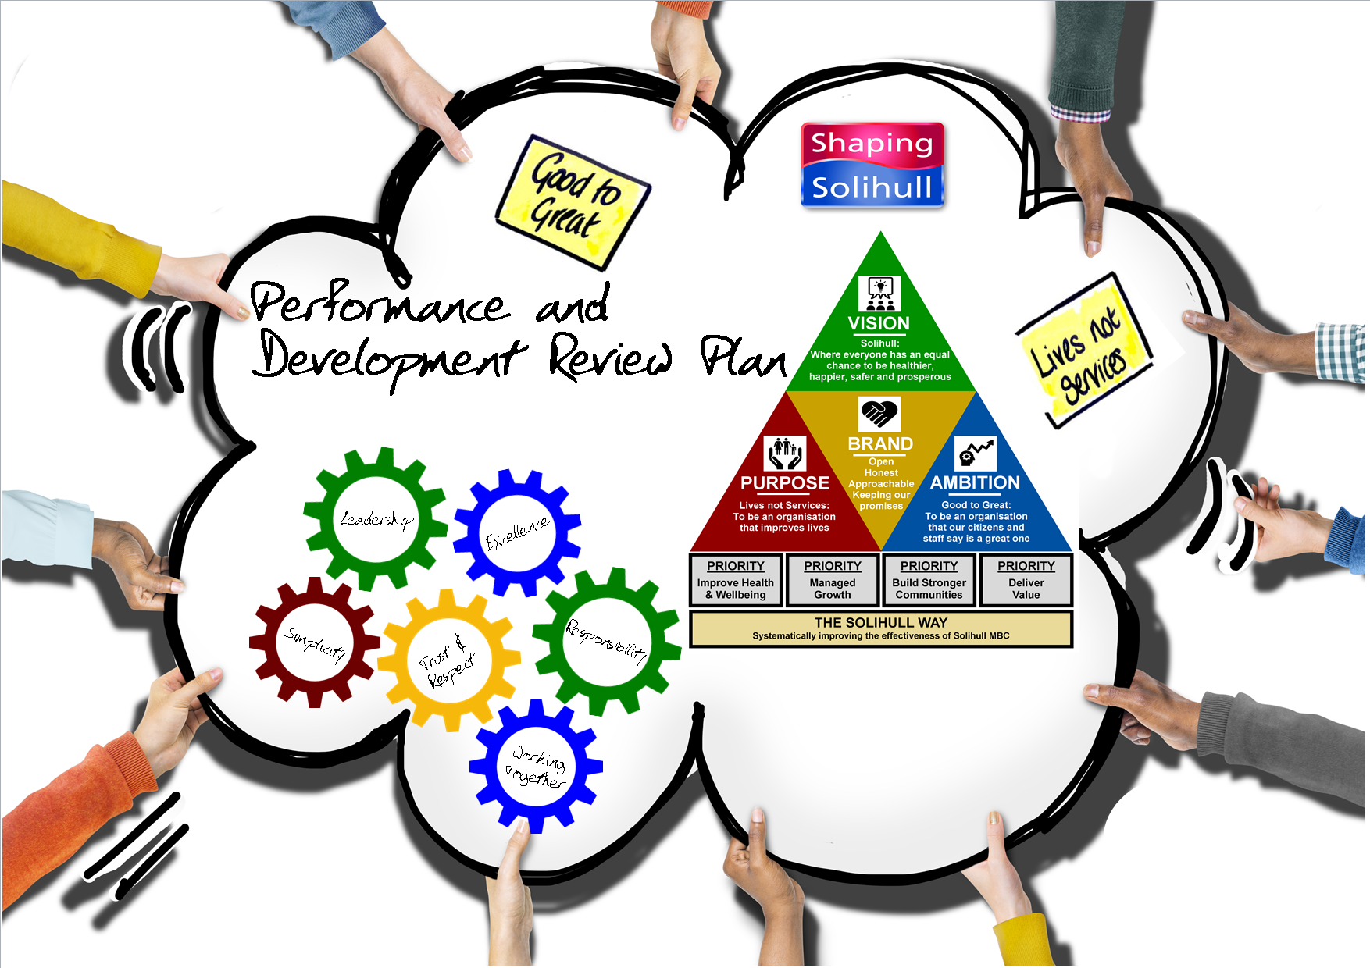
Your Name
Line Manager
Plan year

Your plan should describe what you are going to achieve; how you will measure your success and the way in which you do this through demonstrating all expected behaviours and our core values. Your plan describes the level of acceptable performance you need to achieve over the year and should be aligned to local performance and operating plans and link to the overall goals of your Directorate and the Council Plan.

INSTRUCTIONS AND EXAMPLES FOR COMPLETING THIS FORM
What am I going to achieve? | What are the expected outcomes and by when? | How am I going to demonstrate the behavioural requirements?
In the first column, define the objective and what you are going to achieve. | In the second column, define your measures of success and the things you will measure to track your progress. | In the third column, identify the behaviours you will focus on and how you will demonstrate this in the delivery of your objective.
OUTCOMES, LESSONS LEARNED & FEEDBACK
For each objective and at the end of the year, with your manager, use this space to summarise your outcomes and how you have demonstrated your agreed behaviours, include any feedback and lessons learned.

Example 1
Increase customer service so that 80% of my customers rate me as a minimum of ‘good’ on the customer service questionnaire by April. | - Develop four different customer service techniques; record reactions of customers to these techniques and report by 31st January.  - Unsolicited positive feedback received on service.  - Phone calls are returned within the same business day.  - Extra steps taken to ensure that customer needs are attained – e.g. following the ‘Lives Not Services’ approach to work. | Trust & Respect  - You build effective working relationships with customers, stakeholders, colleagues and partners.  - You listen to others – showing that you respect and value their input.  - You build effective relationships with customers, stakeholders, colleagues and partners.  - You understand how your behaviours can be interpreted and consider the impact you have on others.  - You manage your reactions to situations professionally and calmly.  Responsibility  - You make informed decisions and take responsibility for their impact.  - You are flexible in providing solutions to deliver improvements and resolve issues.  Excellence  - You promote and drive continuous improvement, constructively challenging the way things are done and strive for excellence.  - You focus on the right things and work to deliver maximum value to the customer.
OUTCOMES, LESSONS LEARNED & FEEDBACK
Increase in customer service to 88% of customers rating me as a minimum of ‘good’. Four different customer service techniques developed and trialled, report attached. Examples of many positive comments received [attached], and all phone calls returned within the same business day. Adopted the Lives not Services approach to all customer contact, examples of which are attached from my 1:1 evidence. I learnt that I need to adapt my style more to meet the needs of different customers.

Example 2
Develop a training strategy for staff on utilising the new department information system by April. | - Identify/prioritise staff training needs by 31st December.  - Develop a schedule for training based on grouping individual needs by 31st January.  - Identify a strategy for training new staff entering the department by 28th February.  - Identify the key components of the new department information system by 31st December.  - Evaluate training and identify changes for next programme, where appropriate. | Simplicity  - You design, innovate and influence solutions to address inefficiencies.  - You tailor communication methods to promote an inclusive team culture.  Working Together  - You spend time building relationships for maximum impact.  - You support others in working together; helping them to develop a common focus.  - You build networks collaboratively, to help provide support and expertise by shaping and driving forward agendas and addressing concerns.  - You listen to, and involve colleagues and external customers, and respond positively to suggestions before making decisions.  - You are willing to re-allocate resources for the mutual benefit of customers and organisations.
OUTCOMES, LESSONS LEARNED & FEEDBACK
Training development strategy was developed which included the expected outcomes [as attached]. In addition to this, identified that certain staff needed additional support which was provided. Demonstrated all of the behaviours highlighted – namely, spending time building key relationships with staff and building up networks. I demonstrated that I was willing to re-allocate resources in terms of my own time and flexibly responding to customer requests. I learnt that I need to be flexible in terms of working to a plan; that other things came up, which meant that the plan needed to change.

What am I going to achieve? | What are the expected outcomes and by when? | How am I going to demonstrate the behavioural requirements?
Objective 1
OUTCOMES, LESSONS LEARNED & FEEDBACK
Objective 2
OUTCOMES, LESSONS LEARNED & FEEDBACK
Objective 3
OUTCOMES, LESSONS LEARNED & FEEDBACK
Objective 4
OUTCOMES, LESSONS LEARNED & FEEDBACK
Objective 5
OUTCOMES, LESSONS LEARNED & FEEDBACK

Development Actions
Your development actions describe what support, development activity, training or opportunity you need to achieve your objectives
Action | By whom | By when

