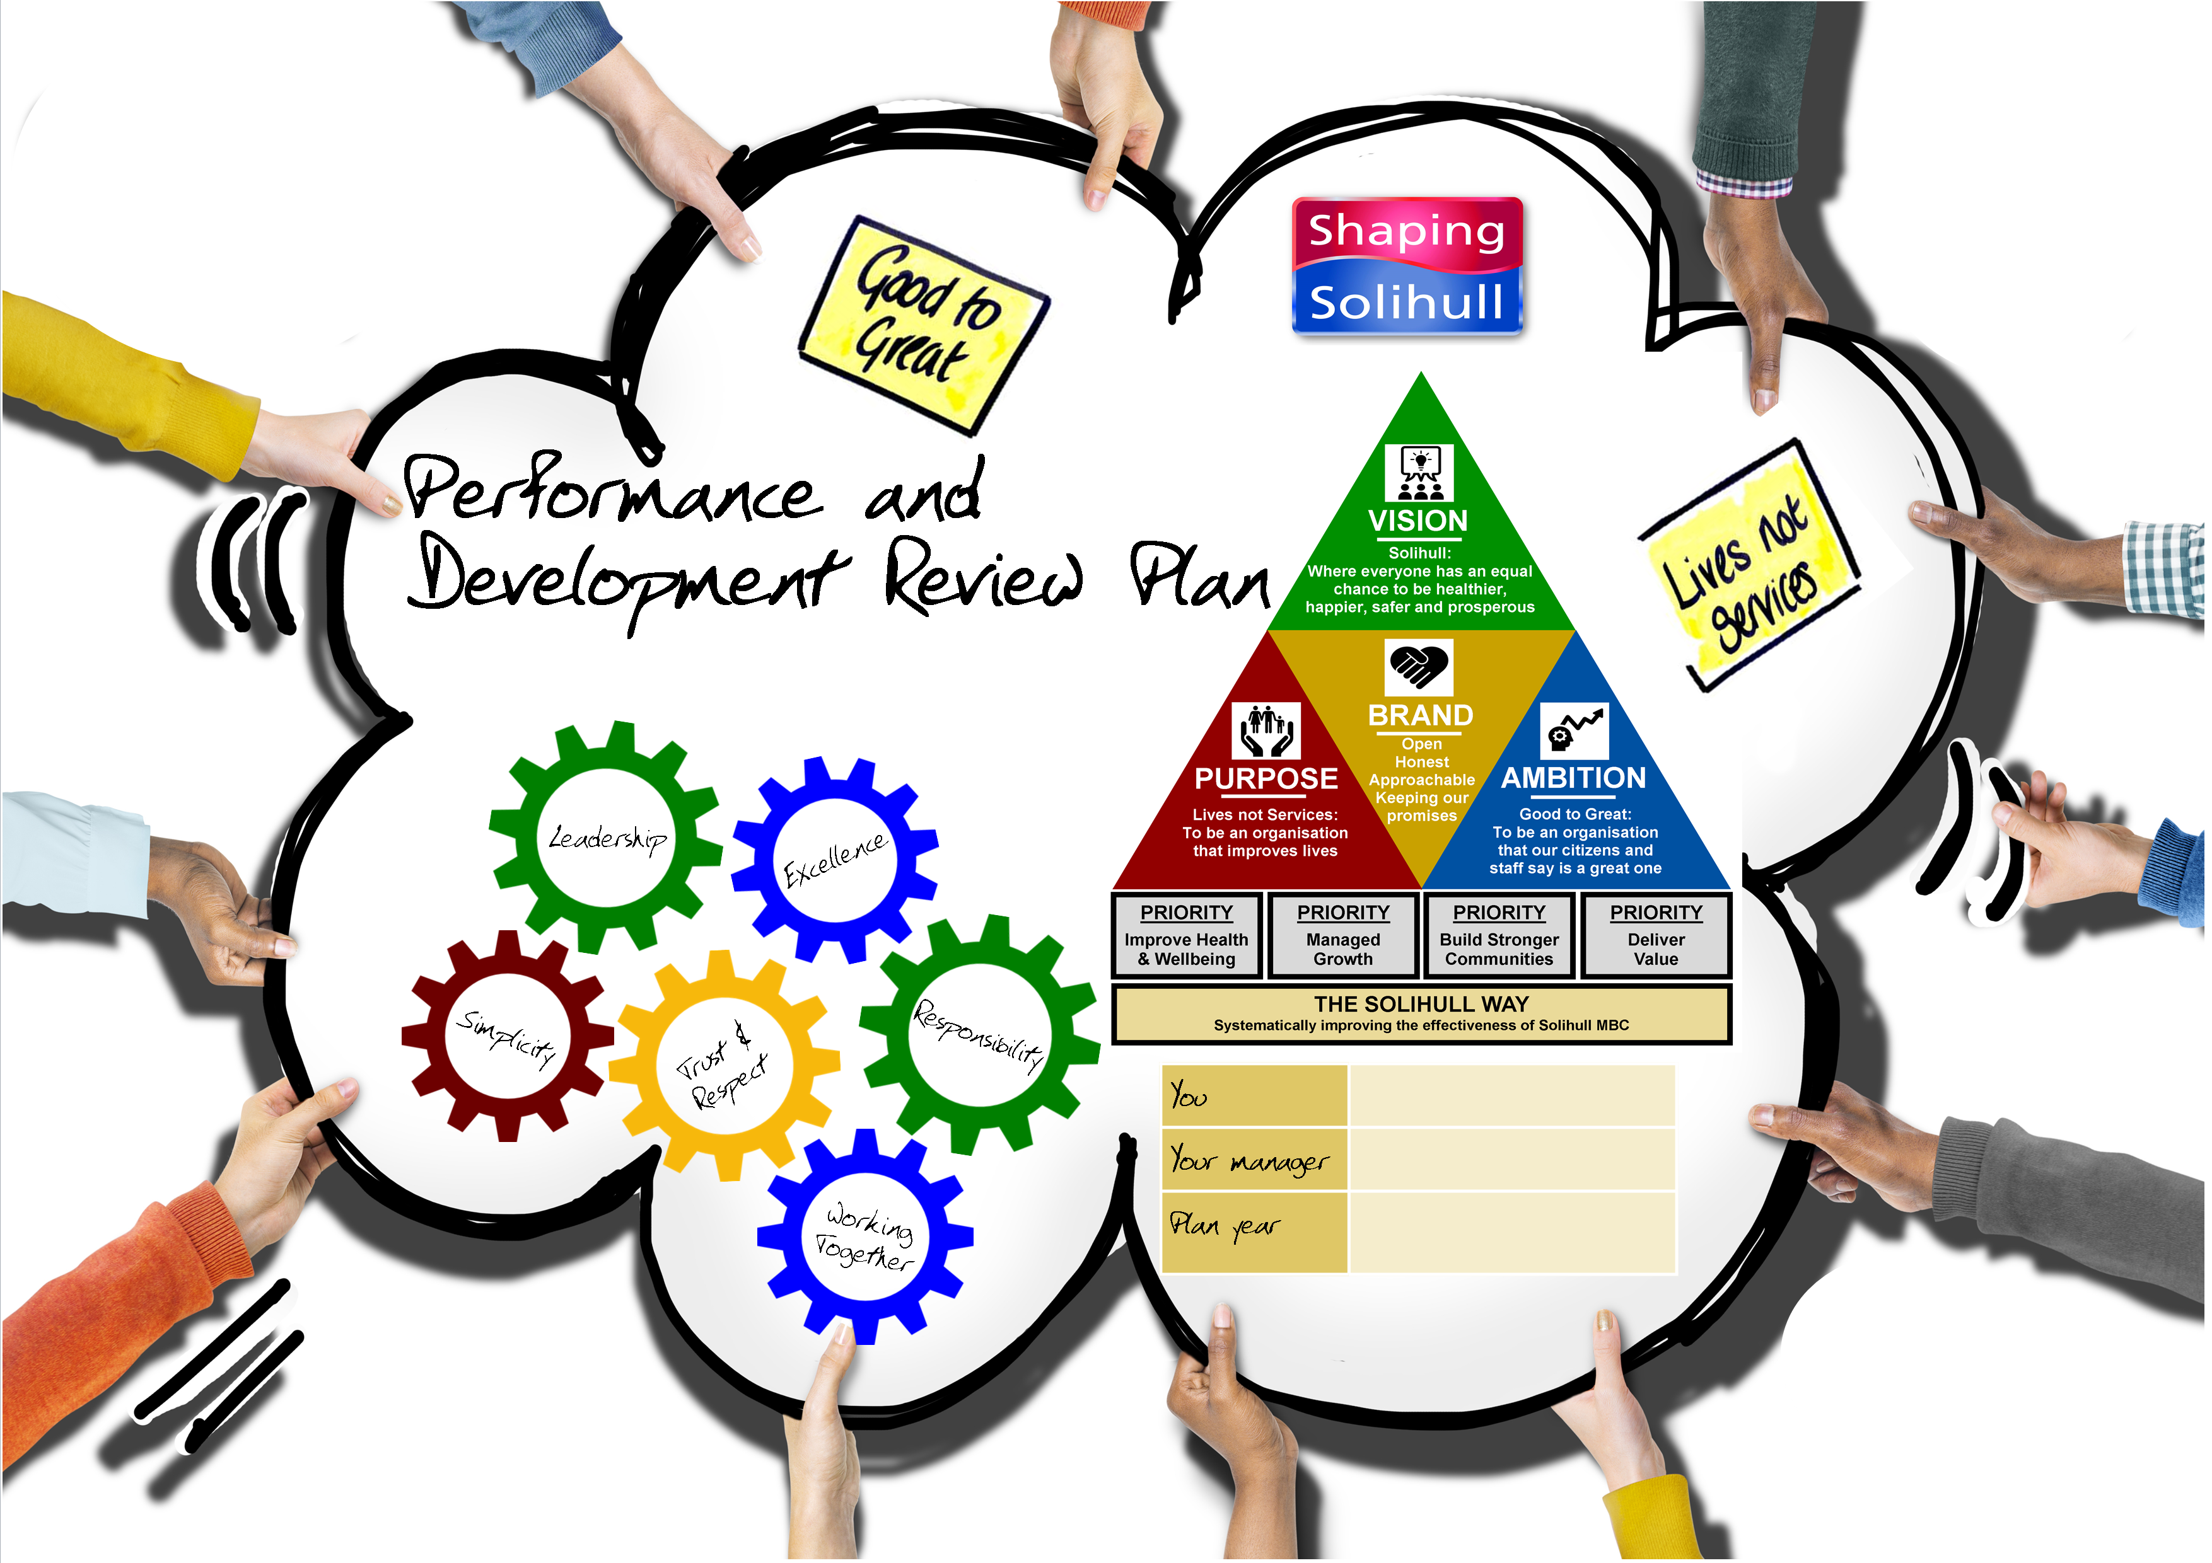
Your plan should describe what you are going to achieve; how you will measure your success and the way in which you do this through demonstrating all expected behaviours and our core values. Your plan describes the level of acceptable performance you need to achieve over the year and should be aligned to local performance and operating plans and link to the overall goals of your Directorate and the Council Plan.

What am I going to achieve? | What are the expected outcomes and by when? | How am I going to demonstrate the behavioural requirements?
Objective 1
- Use this space to define the objective and what you are going to achieve. | - Use this space to define your measures of success and the things you will measure to track your progress. | - Use this space to identify the behaviours you will focus on and how you will demonstrate this in the delivery of your objective.
OUTCOMES, LESSONS LEARNED & FEEDBACK
At the end of the year with your manager, use this space to summarise your outcomes and how you have demonstrated your agreed behaviours, include any feedback / lessons learned.

Objective 2
OUTCOMES, LESSONS LEARNED & FEEDBACK
Objective 3
OUTCOMES, LESSONS LEARNED & FEEDBACK
Objective 4
OUTCOMES, LESSONS LEARNED & FEEDBACK
Objective 5
OUTCOMES, LESSONS LEARNED & FEEDBACK

Development Actions
Your development actions describe what support, development activity, training or opportunity you need to achieve your objectives
Action | By whom | By when

