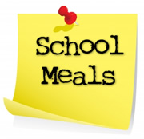**Solihull Governor Services**

**Solihull School Governors’ Training Programme**

**A Briefing about Solihull Catering Services**

What do you remember about school dinners? Is there a particular dish that stands out as a favorite? Pink custard perhaps?

Well, for over 25 years, Solihull Catering Service (SCS) has been serving healthy, high quality and affordable school meals that have hopefully provided lots of children with fond memories. Our menus have changed with the times, so you might be surprised at what new foods we now have on offer!

And although we feel SCS provides good value for money, we recognise that schools are facing an accumulation of financial pressures that means the cost of school meals is coming under closer scrutiny.



So, we want to tell you a bit more about ourselves, the food we provide, what it costs and how we can work with you to make sure your school meals contract is tailored to best meet the needs of your school.

Come and find out for yourself how good our food tastes and how to get the best from your catering!

Samples of food will be available to try, so please come and join us!

This briefing will take place on 26th September 2017

in the Civic Suite, 7pm – 8.30pm

**To reserve a place please contact Governor Services on**

**governorservices@solihull.gov.uk**

