Adding a title to a module
Navigate to the page where you want to add a title to the module. Click on Edit Page>Edit This Page.
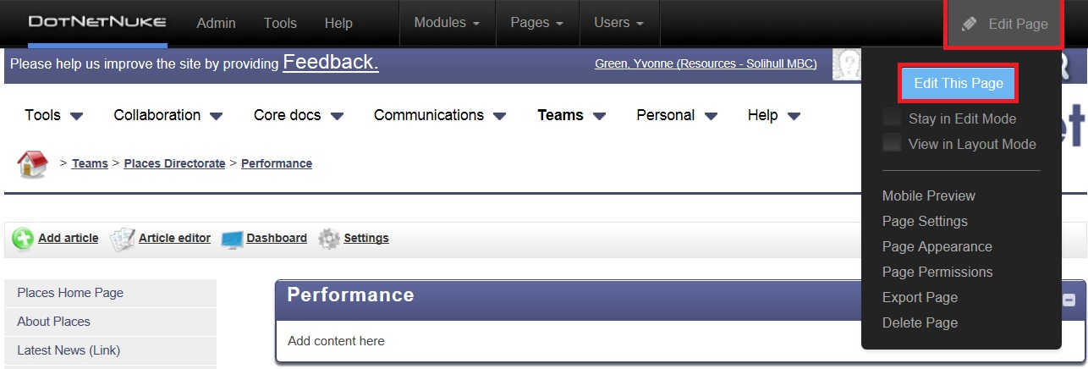
Click on the pencil icon above the module you want to add the title to>Edit Content>Settings
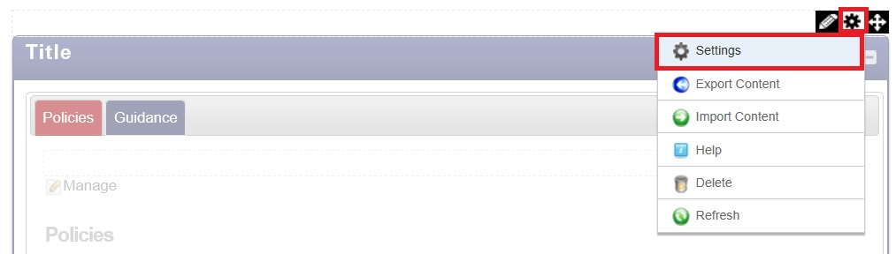
Under Module Settings>enter title under Module Title>click Update | 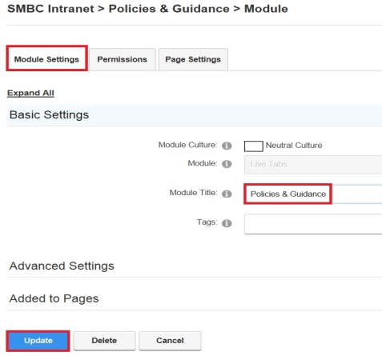
You will now see your title added at the top of the module. | 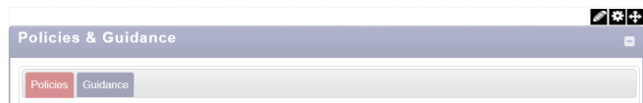

If you want to know more, or have any questions, please contact
Team | E-web
Team email | eweb@solihull.gov.uk
Intranet area | http://intranet/Help/Guidanceforauthors

