# [Solihull Natter Matters: Building Communication Champions in Early Years](https://www.solgrid.org.uk/eyc/training/special-events/)

](https://www.solgrid.org.uk/eyc/wp-content/uploads/sites/31/2025/06/Solihull-SLCN-Pathway-document-updated.pdf)

Solihull early years community of support

**Overview**

This 2-hour practical training on **speech, language and communication** (SLC) and best practice in **universal provision** will strengthen early years practice and support every child’s communication journey.

You will:

* Explore the **Solihull *toolkit* of support**
* Learn how to embed **universal strategies** that promote SLC development
* Discover ways to create **communication-friendly environments** and language-rich provision
* Share best practice and reflect on the new **Ofsted emphasis on early communication**
* Understand your role as a **Communication Champion** within the **Early Years Speech & Language Pathway**

**Dates & Venues:**

* 13 November 2025 – The Loft, Bluebell Centre 9:30–11:30am :  [Booking form](https://forms.office.com/Pages/ResponsePage.aspx?id=rgObbdmfb06EmZuschoIFFupVDIYYelAg_GkXzZuwcpUMEdWWE8wNzFIQTlYTzVJQlNYNUFWSVBHWiQlQCN0PWcu&rb67a7aaf81514c5b87bc000821a98f92=%22SLCN%20-%20Speech%20Language%20and%20Communication%20needs%20(13%2F11%2F2025)%22)
* 5 March 2026 – Solihull Council House, 9:30–11:30am **:** [Booking form](https://forms.office.com/Pages/ResponsePage.aspx?id=rgObbdmfb06EmZuschoIFFupVDIYYelAg_GkXzZuwcpUMEdWWE8wNzFIQTlYTzVJQlNYNUFWSVBHWiQlQCN0PWcu&rb67a7aaf81514c5b87bc000821a98f92=%22SLCN%20-%20Speech%20Language%20and%20Communication%20needs%20(05%2F03%2F2026)%22)

**There is an expectation that a ‘communication champion’, early years lead or a SENCo from every Solihull group setting/ school will attend this training. We hope that you will cascade information back to your setting in your role as Communication Champion.**

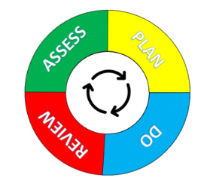

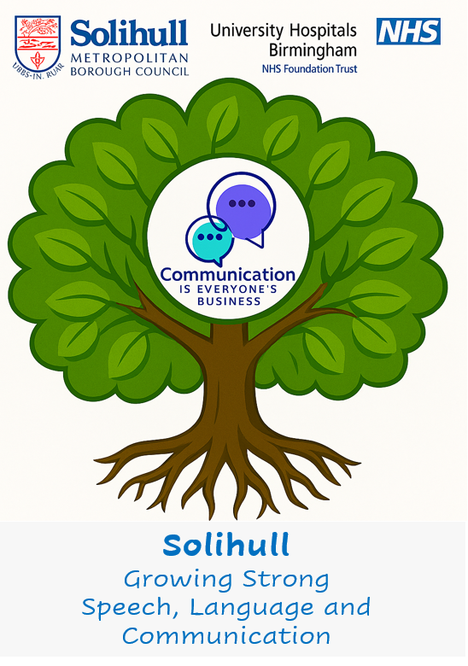

***Presenters***

*Solihull Early Years Team*

<https://www.solgrid.org.uk/eyc/>

<https://www.solihull.gov.uk/children-and-families/solihull-local-offer/early-years-education-0-4-yearsSolihull>

*SISS: Communication and Learning Difficulties Team*

<https://www.solihull.gov.uk/local-offer-communication-and-learning-difficulties-team>

**Solihull Health Visitors**

<https://www.swft.nhs.uk/our-services/solihull-0-19-service>

**Solihull Speech and Language Therapy Team**

<https://childrenscommunitytherapies.uhb.nhs.uk/>