Catering: In-house or External?
There are two primary options for managing catering requirements: in-house provision and external caterers.
In-house catering
There are many advantages of cooking meals on site including greater flexibility over menus, meal timings and the creation of a more homely atmosphere. However, the in-house provision requires significant investment in kitchen facilities, equipment, and skilled personnel. It also involves the complexities of buying food, adhering to food safety regulations, and the management of staff absences and holiday cover which can be challenging. Even if external caterers are used then settings may have to provide breakfast and tea.
External caterers
This option can offer several benefits including professional expertise and reducing the workload of management and staff.
Both options serve hot, healthy, nutritious meals and most caterers are now able to meet different dietary requirements, for children who are vegetarian or have an intolerance for example.
How do the costs compare?
A breakdown of the costs illustrates that in-house catering, external caterers may be comparable in price. If you are struggling to cook hot meals in-house, there are other options that do not always cost more!

Estimate based on 40 children
Daily costs | In-house catering | External caterers
Staff Costs  - Menu planning  - Shopping  - Cooking  - admin | £36.63  (based on 3 hours minimum wage April 2025) | 0 (small amount of admin time to order food and pay invoice)
Ingredients | £44.42 (see ingredients below) | None
Kitchen Equipment | Considerable initial outlay ££ | None
Fuel Costs | £1 or more | None
Caterer invoice | None | £1.95 or £2.10 (per child)
Total | £82.05 | £78.00 - £84.00 depending on supplier

Ingredients Spaghetti bolognaise.
• beef mice750g x 2 (9.98)
• Quorn mince 500g x 2(£5.90)
• Tinned tomatoes x 6 (£2.79)
• oxo cubes for 12 only need 8 (£2.79)
• tomato puree (£1)
• dried oregano (£1)
• dried garlic granules (£1)
• pasta 3kg bag (£4)
• garlic bread 8 baguettes (£2.96)
• Vegetables onions, carrots, parsnips, celery, mushrooms any £3.
• Pudding Banana and custard
• banana x 15 (£3.90)
• Custard 500ml x 8 (£5.52)
Total £44.42 (Prices from Morrisons Nov 2024)

Caterers
These are details of 3 Birmingham based External caterers.
Caterer A | Caterer B | Caterer C
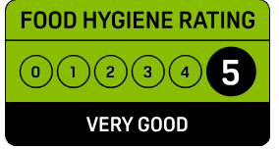  - Formed in 2007  - Accredited by StartWell  - NEW Online ordering  - 3-week menu cycle  - Twice a year menu changes  - Already providers of Nursery meals in Solihull.  - Menus for children with severe allergies and dietary needs can be specifically created.  Prepared from the best locally sourced ingredients, all our meals are delivered fresh.  We are skilled and experienced in catering for allergies, specialist dietary, nutritional or religious requirements.  We are proud of our excellence in food hygiene standards.  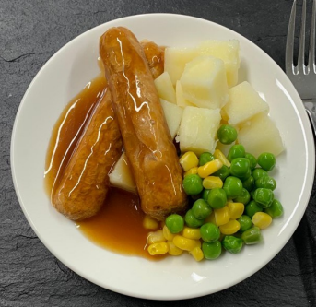  Price per meal -£1.95 Hot Lunch two-course  Tea also available -£1.45 -for a two-course | - Established in 1997  - Comply with the StartWell Programme  - Menus include the correct requirements to count towards children's "5 a Day".  - 3-week menu cycle  - Already provide Nursery meals in Solihull.  We believe in providing healthy, interesting meals and puddings that children will eat and enjoy on a daily basis. No salt is added during cooking, we always source the best quality ingredients.  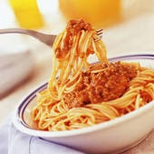  Price per meal -£2.10 Lunch two-course | - Opened in 2017  - Provides healthy nutritionally balanced meals.  - We cater for all dietary and cultural needs.  - 4-week menu cycle  - No added salt in our meals.  We pride ourselves as being a specialist nursery catering supplier, supplying hot lunches with a hot or cold pudding.  All our meat, dairy, fruit and vegetables are as locally sourced as possible, using only the freshest and the best quality ingredients to make our meals.  We feel it’s up to us to produce a wide range of flavours for young children to explore as they grow to develop their food  preferences.  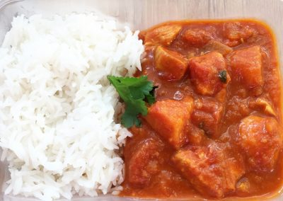  Price per meal -£2.10 Lunch two-course

