Early Years Physical Activity Training
Solihull Active would like to support Early Years Providers in Solihull to better understand physical activity in young children
We have partnered with National Charity, Youth Sport Trust to offer their Healthy Movers course. The course is based on their Early Years Physical Literacy Framework.
Healthy Movers approach has been effective at increasing children’ physical, emotional and social development as a foundation for improving language, communication and literacy.

For more information about the course and to watch the video please visit: https://www.youthsporttrust.org/programmes/healthy-movers
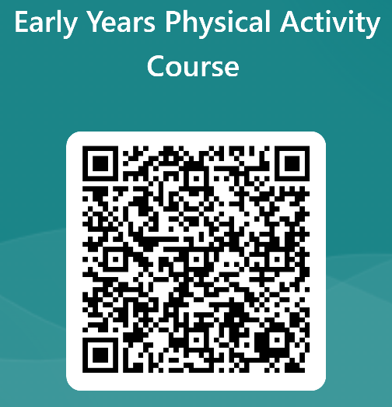
To register your interest, please complete the following, or scan the QR code:

https://forms.office.com/e/ZsqL6sFHTe

