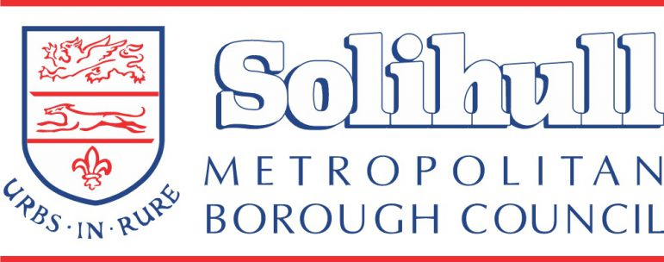
Training to support communication, including behaviour in the early years
National training
Speech and Language UK
https://speechandlanguage.org.uk/talking-point/cpd-online-short-course/
A short course that is free and a great place to start learning about children and young people’s speech and language development. It looks at how you can support the development of these skills on a day-to-day basis in your setting, and how to spot children and young people who might be struggling to develop these important skills.

DfE funded Professional development Programme (3)
Early Years Professional Development Programme – Currently registering interest for February 2023 starts and beyond (earlyyearspdp.com)
https://www.earlyyearspdp.com/
Available to eligible practitioners in local authorities across England and the first PDP 3 cohort will begin in February 2023. Participants will receive high quality, evidence-based CPD (continuous professional development) to support them to improve outcomes on school readiness, early language, early mathematics and Personal, Social and Emotional Development (PSED).

Online Early Years Foundation Stage Modules -Help EYFS
https://child-development-training.education.gov.uk/
Early years child development training : About training (education.gov.uk)
Module 3: Supporting children’s personal, social and emotional development
Personal, social and emotional skills play a central role in helping children to understand and regulate their emotions and behaviour, build positive relationships, and navigate the social world around them.
Module 4: Supporting language development in the early years
Children’s speech, language and communication skills affect the way they behave, learn, and interact with the world. As an early years practitioner, you will play a central role in helping children to learn, practise and use a wide range of language with confidence.

Early Years Practitioner Guidance | Babies, Young Children Mental Health & Wellbeing | Early Years In Mind | Anna Freud Centre

Local Training
Dingley’s Promise Inclusion Training
Early Years Inclusion Programme – Dingley's Promise
https://dingley.org.uk/dingleys-promise-training/early-years-inclusion-programme/
This programme is a series of ten courses over five years aimed at empowering early years practitioners to deliver inclusive practices by upskilling them through training and shared information/learning resources. It is expected that the training will increase learners’ awareness of the needs of all children, especially those with Special Educational Needs and Disabilities (SEND), and their confidence in supporting the learning and well-being of all children in their setting.
Modules include Inclusion and Behaviour and there are 4 available for Solihull settings.

Solihull Approach- Understanding your child
www.solgrid.org.uk/fivetothrive
Every Solihull resident can complete a range of online parenting courses for FREE using the access code APPLEJACKS.
Understanding your child- Online course for all parents, grandparents and carers of children aged 0-18 years.

Working with Trauma in Early Years (2 HRS) West Midlands
By focusing on Trauma in the Early Years, practitioners will be able to support children in identifying how to stay safe and encourage them to share when they may be struggling. This training aims to support practitioners in understanding signs of trauma and how it may present in the early years. Various dates are available
VRP Free Training – Working with Trauma in the Early Years - news (solgrid.org.uk)

There is also support available through the early years setting improvement visits
https://www.solgrid.org.uk/eyc/support/

