Solihull Speech Language and Communication – further assessment guidance
In Solihull we believe that if children’s speech, language and communication develop well they can communicate their thoughts, feelings and ideas, be understood, build relationships and interact with others. Children learn to talk and talk to live and learn.
The revised EYFS Statutory and non-statutory guidance gives a focus on children being able to communicate in a variety of ways. What happens early, matters for a lifetime and this statement is threaded through the non-statutory ‘What to expect in the Early Years Foundation Stage: a guide for parents.’
Communication and Language Education Programme
The development of children’s spoken language underpins all seven areas of learning and development. Children’s back-and-forth interactions from an early age form the foundations for language and cognitive development. The number and quality of the conversations they have with adults and peers throughout the day in a language-rich environment is crucial. By commenting on what children are interested in or doing, and echoing back what they say with new vocabulary added, practitioners will build children's language effectively. Reading frequently to children, and engaging them actively in stories, non-fiction, rhymes and poems, and then providing them with extensive opportunities to use and embed new words in a range of contexts, will give children the opportunity to thrive. Through conversation, story-telling and role play, where children share their ideas with support and modelling from their teacher, and sensitive questioning that invites them to elaborate, children become comfortable using a rich range of vocabulary and language structures.
Statutory Framework for the EYFS 2021 DfE https://www.gov.uk/government/publications/early-years-foundation-stage-framework--2
Early years settings will be using the educational programmes to plan their unique curriculum offer. They may also use non-statutory guidance such as Development Matters and Birth to Five Matters to guide this. To support understanding of a child’s developing communication needs the local authority also suggest the following assessment tools:
Development matters- https://development-matters.org.uk/
Birth to Five Matters - https://birthto5matters.org.uk/
Early Support Development Journal- https://councilfordisabledchildren.org.uk/resources/all-resources/filter/inclusion-send/early-years-developmental-journal
Every Child a Talker https://birthto5matters.org.uk/wp-content/uploads/2021/03/PDF-13-ECAT_child_monitoring_tool1.pdf
I Can - https://ican.org.uk/media/2860/tct_univspeak_0-5.pdf
https://ican.org.uk/i-cans-talking-point/professionals/tct-resources/more-resources/professional-development-video/ Support for practitioners working with children and young people with how to raise initial concerns about a child or young person’s speech, language and communication development with their parents.
The following websites may also be useful to support parents to support speech, language and communication
https://ican.org.uk/i-cans-talking-point/parents/ages-and-stages/ I Can’s guide to the typical stages of speech and language development
https://ican.org.uk/i-cans-talking-point/professionals/tct-resources/through-the-eyes-of-a-child/ - Advice on how parents can encourage their child to talk and how they can interact with them.
https://childrenscommunitytherapies.uhb.nhs.uk/speech-and-language-therapy/resources-for-everyone/ Solihull Speech and Language Therapy
Chat, Play, Read and ideas for communication rich activities……..
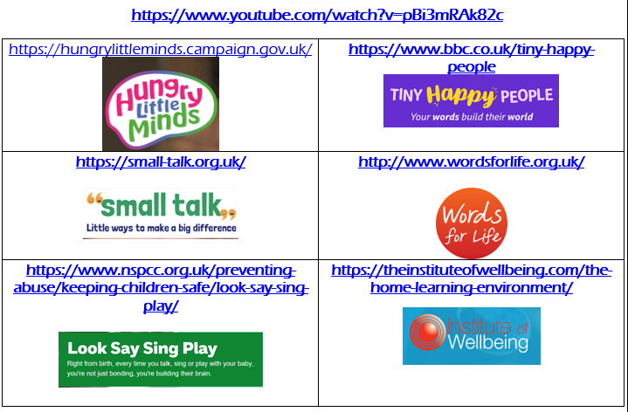

Solihull local authority acknowledge that other small step language assessment tools are available both as freely downloadable development guides and purchased screening tools.

