July 30 or August 1st 2021- Friendship Day
KS1 ACTIVITY PACK: Celebrate Friendship Day with Peter Rabbit - Puffin Schools
Flexible activities for children aged 3-6 years to encourage their curiosity about nature and use the activities to explore local green spaces. Themes of friendship, nature, wellbeing and looking after the natural world

You got a friend in me ……
Preschool Education Songs & Fingerplays: Friendship -https://www.preschooleducation.com/sfriend.shtml
Free Friendship Songs and Rhymes {Character Education Resources} - Bits of Positivity - https://bitsofpositivity.com/free-friendship-songs-and-rhymes-character-education-resources/

books-friendship | BookTrust - https://www.booktrust.org.uk/booklists/b/books-friendship/
Eight beautiful books about making friends | BookTrust - https://www.booktrust.org.uk/news-and-features/features/2020/november/eight-beautiful-picture-books-about-making-friends/
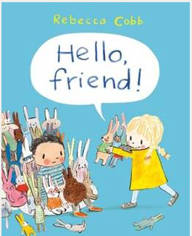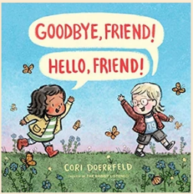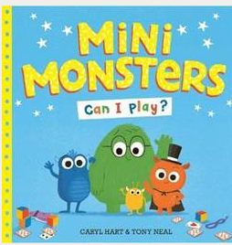
Friendship Activities: 10 Top Games for Kids (healthline.com) -https://www.healthline.com/health/parenting/friendship-activities#Preschool-Friendship-Activities

17 Friendship Activities for Preschoolers - Kid Activities https://kidactivities.net/friendship-activities-for-preschoolers/

The Making Friends Badge - Hey Duggee Series 2 - Hey Duggee - YouTube https://www.youtube.com/watch?v=sJhtuYyGBSs

Children explain how you make Friends - YouTube - https://www.youtube.com/watch?v=6qu2cQnULjE

International Day of Friendship | Free Classroom Resources & Activities (teachstarter.com) -https://www.teachstarter.com/gb/blog/international-day-friendship-activities-gb/

- https://www.ricpublications.com.au/blog/post/15-activities-to-celebrate-international-friendship-day/

'We'll be Friends Forever, won't we, Pooh?' asked Piglet.
'Even longer,' Pooh answered.

In 1998 Winnie the Pooh was named the world’s Ambassador of Friendship at the United Nations, and in April 2011, the United Nations officially recognized 30th July as International Friendship Day; although most countries celebrate on the first Sunday of August!
According to the Friendship Day declaration, we are invited to “observe this day in an appropriate manner, in accordance with the culture and other appropriate circumstances or customs of their local, national and regional communities, including through education and public awareness-raising activities.” Friendship Day: Celebrate Friendship Day, Friendshipday.org -https://www.friendshipday.org/

