Reading with children for pleasure!
We all know that illustration and humour appeal to children. We see when we read with children, the importance and power of humour in children's literature.
Over the next couple of months here are some opportunities to enjoy reading with children, sharing in their fun, excitement, and love of reading!
World book night
The Reading Agency has announced that “Books To Make You Smile” will be the theme of World Book Night 23 April 2021, to mark the tenth year of the annual campaign celebrating the shared pleasure of reading.
https://worldbooknight.org/news/world-book-night-specsavers-team-up-make-nation-smile
https://summerreadingchallenge.org.uk/book-sorter
https://tommclaughlin.co.uk/books/
https://youtu.be/Z48B_90YVH4
https://youtu.be/8Ng3QOLKXxs

May 2021 National share a story month
The theme of Myths, Magic and Mayhem.
National Share-A-Story Month is an annual celebration of the power of storytelling and story sharing, providing a fantastic opportunity to bringing children and stories together. You might like to organise opportunities for children and adults to share and act out stories during the month of May.
4-9 May Childrens book week – Reading is a superpower
Children’s Book Week – Every Child a Reader
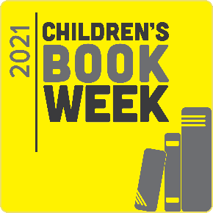
Children’s Book Week is a celebration of books and connections. It unites children and adults with books, authors, and illustrators to foster a love of reading. You might like to take this opportunity to connect with your local library and create an exciting and fun Children’s Book Week experience for all in 2021!

https://clpe.org.uk/library-and-resources/booklists/superhero-booklist

