17th March 2021National ‘Beep Beep Day’
Ideas and suggestion to use with children 2-7 years
Beep Beep Day is a national road safety awareness day for pre-school children. https://www.brake.org.uk/get-involved/for-professionals/teachers-and-youth-workers/beep-beep-days
Opportunities to support parents
Car seat-Child car seat safety – Good Egg Safety Guides
Teaching Road Safety: A Guide for Parents (rospa.com)
Supporting Communication and Language through Songs and rhymes
(10) STOP LOOK AND LISTEN Road Safety Song | Kindergarten Nursery Rhymes & Songs for Kids 👵🏻 NANNY NITRO - YouTube
http://www.dltk-kids.com/safety/milk_carton_traffic_light.htm
https://www.think.gov.uk
Developing reading for pleasure- Books
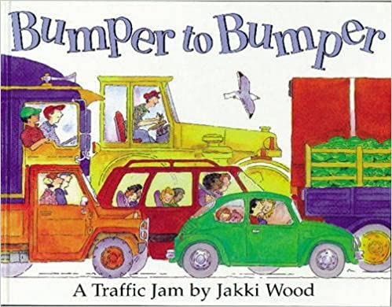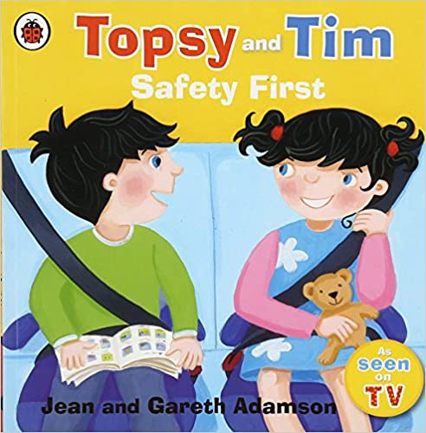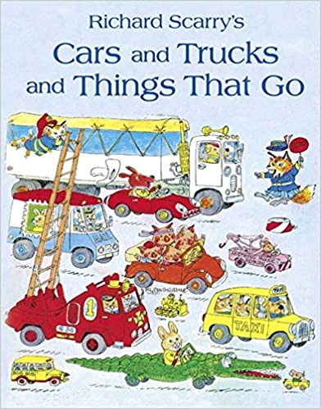
A(522) Pinterest
Creativity
Big box town- can add in signs, roads, parks, buildings
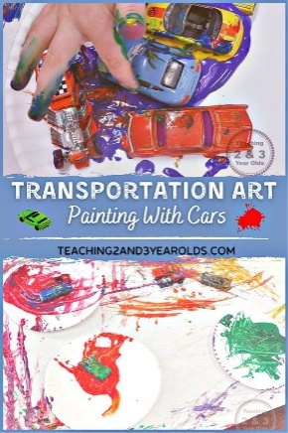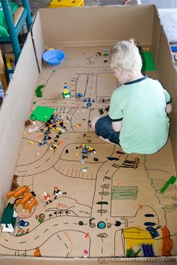
Online games for 3-6-year olds
Explore education resources – THINK!

