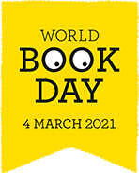
The World Book Day website provides many fabulous ideas for celebrating World Book Day!
https://www.worldbookday.com/2020/12/guides-to-world-book-day-2021/

Other ideas!
World Book Day Bingo
Read 20 books this week
A poetry book | Fiction | Reading online text
Non-fiction | a new book | Listen to a story told or read by someone else
an old favourite | A rhyme | Your own choice

Find objects to help you retell a story such as Goldilocks and the three bears -
3 stones to represent the bears, a yellow object for Goldilocks, 3 bowls of different sizes, etc.
Use a line of string to be the story line and place the objects along the line as you and the children tell the story together.
Charades
Line up some favourite books [clues]
Takes it in turns to act out a character/story for others to guess
Take it outside to play - encourage large actions

https://www.ltl.org.uk/resources/storytelling-outdoors/

Choose a story linked to the weather then go outside to investigate some of the words or explore the same things as in the picture e.g. find drip drop and plip plop opportunities!

https://www.booktrust.org.uk/books-and-reading/bookfinder/bookfinder-results/#!?cat=2541&sortOption=Relevance&pageNo=1&pageSize=48

Search rain and an age range and you might find: It's Raining! It's Pouring! We're Exploring! Author: Polly Peters Illustrator: Jess Stockham or Splish, Splash, Ducky Author: Lucy Cousins
https://www.oxfordowl.co.uk/for-home/find-a-book/library-page

About Words for Life
Words for Life is created by the National Literacy Trust and supported by UK publishers with funding for its creation from the DfE and Kindred.
https://wordsforlife.org.uk/

A campaign to support parents to incorporate ways to ‘chat, play and read’ with their children into their daily routines.

https://literacytrust.org.uk/communities/north-east/-chat-play-read/everyday-adventures-chat-play-read/

Simple, fun activities for kids, from newborn to five
https://hungrylittleminds.campaign.gov.uk/

Free resources to celebrate books and reading

https://clpe.org.uk/free-resources-celebrate-books-and-reading

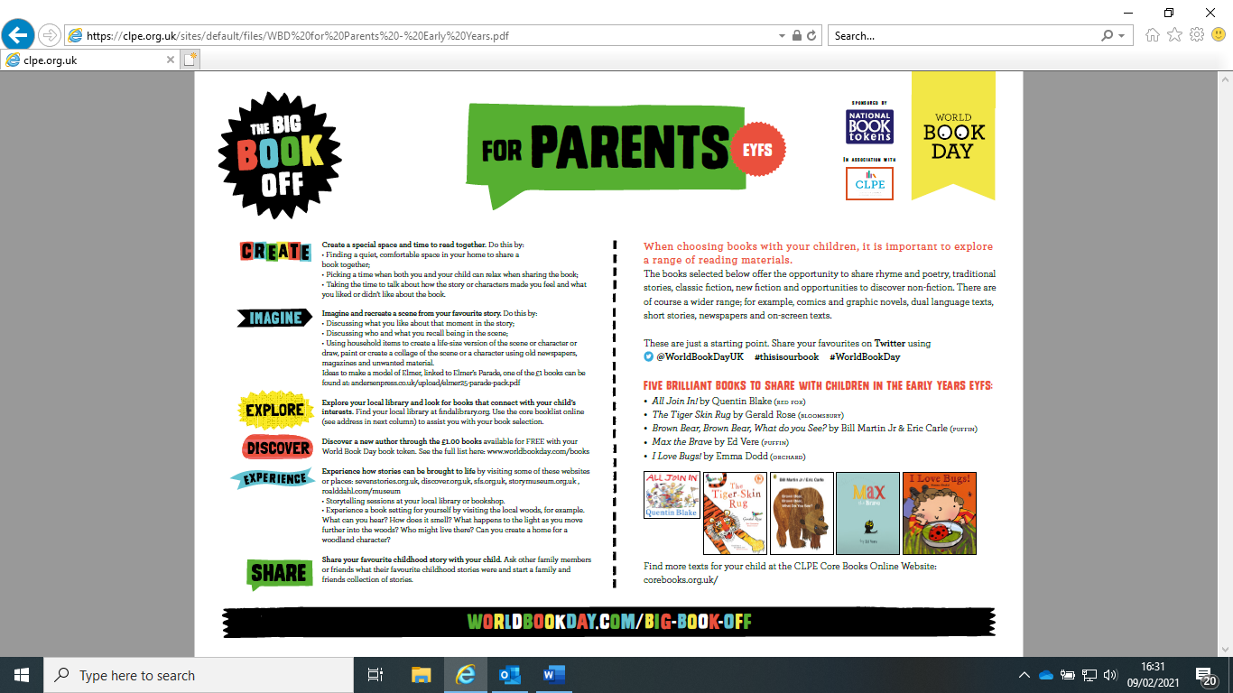

https://clpe.org.uk/sites/default/files/WBD%20for%20Parents%20-%20Early%20Years.pdf

World Book Day and beyond…

Solihull Library Remote Activities

These events can be accessed through Facebook
https://www.facebook.com/solihulllibraries

YouTube channel https://www.youtube.com/channel/UCtlqLMXGKw8Wk6LCoT7g4sw
Here you will find archives of the Rhymetime and Make & Create activities

The Library posts a Home Learning Help link every weekday at 8:00am
This is for school age and early years children, with links to free help with
English, maths, science, and other curriculum topics

Empathy Day has launched its book collections for 2021 details available at https://www.empathylab.uk/RFE

Weekly activities
Monday | An Author Reads | A link to authors reading their own books
Tuesday | Tuesday download | A review of a children’s or Young Adult books available as a free ebook or eaudiobook from the library. The collection includes picture books and books to support families through stresses imposed by lockdown and isolation.
Wednesday | Storytime | A library storytime online  From 24th Feb the library will be trialling this as a Facebook Live experience to support chat and friendship during lockdown.
Thursday | Rhymetime | A short session of action rhymes delivered by library staff
Friday | Make & Create | Simple craft ideas and support

