Supporting Learning at Home
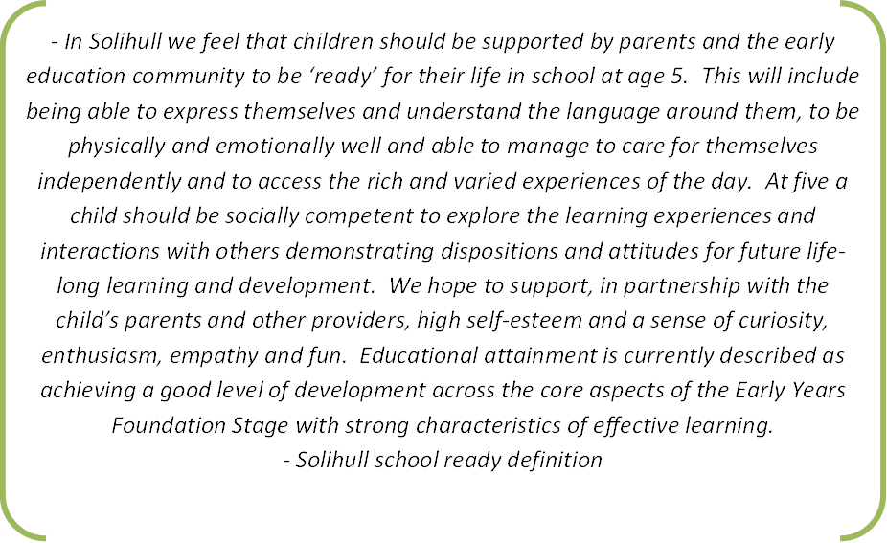
Websites to support home learning
Chat, Play, Read
https://www.youtube.com/watch?v=pBi3mRAk82c
https://hungrylittleminds.campaign.gov.uk/ | https://www.bbc.co.uk/tiny-happy-people
https://small-talk.org.uk/ | http://www.wordsforlife.org.uk/
https://www.nspcc.org.uk/preventing-abuse/keeping-children-safe/look-say-sing-play/ | https://theinstituteofwellbeing.com/the-home-learning-environment/

