Language and Communication

Moderation for in-setting training

Overview of the session: approx. 45 minutes

1. In small groups of 3 or 4 practitioners

* List - what do we want children to learn about communicating and talking in our setting? Consider - knowledge, skills, understanding, attitudes and motivation to enjoy stories/books, chatting, role play, listening to sounds and each other etc.

1. Share the ideas between the whole team

* This will include skills and their confidence and seeing themselves as able to share stories, play partner, talk and interact well with children etc.
* Look at a couple of comments and aspirations
* Look to the development matters bands to see what age children are ‘expected’ to be learning or to have acquired the knowledge, skills and understanding you are expecting in the setting. So what should we be teaching each age group – are we teaching to an appropriate age band?

1. In pairs, 1 person describes the things you have noticed about your chosen child’s communication and language ability [speaking, listening or understanding]. The examples of evidence could be both in their learning journeys and things that the practitioner recalls and describes from memory.
2. The 2nd person will match the descriptions to the development band statements. You may also like to use the ‘Celebrating Children’s Learning’ materials as exemplification for the communication aspects.

Purpose: To support language and communication development and attainment and the identification of learning within the EYFS development bands

Resources:

* Development Matters document
* What happens, When?- parents guidance
* Letters and Sounds Phase One – If a hard copy is not available in the setting, download from the internet <http://www.solgrid.org.uk/eyc/resources/learning-and-development/>
* Quick reference communication and language development matters progress document [see [www.solgrid.org.uk/eyc-](http://www.solgrid.org.uk/eyc-) grids and resources]
* Blank paper and pens and post-it notes
* [www.eleysp.co.uk/celebrating-childrens-learning](http://www.eleysp.co.uk/celebrating-childrens-learning) for the communication aspects

Preparation in advance: choose a key child; be able to discuss the child’s communication and language skills. In addition you may bring some supporting observations, learning journals, parents’ contributions etc. Your own evidence of children’s development and attainment to match against the development matters bands.

4

Notes and thoughts:

Effective use of talking tips - <https://www.thecommunicationtrust.org.uk/early-years/>



1. Swop places and repeat the activity.
2. Is there an agreement that what you hear and see will contribute towards an accurate and consistent judgement of a child working within the band attributed to them? Professional conversation will support each other to recognise the quality of the evidence and the accuracy of the judgement.
3. Reflect on the usefulness and purpose of moderation to ensure the accuracy of the judgements and the impact on future planning and provision that meets the needs of the children and supports their progress.

Evaluation on post-it notes- What did you find most useful about moderating as a team? How will this impact on future practice and provision? You might note 2 likes and a want - 2 things you valued about the opportunity to moderate and a ‘next step’ for you to be recorded on the post it for future training/ discussion.

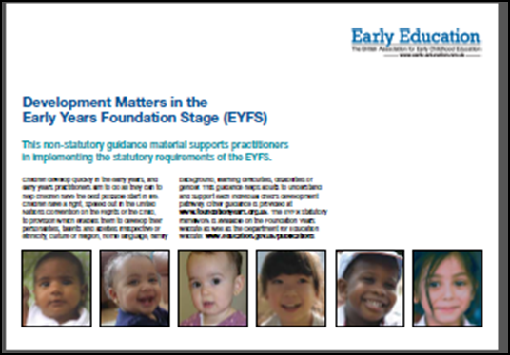 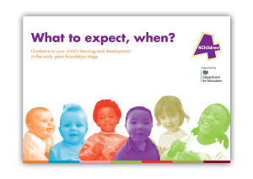 [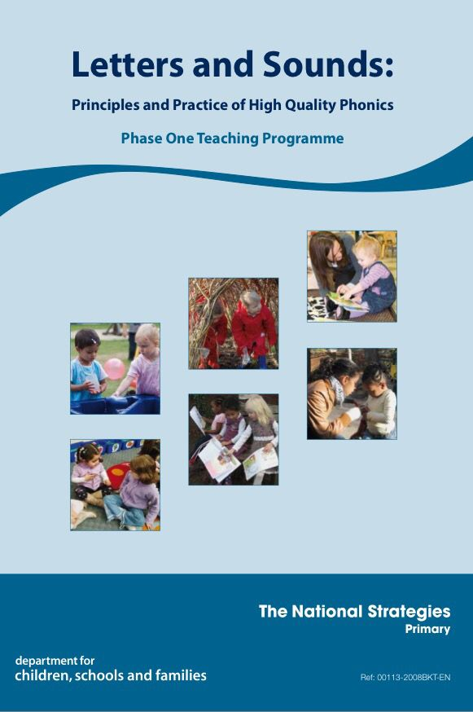](https://www.google.co.uk/url?sa=i&rct=j&q=&esrc=s&source=images&cd=&cad=rja&uact=8&ved=2ahUKEwjd2LDUh9bcAhVLTBoKHQzDAwkQjRx6BAgBEAU&url=https://www.pinterest.co.uk/pin/175358979219109203/&psig=AOvVaw1sHlmKEcbh7bYp6rRm2BrS&ust=1533563523946518) [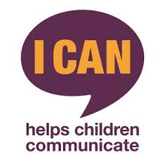](https://www.google.co.uk/url?sa=i&rct=j&q=&esrc=s&source=images&cd=&cad=rja&uact=8&ved=&url=https://twitter.com/icancharity&psig=AOvVaw3Za82CJ-d71-2LnSb7Ztl3&ust=1538232759311763)