Who do I call? A child has injured themselves in the setting.
EYFS 2017
3.51. Registered providers must notify Ofsted or the childminder agency with which they are registered of any serious accident, illness or injury to, or death of, any child while in their care, and of the action taken. Notification must be made as soon as is reasonably practicable, but in any event within 14 days of the incident occurring. A registered provider, who, without reasonable excuse, fails to comply with this requirement, commits an offence. Providers must notify local child protection agencies of any serious accident or injury to, or the death of, any child while in their care, and must act on any advice from those agencies.
Solihull MASH: 0121 788 4300 – notification of a serious accident or injury whilst a child is in your care
OFSTED-https://ofstedonline.ofsted.gov.uk/ofsted/Ofsted_Early_Years_Notification.ofml
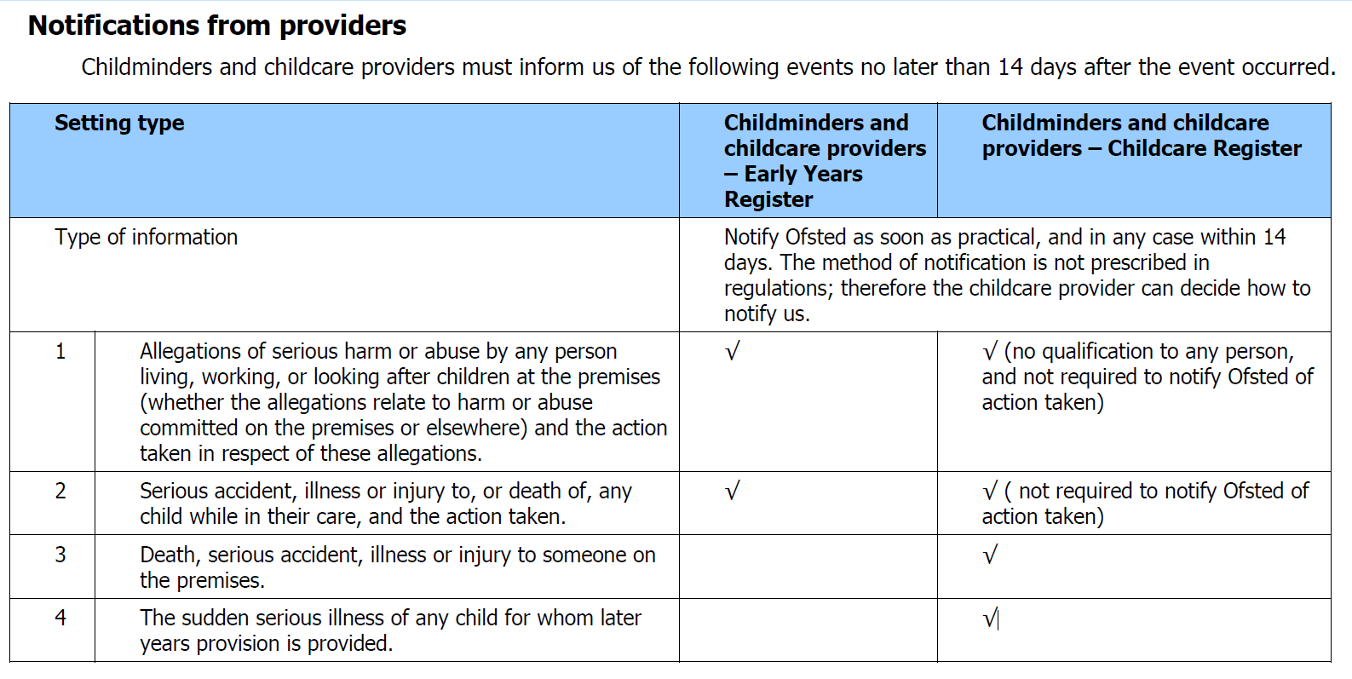
Ofsted Compliance Handbook

55. We define serious injuries as:
 broken bones or a fracture
 loss of consciousness
 pain that is not relieved by simple pain killers
 acute confused state
 persistent, severe chest pain or breathing difficulties
 amputation
 dislocation of any major joint including the shoulder, hip, knee, elbow or spine
 loss of sight (temporary or permanent)
 chemical or hot metal burn to the eye or any penetrating injury to the eye
 injury resulting from an electric shock or electrical burn leading to unconsciousness, or requiring resuscitation or admittance to hospital for more than 24 hours
 any other injury leading to hypothermia, heat-induced illness or unconsciousness; or requiring resuscitation; or requiring admittance to hospital for more than 24 hours
 unconsciousness caused by asphyxia or exposure to harmful substance or biological agent
 medical treatment or loss of consciousness arising from absorption of any substance by inhalation, ingestion or through the skin
 medical treatment where there is reason to believe that this resulted from exposure to a biological agent, or its toxins, or infected material.
Some examples of serious injuries that must be notified to us are set out below.
 A child trips and falls in a nursery and loses consciousness due to a bang on the head.
 A child is accidently hit hard in the chest by a football during outdoor play at an out of school club, and has persistent, severe breathing difficulties.
 Parents take their child to hospital, several days after the child suffers a blow to the head while at your childcare provision. The child is still suffering from the initial injury.
 A baby breaks a leg during a fall at the nursery.
 A child takes a heavy fall while running around and is taken to hospital; the child is kept in hospital for over 24 hours.

56. Providers are not required to inform us of minor injuries, nor of general appointments to hospital or routine treatment by a doctor, such as the child’s general practitioner, that is not linked to, or is a consequence of, a serious accident or injury.
We define minor injuries as:
- sprains, strains and bruising
- cuts and grazes
- wound infections
- minor burns and scalds
- minor head injuries
- insect and animal bites
- minor eye injuries
- minor injuries to the back, shoulder and chest.
57. Some examples of minor injuries that do not need to be notified to us are set out below.
~ A child trips over their shoelaces, falls and sprains a wrist in the nursery.
~ A baby, attempting to sit up, loses balance and drops face first onto the floor, cutting their lip.
~ A bee stings a child while playing in the outdoor space. The child is not allergic to bee stings and does not require hospital treatment.
Ofsted Compliance Handbook Pages 19,20,21

