**INSERT NAME OF SETTING/SETTING LOGO HERE**

**SAFEGUARDING CHILDREN CONCERNS FORM**

To be completed by staff or volunteers when they become aware of any child welfare or child protection concern. The completed form should be handed to the Setting’s Designated Safeguarding Lead (DSL) without delay. Consider escalation to MASH if DSL is unavailable.

|  |  |  |
| --- | --- | --- |
| **Name of child :** | **DOB of child:** | |
| **Name and role of person making this record :** | **Key Person :** | |
| **Date:** | **Time:** | |
| **Nature of incident/concern/disclosure:**  (Include any relevant background and any injuries or marks. Injuries or marks should also be recorded on the body map sheet). Record what the child said or did, using the same words that the child used (if any) | | |
| **Signature: Date :** | | |
| **Name of child :** | | **DOB of child:** |

|  |  |  |  |
| --- | --- | --- | --- |
| **Actions taken** | **Who** | **Date & Time** | **Notes** |
| **Discussed with DSL**  **Information reviewed**  **Discussed with Parent(s):**  **Discussed with MASH (if necessary)**  **Referral made to MASH (if necessary)**  **Other:** | **DSL** |  |  |
| **DSL:**  **Signature: Date:** | | | |

|  |
| --- |
| **Final outcome:**  ( feedback should be given to the person who raised the concern unless advised otherwise by MASH or another agency) |
| **DSL:**  **Signature: Date :** |

|  |  |
| --- | --- |
| **BODY MAP 1** | |
| **Name of child :** | **DOB of child:** |
| **Name and role of person completing body map record:** | **Date:** |
| **Time:** |



|  |  |
| --- | --- |
| **BODY MAP 2** | |
| **Name of child :** | **DOB of child:** |
| **Name and role of person completing body map record:** | **Date:** |
| **Time:** |
|  |  |

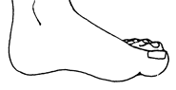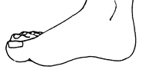

Outer Inner

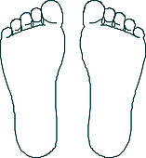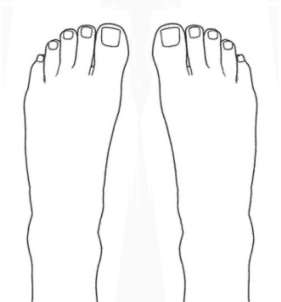

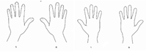

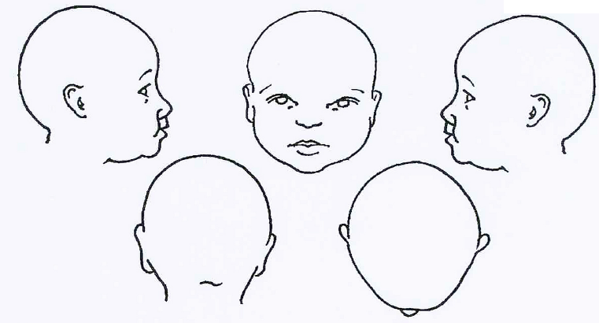

**ACCIDENTAL INJURIES NON-ACCIDENTAL INJURIES**

