

Contents

Overview 2
Who can apply 3
Criteria 3
Closing date 3
What a Specialist Leader of Education does 4
Time commitment 4
Selection Process 4
Application Process 5
Application form 6
Appendix 1 12
Pricing Structure: 12
Complaint Procedure 12
Appendix 13
Policy for Reviewing Designation 13
Appendix 3: 15
SLE de-designation criteria 15

Overview

If you are an experienced or middle leader, or equivalent (see Appendix for Clarification of Terms), and you would like to work with leaders in other schools to improve pupil outcomes, you might want to consider applying to be a Specialist Leader of Education.
In addition to continuing the work in your own school (which includes maintained, faith, free, academy or equivalent), you would have a school improvement role with another school or schools. SLEs may operate as a discrete part of a bigger project, or stand-alone, but ultimately, the aim for all work is to drive forward school improvement. The impact of work is measured carefully.
The goal of the Specialist Leaders of Education is to increase the leadership capacity of other schools to help raise standards. This is an important element of the government’s plan to give schools a central role in developing a self-improving and sustainable school-led system.

For further information regarding designation, please contact:
Gemma Hobbs at teachingschool@st-peters.solihull.sch.uk 0121 705 3988
You may wish to consult the DfE guidance, which can be found by following this link:
https://www.gov.uk/government/uploads/system/uploads/attachment_data/file/431968/sle-application-guidance.pdf

2

Who can apply

To become a Specialist Leader of Education, you and your school need to meet the following criteria.

Criteria

To be eligible to be a Specialist Leader of Education, you must:
- have at least 2 years of experience as a serving leader (not a headteacher)
- commit to the time expectations.
- have the support of your school’s head teacher or principal
- commit to the time expectations
- have a specialism in any one (or more) of the following areas:

Ofsted focus | Areas of expertise
Effectiveness of leadership and management | Academies; leadership of continuing professional development; school business management and financial management; leadership of curriculum
Outcomes for children and other learners | Art; Closing the Gap; Drama; Design and Technology; Early Years; English; Geography; History; Information and Communication Technology; Maths; Modern Foreign Languages; Music; Phonics; Physical Education; Personal, Social and Health Education; Religious Education; Science; Special Educational Needs; support for the most able pupils
Quality of teaching, learning and assessment | Initial teacher training; assessment
Personal development, behaviour and welfare | Behaviour and discipline; attendance

Closing date
The application round is currently open.
- Closing date for applications is 9am on Monday 30th April 2018
Applications need to be emailed to: teachingschool@st-peters.solihull.sch.uk

3

What a Specialist Leader of Education does
SLEs focus on developing leadership capacity. While other roles focus specifically on developing classroom expertise, this role is about developing the capacity and capability of other leaders so that they have the skills to lead their own teams and improve practice in their own schools.
This may be done through one-to-one or group support and could involve a variety of activities, such as:
- data analysis
- coaching
- facilitating and training
- joint action planning
If selected, you’ll be expected to provide evidence that your work has had a positive impact on outcomes for children and young people by developing leadership capacity in other schools.

Time commitment
The role lasts for 4 years, at which time there will be a review. The types of placements will vary. For example, one might be a two-day diagnostic exercise, while another might require a longer, full time support role. Time may be taken as a block of consecutive days or spread over a longer period.
There is no minimum or maximum time commitment. You and your school will need to think carefully about capacity and negotiate your availability together.

Selection Process
- Each applicant completes an application form
- A reference on each applicant will be requested from the Headteacher of the applicant’s school
- Applications will be assessed, and successful applicants will be invited to interview
- Interview panels will consist of colleagues from St. Peter’s Solihull Teaching School Alliance and its partners
- Successful applicants will be required to attend the orientation sessions (see above) prior to deployment
- Each successful SLE will be aligned to St. Peter’s Solihull Teaching School Alliance.
- Unsuccessful applicants will be given developmental feedback and offered the opportunity to apply at a later stage

4.

Application Process

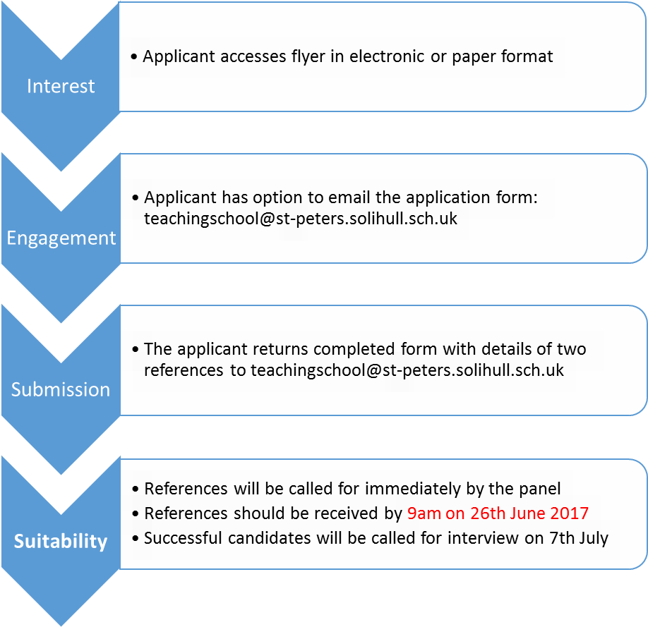

5

Application form
Section 1
Application form (to be completed by the SLE applicant)

Applicant details
Title
Surname
First name
Role
School
Address
Phone
Email
St. Peter’s will use this information to contact you.
Teaching School Alliance you wish to consider your application.

School phase
6
Your specialism
Please indicate the specialist area(s) that you wish to be designated for.
Please tick all that apply.
Specialism | Mark your specialism with a tick () | Length of time in role (this should be at least two years)
Leadership and management
Academies and academy transition
Leadership of continuing professional development (CPD)
School business management and financial management
Leadership of curriculum
Pupil achievement
Early years
English
Geography
History
ICT/Computing
Maths
Music
Modern foreign languages (MFL)
Phonics
Physical Education (PE)
Science
Special educational needs (SEN)
Support for most able pupils
Religious Education (RE)
Quality of Teaching
Initial Teacher Training (ITT) and/or NQT development
Behaviour and Safety
Behaviour and discipline
Attendance
Eligibility criteria confirmation

a) Do you hold a leadership role or responsibility within your school?
√

Yes No

b) Please indicate how long you have been in this role. If less than two years, please provide details of your previous leadership role or responsibility. Please include the name of the school where the role was held.

Question 1
What motivates you to participate in system leadership?

Word limit: 300 words

Question 2
Please outline the significant impact of your contribution as a leader to supporting leaders in other schools or to your own school’s performance. Please detail the impact and demonstrate clear evidence of your outstanding practice within your area(s) of expertise or specialism.
Word limit: 300 words
9

Question 3

Please provide examples of where you have worked sensitively and collaboratively with peer colleagues using coaching or facilitation skills to grow leadership capacity in others leading to sustainable improvements.

Word limit: 300 words

Question 4

Please provide a clear example of a time when you have significantly challenged, collaborated, motivated and/or inspired your colleagues to establish new, innovative working practices. What was the impact?

Word limit: 300 words

Question 5

Please give excerpts from Ofsted reports if your practice has been cited there and/or performance results/outcomes you have been accountable for in your area of work have been commented on. Please reference clearly the Ofsted report(s) where these comments are made as these may be verified.

Unique Reference Number
Local Authority
Inspection number
Inspection dates

Word limit: 300 words

Additional information
Please provide any other information that demonstrates your expert knowledge in your field of expertise in support of your application.

Word limit: 300 words
Additional requirements
If you are successful, you will be invited to a face-to-face assessment at the teaching school alliance you have selected. If you have any special requirements that they should be aware of, please state these below.

Referees
Please include the name and contact details of two referees. For colleagues employed in a school setting, one referee must be your Headteacher. You must discuss this application with your referees before submitting:

Name | Position | Address | Telephone Number | Email address

Please email your application to: teachingschool@st-peters.solihull.sch.uk 12

Appendix 1

Pricing Structure:

General Principles:

The table below outlines the proposed Coventry, Solihull and Warwickshire agreed daily consultancy rates for all schools; charges are based on a full day rate. For twilights/half days please pro-rata the charges.
The daily consultancy rates are based on the complexity of the work, rather than the role or designation of the person carrying it out;
Some examples of the nature of the work are given for each charging band – this list is by no means exhaustive and is for illustration purposes only; colleagues recognise the wide range of support requests and the need for flexibility as school-to-school support partnerships develop.

Level of Deployment/Professionals Deployed | Examples of nature of the work | Client School Pays | Commissioned School Receives | Hourly rate | TSA Retains
COMPLEX WORK  Head teacher/NLE/CSW LE/Head of School or equivalent | - Complex HR or governance work  - Multifaceted work with other agencies  - Bespoke school improvement work  - Safeguarding work  - Statement of action writing  - Report for HMI/external parties | £550.00 | £467.50 | £91.666 | £82.50
TARGETTED OR TASK & FINISH WORK  Head teacher / NLE/ CSW LE / SLT Member/ SLE / SBM / lead practitioner etc | - School Peer or Partnership review  - Targeted work – Task & Finish  - Delivering training to whole school groups  - Head teacher coaching and mentoring  - CPD delivery to large groups  - Support to produce financial deficit repayment plan | £450.00 | £382.50 | £75 | £67.50

Complaint Procedure
This is available on request

13

Appendix 2

Policy for Reviewing Designation

Review of Designation Panels are Teaching School-led and reviews may be undertaken at any time.

The review of designation process consists of four stages:
1. Identification: SLE is identified for a review of designation
2. Notification of review: SLE is informed a review is required
3. Supporting statement: SLE given the opportunity to submit a supporting statement
4. Review of designation panel: A panel consisting of teaching school leaders who review the available evidence
5. Moving On: When a SLE moves on, they should contact us at teachingschool@st-peters.solihull.sch.uk
and we will agree the next steps.

Stage ONE: Identification

SLEs are identified for a review of designation for one or more of the following reasons:
- Eligibility: The SLE or school associated no longer meets the eligibility criteria
- Misconduct: The SLE has behaved in a way which brings the LE role, Teaching School Alliance into disrepute
- Delivery: The SLE has failed to demonstrate that they have met expectations in relation to delivery of the role

14

Appendix 3:

SLE de-designation criteria
CSW LEs will be eligible for de-designation if they meet one or more of the following criteria. The review of designation will determine the final outcome.
Area | Criterion | Potential outcomes for designation and frequency of review | Examples:
Eligibility | An SLE no longer meets one or more of the current designation criteria | - Retained  - De-designated  - Placed ‘under review’  Reviewed termly or as required | SLE no longer meets one or more of the eligibility criteria
Professional misconduct | The SLE has behaved in a way which brings the role or Teaching School into disrepute.  Please note: this is in relation to the SLE designation and any cases of alleged serious misconduct can be referred to DfE under the teacher regulations. This is a separate process. | - Retained  - De-designated  - Placed ‘under review’  Reviewed as required | The Review of Designation (RoD) Panel will seriously consider complaints which allege that an LE has engaged in professional misconduct. The preliminary stage of any complaints review will determine whether there are grounds for a review of designation.  The ROD Panel broadly defines professional misconduct as:  - failure to behave in a way that upholds the reputation of the LE role and the Teaching School.  - Failure to comply with Teachers’ Standards, as set out by the DfE.  Examples of behaviour and practice which may lead to de-designation under the misconduct criterion, include, but are not limited, to:  - withdrawal from a commitment (contractual or otherwise) to provide support to a school, without just cause and reasonable notice  - failure to meet terms and conditions agreed in the brokerage process of the LE deployment, including conditions related to past or present grant funding
 |  |  | 15
- withholding or misrepresenting any information in the LE application which may have materially affected the orginal decision

- involvement by the SLE in behaviour, including that outside their work in school, which brings into question their integrity or probity*

*Where a SLE has been suspended from his/her post pending investigation by an external body, the designation of the S LE will automatically be placed under review until such point as the investigation has concluded.

Delivery | A year or more has elapsed since the SLE has provided school-to-school support. | - Retained  - De-designated  - Placed ‘under review’  Reviewed annually or as required | A year or more has elapsed since the SLE has provided school-to-school support, despite being offered appropriate opportunities to do so by the Teaching School.  Examples of exemptions from this criterion include:  - The SLE is suffering long-term illness  - The SLE is on maternity/paternity/adoption/carer’s leave  - The SLE’s school is undertaking conversation to academy status; amalgamation, federation or other significant structural change (grace period of up to twelve months allowed)

16

