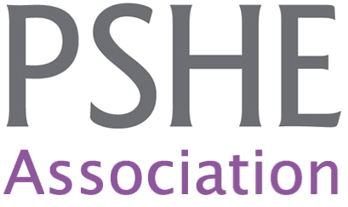

Teaching about Mental Health Issues

Sources of Further Support

www.pshe-association.org.uk – PSHE resources, support and ideas. We can also offer tailored support to PSHE Association members, email info@pshe-association.org.uk or call 020 7922 7950
www.b-eat.co.uk – Beat are the UK’s largest eating disorders charity. Their website provides eating disorders support & advice for young people, parents and teachers. Until December 2014 you can access free self-esteem workshops for KS3 via Beat. Contact Jasmine Stedman: 01603 753321 or j.stedman@b-eat.co.uk
www.self-harm.co.uk – This is a charity run website providing support and advice for people who self-harm and their families. You can also access their ‘Alumina’ programme via the website which is a 6 week online programme for young people trying to overcome self-harm.
www.youngminds.org.uk – Young Minds are a UK based mental health charity focusing specifically on young people. Their website includes a wide range of information for young people, their carers and teachers.
www.headmeds.org.uk – Is also run by Young Minds and provides information for young people who have been prescribed medication to help with a mental health issue.
www.cornwallhealthyschools.org/stop-stigma – Stop Stigma is a resource to help address mental health stigma and to support awareness of mental health in the secondary classroom. It has received the PSHE Association Quality Mark.
www.Samaritans.org – info & online support. Helpline: 08457 90 90 90 <24 hour, confidential
www.childline.org.uk – info & online support. Helpline: 0800 1111 <24 hour, confidential
www.time-to-change.org.uk – Time to change aim to reduce mental health stigma. They regularly produce videos about mental health issues, some of which would be suitable for use in class.
www.mind.org.uk – Support & advice, mental health (all ages)
www.inourhands.com – Pooky’s site, which includes a regularly updated mental health blog with practical suggestions and information for school staff and parents.
www.eatingdisordersadvice.co.uk – another site by Pooky which includes a wide range of information and practical strategies for supporting young people with eating disorders. Aimed at school staff and parents.

YouTube Channels
These channels are regularly updated with videos which may be useful for your information. Some of the videos will be suitable for use in class, but not all.
Childline: http://www.youtube.com/user/childline
Time to Change: http://www.youtube.com/user/ttcnow2008
Young Minds: http://www.youtube.com/user/youngmindscharity
Samaritans: https://www.youtube.com/user/samaritans
Mind: https://www.youtube.com/user/MindWebteam
Beatbullying: https://www.youtube.com/user/Beatbullying
National Institute of Mental Health: https://www.youtube.com/user/NIMHgov

PSHE Association resources:
Dos and Don’ts when teaching about eating disorders (blog post)
Common Misconceptions about Eating Disorders (downloadable resource)
Talking to Pupils when they make Mental Health Disclosures (downloadable resource)

Contact Pooky:
Dr Pooky Knightsmith, Mental Health and Emotional Wellbeing Advisor, PSHE Association.
pooky@pshe-association.org.uk
020 7922 7950

