Solihull Early Years Setting Improvement Joint –Evaluation & Support Visit OUTCOMES
GOOD OUTCOMES | ◦Children make at least typical progress and most children make progress that is better than typical from their starting points. This includes disabled children, those who have special educational needs, those for whom the setting receives additional funding and the most able.  ◦ Where children’s starting points are below those of other children of their age, assessment shows they are improving consistently over a sustained period and the gap is closing. Any gaps between the attainment of groups, including those for whom the setting receives additional funding, are closing.  ◦ Children are working comfortably within the range of development typical for their age, taking account of any whose starting points are higher or any disabled children and those with special educational needs.  ◦ Children develop the key skills needed for the next steps in their learning, including, where appropriate, for starting school.
Joint activity – Cohort data and meeting the curriculum needs of the geographical area
Cohort tracking and curriculum opportunities -data to inform developments
- How does the setting use its own cohort tracking data? attainment / progress/ groups
- How does it use knowledge of the needs of the geographical area it service to develop curriculum opportunities?
- So what has it adapted as a result of the current/ recent setting data – Gender/ 2 y EEF/ EYPP/ EAL/ ethnicity etc Curriculum areas?
- EVALUATIVE -Does the data tell them what they do well/ needs consideration – for all/ groups?
SO Info which may be useful to pursue……………..
Solihull HRBQ – at Year2 [health related behaviour questionnaire] shows us that not enough children wash their hands after visiting the toilet or eat sufficient fruit and veg .. how can settings support this? See separate chart HRBQ
Dental decay is highest in Synergy : Synergy 25.5%/ Unity 21.7%/ Rural 18.5%/ Mosaic 9.1%/ Evolve 8.6% setting action?
Ages and Stages Questionnaire at 2 years old - % children below expected levels highest for communication 30%/ PSE 20%/ Gross motor 18%/ problem solve 17%/ fine motor 15%
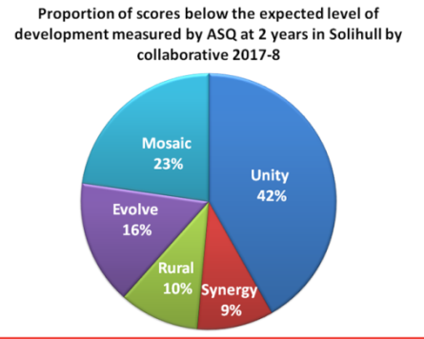
What is the setting noticing about their 2 y checks and assessment summary at 2 – does it match the findings of ASQ? Where are children least/ most likely to be on-track?
Who are the children that are not at expected dev’t stages- boys/ EAL/ with disadvantage/ LAC/ SEN etc?
What are they doing to support these children?
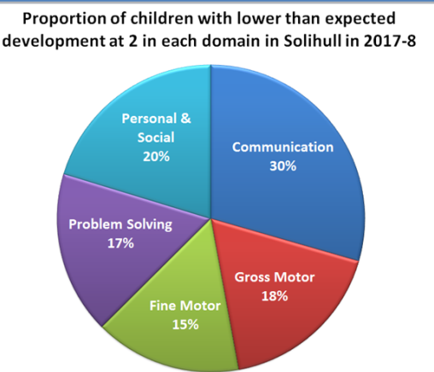

EYFSP at 5 – Headlines Good Level of Development/ Early Learning Goal +
GLD Unity 67%/ Lyndon& Lode Heath[Mosaic] -71%/ Synergy – 74%/ Shirley/ Olton [Evolve] -76%/ Rural -78%
GLD Collaborative difference for gender
Solihull | 10 | 9 | 9 | 10 | 12 | 12 | 10 | 10 | 10 | 14 | 6 | 6 | 8 | 7 | 3 | 12 | 12
GAPS | LA | U | Sp | MH | HSc | ScSe | Mfb | MR | R | W | N | SSM | PC | W | T | EMM | BI
Mosaic | 12 | 9 | 10 | 8 | 10 | 10 | 13 | 10 | 12 | 10 | 1 | 4 | 9 | 6 | 3 | 15 | 13
Rural | 6 | 5 | 6 | 8 | 4 | 5 | 8 | 7 | 7 | 13 | 3 | 6 | 5 | 5 | 2 | 6 | 4
Evolve | 8 | 10 | 9 | 11 | 8 | 8 | 10 | 11 | 9 | 14 | 6 | 7 | 7 | 7 | 2 | 12 | 12
Synergy | 8 | 5 | 7 | 8 | 3 | 5 | 11 | 7 | 9 | 15 | 6 | 6 | 3 | 5 | 1 | 9 | 9
Unity | 15 | 11 | 15 | 13 | 13 | 12 | 13 | 13 | 13 | 12 | 10 | 9 | 14 | 13 | 7 | 19 | 18

